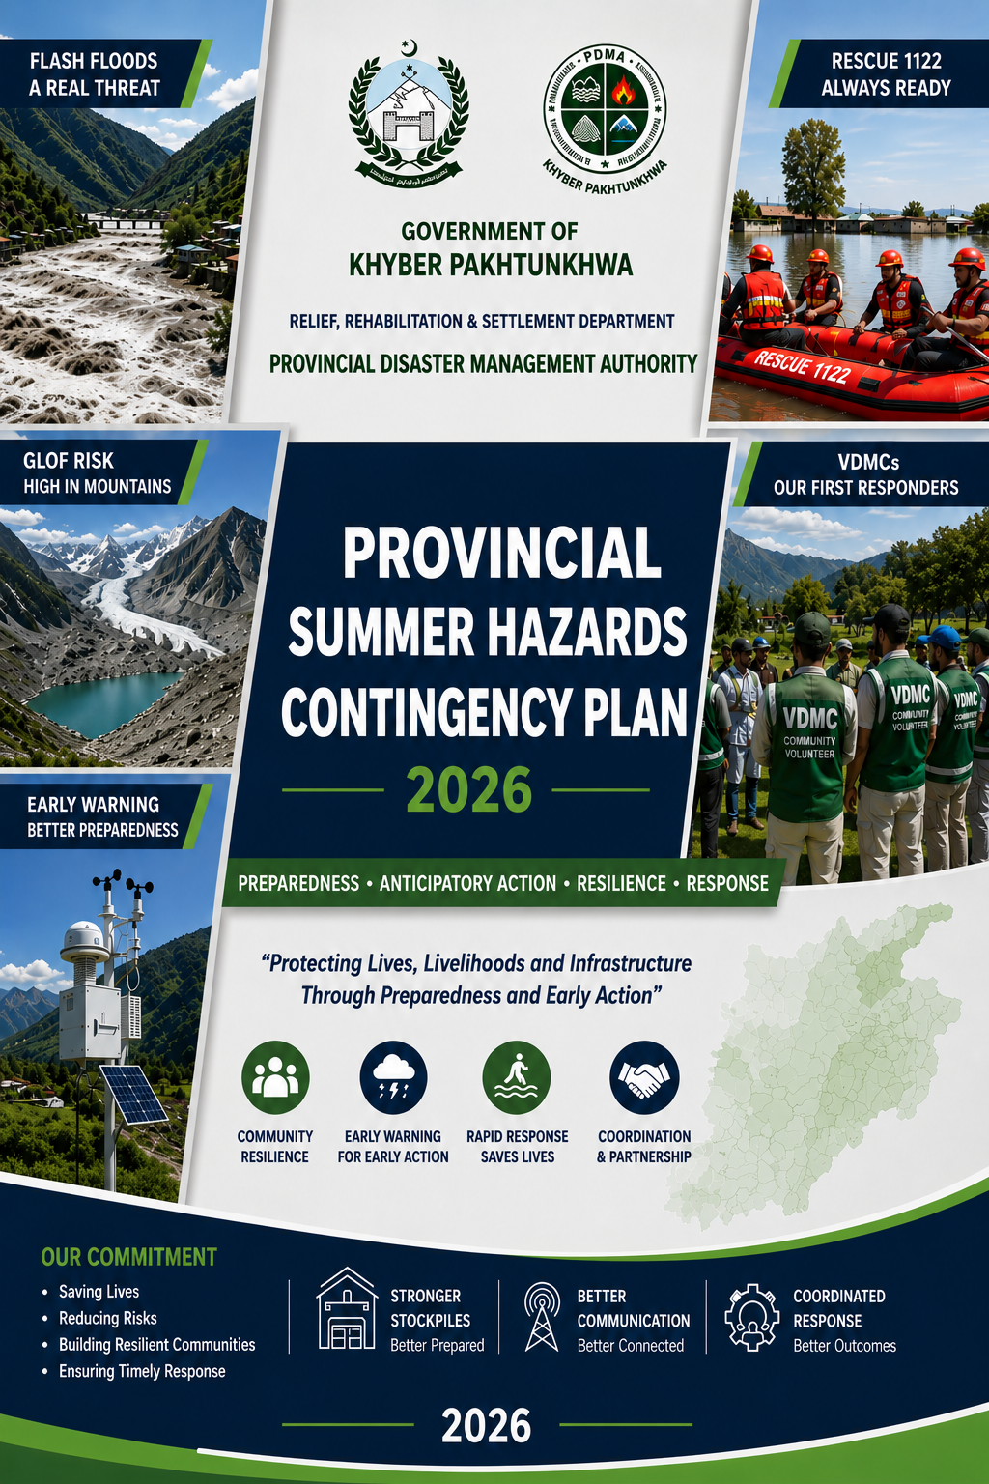

Government of Khyber Pakhtunkhwa



SUMMER HAZARDS CONTINGENCY PLAN 2026
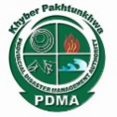

Provincial Disaster Management Authority, Khyber Pakhtunkhwa

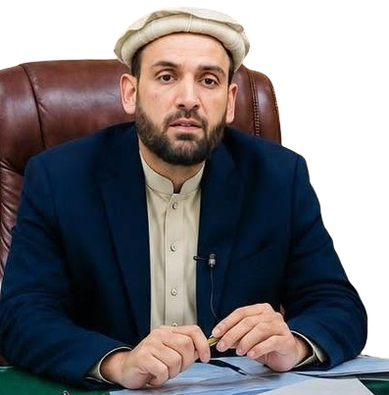
Message from the Minister for Relief, Rehabilitation & Settlement Department Government of Khyber Pakhtunkhwa
As we approach the Monsoon Season 2026, I am pleased to present the Monsoon Contingency Plan (SHCP 2026) prepared by the Provincial Disaster Management Authority (PDMA) Khyber Pakhtunkhwa.
Mr.Aqibullah Minister for Relief, Rehabilitation & Settlement Department
Government of Khyber Pakhtunkhwa

In recent years, Khyber Pakhtunkhwa has experienced increasingly severe and unpredictable weather patterns driven by climate change, including intense rainfall, flash floods, riverine flooding, Glacial Lake Outburst Floods (GLOFs), landslides, windstorms, and urban flooding. These recurring hazards continue to pose serious threats to human lives, livelihoods, agriculture, public infrastructure, and essential services across the province.
The changing climate realities demand a more proactive, coordinated, and resilient disaster management framework. This Contingency Plan reflects the Government’s firm commitment to strengthening preparedness, enhancing early warning and anticipatory actions, improving emergency response capacity, and safeguarding vulnerable communities through timely and effective interventions.
The SHCP 2026 provides a comprehensive roadmap encompassing seasonal hazard forecasts, district-wise risk analysis, preparedness measures, emergency stock positioning, communication and coordination mechanisms, and clearly defined institutional roles and responsibilities. Special emphasis has been placed on community-based preparedness, inter-agency coordination, localized response planning, and the utilization of modern early warning systems for timely dissemination of alerts and evacuation advisories.
I highly appreciate the dedicated efforts of PDMA, district administrations, line departments, humanitarian partners, rescue services, and civil society organizations in the development of this comprehensive plan. I urge all stakeholders to ensure effective implementation of the preparedness and response measures outlined herein, with utmost professionalism, coordination, and commitment.
Preparedness is our collective responsibility. Through unity, vigilance, and timely action, we can significantly reduce disaster risks and protect the people and communities of Khyber Pakhtunkhwa from the adverse impacts of monsoon-related emergencies.
Let us stand prepared — together, resilient and ready.

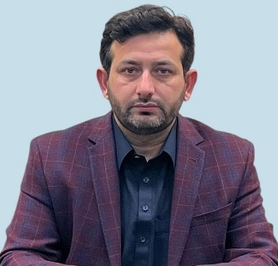
MESSAGE FROM SECRETARY RELIEF REHABILITATION SETTLEMENT DEPARTMENT KHYBER PAKHTUNKHWA

The Relief, Rehabilitation & Settlement Department fully endorses the Monsoon Contingency Plan 2026 and the comprehensive measures outlined therein for preparedness, mitigation, response, and coordination during the monsoon season. The increasing frequency and intensity of climate-induced disasters demand a well-coordinated, multi-sectoral, and proactive approach to disaster management across the province.
Mr. Sohail Khan
SECRETARY RELIEF REHABILITATION SETTLEMENT DEPARTMENT
KHYBER PAKHTUNKHWA
Over the past years, experts and practitioners have consistently observed that extreme weather patterns are creating increasingly complex humanitarian and environmental challenges. Khyber Pakhtunkhwa is particularly vulnerable to a wide range of hydro-meteorological hazards, including urban flooding, riverine floods, flash floods, landslides, Glacial Lake Outburst Floods (GLOFs), avalanches, windstorms, and drought-like conditions in arid regions. These hazards continue to adversely affect human lives, livelihoods, public infrastructure, agriculture, water resources, and ecosystems. Erratic monsoon rainfall, rising temperatures, accelerated glacier melts in the northern regions, declining agricultural productivity, forest degradation, pest infestations affecting crops, and increasing scarcity of safe drinking water are among the visible impacts of climate change confronting our province today. These evolving risk patterns necessitate enhanced preparedness, timely early warning dissemination, effective coordination, and resilient response mechanisms at all levels.
It is in this context that the Provincial Disaster Management Authority (PDMA) Khyber Pakhtunkhwa has developed the Monsoon Contingency Plan 2026 in close coordination with provincial line departments, district administrations, humanitarian organizations, rescue services, and other stakeholders. The Plan reflects a collective commitment to minimizing the impact of monsoon-related hazards through integrated planning, resource mobilization, and coordinated response arrangements.
The document has been carefully structured into analytical and operational components, making it a practical and effective tool for both planners and field implementers. It provides strategic guidance on hazard assessment, preparedness actions, institutional coordination, emergency response arrangements, resource availability, and district-level operational planning. I am confident that, through effective implementation and continued coordination among all stakeholders, the objectives of this Plan will be successfully achieved, contributing towards safer, more resilient, and better-prepared communities across Khyber Pakhtunkhwa.
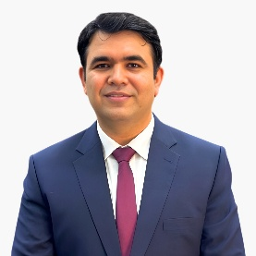
Message from the Director General
Provincial Disaster Management Authority (PDMA)Khyber Pakhtunkhwa
Khyber Pakhtunkhwa remains increasingly vulnerable to a range of climate-induced summer hazards including flash floods, riverine floods, Glacial Lake Outburst Floods (GLOFs), cloud bursts, heat waves, landslides, and urban flooding. The growing frequency and intensity of extreme weather events continue to pose serious risks to human lives, livelihoods, infrastructure, and essential services across the province.
Mr. Arifullah Awan
Director General PDMA
Khyber Pakhtunkhwa

In response to these evolving challenges, the Provincial Disaster Management Authority (PDMA) Khyber Pakhtunkhwa has developed the Summer Hazards Contingency Plan (SHCP) 2026 as a comprehensive and proactive framework to guide preparedness, anticipatory actions, emergency response, and early recovery efforts during the monsoon and summer hazard season.
This Plan has been prepared through close coordination and consultations with provincial line departments, district administrations, humanitarian partners, rescue services, and other stakeholders. It is based on seasonal weather forecasts, historical disaster trends, district-level risk assessments, and lessons learned from previous emergencies.
The SHCP 2026 outlines hazard profiles, vulnerable districts, preparedness measures, resource availability, coordination arrangements, communication protocols, and operational response mechanisms to ensure timely and effective action. Special emphasis has been placed on community preparedness, early warning dissemination, and protection of vulnerable populations including women, children, elderly persons, and persons with disabilities.
At PDMA, we believe that preparedness, coordination, and collective action are essential for building resilient communities. I appreciate the valuable contributions of all stakeholders involved in the development of this Plan and urge all departments and partner organizations to implement it in true spirit and maintain close coordination for an effective and unified response.
Let us remain vigilant, prepared, and committed to safeguarding the people of Khyber Pakhtunkhwa from the impacts of summer hazards and monsoon-related emergencies.


Acknowledgment
Director (DRM)
Provincial Disaster Management Authority (PDMA)
Khyber Pakhtunkhwa
The development of the Summer Hazards Contingency Plan (SHCP) 2026 is the outcome of a comprehensive, collaborative, and consultative process involving the dedicated efforts of numerous institutions, departments, technical experts, and individuals committed to strengthening disaster preparedness and resilience in Khyber Pakhtunkhwa.
Ihsan Dawar Deputy Director DRM PDMA Khyber Pakhtunkhwa

I would like to express sincere gratitude and acknowledge the invaluable guidance and continuous support of the Secretary, Relief, Rehabilitation and Settlement Department, Government of Khyber Pakhtunkhwa Mr. Sohail Khan, and the Director General, PDMA Khyber Pakhtunkhwa Mr.Arifullah Awan, whose leadership and strategic directions have been instrumental in the preparation and finalization of the Summer Hazards Contingency Plan (SHCP) 2026. Their commitment to strengthening disaster risk preparedness and response across the province has significantly contributed to enhancing institutional coordination and operational readiness.
I extend my sincere appreciation to all district administrations, line departments, Rescue 1122, Pakistan Meteorological Department (PMD), National Disaster Management Authority (NDMA), humanitarian organizations, development partners, and relevant stakeholders whose valuable contributions enriched this Plan through technical input, risk assessments, operational feedback, and district-specific information. Their active coordination and commitment have played a vital role in shaping a practical and operationally effective contingency framework for the province.
I also acknowledge the important role of local communities, civil society representatives, and field teams, particularly in hazard-prone districts, whose observations and experiences during consultations and field engagements contributed significantly towards developing localized and community-cantered preparedness and response strategies.
Special appreciation is extended to the Disaster Risk Management (DRM) team of PDMA Khyber Pakhtunkhwa, including Mr.Sajid Ali Khan Climate Change Expert, Engineer Muhammad Sohail, and all team members, who worked tirelessly with exceptional dedication and professionalism to coordinate the planning process, compile district data, conduct risk analysis, and finalize this important document well in time before the onset of Monsoon 2026. Their continuous efforts, often under demanding timelines, ensured the timely completion of a comprehensive and actionable contingency plan.
The SHCP 2026 is intended to serve as a living document that will continue to evolve in light of emerging risks, operational experiences, and changing climate realities. I encourage all stakeholders to treat this Plan not only as a guiding framework but also as a shared responsibility towards protecting vulnerable communities and strengthening resilience across Khyber Pakhtunkhwa.
Together, let us continue working towards a safer and more resilient Khyber Pakhtunkhwa.
LIST OF ACRONYMS
Acronym | Full Form
AA | Anticipatory Action
AJ&K | Azad Jammu & Kashmir
AMJ | April-May-June
ASVS | Anti-Snake Venom Serum
AWD | Acute Watery Diarrhea
CAFs | Civil Armed Forces
CBDRMs | Community-Based Disaster Risk Management Committees
CDA | Capital Development Authority
CISE | Comprehensive International Simulation Exercise
CMH | Combined Military Hospital
CMOs | Cellular Mobile Operators
CSO | Civil Society Organization
CUSEC | Cubic Foot per Second
C&W | Communication and Works Department
DDMA | District Disaster Management Authority
DEOC | District Emergency Operations Centre
DEW | Disaster Early Warning
DHQ | District Headquarters Hospital
DMCF | Disaster Management Coordination Forum
DM | Disaster Management
DRR | Disaster Risk Reduction
EAD | Economic Affairs Division
EMT | Emergency Medical Team
EOC | Emergency Operations Centre
EW | Early Warning
EWARS | Early Warning, Alert and Response System
EWS | Early Warning System
FFC | Federal Flood Commission
FFD | Flood Forecasting Division
FM | Frequency Modulation
FWO | Frontier Works Organization
GB | Gilgit-Baltistan
GBDMA | Gilgit-Baltistan Disaster Management Authority
GLOF | Glacial Lake Outburst Flood
GPS | Global Positioning System
ICT | Islamabad Capital Territory
INGO | International Non-Governmental Organization
JAS | July-August-September
KP | Khyber Pakhtunkhwa
LEA | Law Enforcement Agency
LLIN | Long-Lasting Insecticidal Net
LO | Liaison Officer
MIRA | Multi-Sector Initial Rapid Assessment
MMT | Mobile Medical Team
MoCom | Ministry of Communications
MoR | Ministry of Railways
NDMA | National Disaster Management Authority
NDMCF | National Disaster Management Coordination Forum
NDMP | National Disaster Management Plan
NDRP | National Disaster Response Plan
NEOC | National Emergency Operations Centre
NGO | Non-Governmental Organization
NHA | National Highway Authority
OBM | Outboard Motor
ORS | Oral Rehydration Salts
PDMA | Provincial Disaster Management Authority
PEMRA | Pakistan Electronic Media Regulatory Authority
PEOC | Provincial Emergency Operations Centre
PMD | Pakistan Meteorological Department
RCCE | Risk Communication and Community Engagement
RRT | Rapid Response Team
SAR | Search and Rescue
SDMA | State Disaster Management Authority
SHCP | Seasonal Hazard Contingency Plan
SimEx | Simulation Exercise
SITREP | Situation Report
SMS | Short Message Service
SOP | Standard Operating Procedure
SUPARCO | Space and Upper Atmosphere Research Commission
TV | Television
USAR | Urban Search and Rescue
WAPDA | Water and Power Development Authority
WASA | Water and Sanitation Agency
WASH | Water, Sanitation and Hygiene
WHO | World Health Organization

PREFACE
Province of Khyber Pakhtunkhwa is prone to various climate related disasters due to its unique topography. The environmental and climate related changes make the province of Khyber Pakhtunkhwa prone to the vulnerabilities of monsoon such as Flash Floods, Riverine Floods and Glacial Lake Outburst Floods (GLOF). Additionally, winter disturbances such as heavy snow fall in different parts of the province also wreak havoc in the entire Province. Hence, it is imperative to have an integrated scientific approach and preparedness planning in order to minimize the adverse effects of the natural calamities. Provincial Disaster Management Authority, Khyber Pakhtunkhwa, is utilizing the available resources to mitigate disaster risks and enhance preparedness level. In this preview, “Summer Hazards Contingency Plan” is an annual practice, which is undertaken before the start of every summer season by the PDMA Khyber Pakhtunkhwa.
This Summer Hazards Contingency Plan 2026 has been prepared in coordination with all the disaster management stakeholders at the federal, provincial and district levels based on the analysis of seasonal outlook of the Pakistan Meteorological Department (PMD) and relevant technical input from NDMA Technical Team. In this Plan, guidelines have been outlined for all disaster management tiers and relevant stakeholders for adopting a proactive approach towards all aspects of mitigation and preparation against the most probable and possible worst-case scenarios to coordinate a timely response. This Contingency Plan is meant to be read in conjunction with Monsoon Contingency Plan 2023, Heatwave Contingency Plan, Anticipatory Actions Framework of Khyber Pakhtunkhwa 2026 (available on website: https://www.pdma.gov.pk/ ) and other relevant documents & plans.
Aim: To formulate “Summer Hazards Contingency Plan 2026” for proactive preparations and an effective response against likely hazards associated with summers in the available resources.
Scope. The plan encompasses: -
Section I – Hazards Vulnerabilities and Risks
- Monsoon and Climate Changes in Khyber Pakhtunkhwa
- Summer Hazard Profile of the Province
- PMD’s Summer Seasonal Outlook 2026
- Perceived Impact of Summer Seasonal Outlook 2026
- Major Conclusions from Summer Seasonal Outlook 2026
- Threat and Vulnerabilities
- Likely Response Challenges.
Section II – Anticipated Case Loads and Presumed Impact Scenarios
- Major Events of Floods (2010, 2022 & 2025) and their Impacts (Worst Case Scenarios):
- Anticipatory Case Load
- Required number of Non-Food Items (NFIs) and Food Items (FIs)
- Financial Calculation of FIs and NFIs against the Presumed Scenarios
- NFIs Stock Gap Analysis for the Probable Scenario of 2026
- Financial Calculation of Relief Compensation against the Presumed Scenarios
- Total Funds Outlay
Section III - Anticipatory Actions & Response Guidelines for summer 2026
- Preparedness Phase
- Early Warning Phase
- Priority Districts
- Response - Rescue, Relief & Early Recovery Phase
Section IV – Inclusiveness

Gender & Child Protection Mainstreaming in Monsoon Contingency plan-2026.
- Gender & Child Protection Mainstreaming checklist for Monsoon Contingency Plan-2026
- Strengthening preparedness capacity of GCC

Section V – Coordination and Roles
- Provincial Emergency Operation Center – PEOC
- Media & Awareness Campaigns
- Coordination with UN Agencies and INGOs / NGOs
- Roles and Responsibilities
  - Provincial Departments
  - District Disaster Management Units
  - Anticipatory Actions by Communities
Section VI – Appendices
- Appendix I: Maps
- Appendix II: Important Tables (Assessments & Calculassions)
- Appendix III: Stakeholders Consulted in Monsoon Contingency Planning 2026
- Appendix IV: Heat wave Public Guidance
- Appendix V: Important Contacts

SECTION I – HAZARDS VULNERABILITIES AND RISKS
Monsoon refers to the seasonal changes in atmospheric circulation and precipitation. It is usually associated with the Indian Ocean Wind System which blows from colder to warmer regions. The duration of the season lies between 100 and 120 days - starting from mid-June and ending till mid-September. At the time of its arrival, the normal rainfall increases suddenly and continues constantly for several days.
Khyber Pakhtunkhwa as a whole has experienced the climate change impacts in terms of rise in mean temperature from 0.3°C to 1.2°C, average rainfall from 11mm to 15mm (over the thirty years span), changes in precipitation, increases in the frequency or intensity of some extreme weather events (cloud bursts, hail storms, floods, GLOFs, droughts & heat waves), declining biodiversity causing widespread forest die-off and melting glaciers. The graph shows the annual pattern and rainfall trends in northern, central and southern KP based on historical PMD data for period 1960–2020;
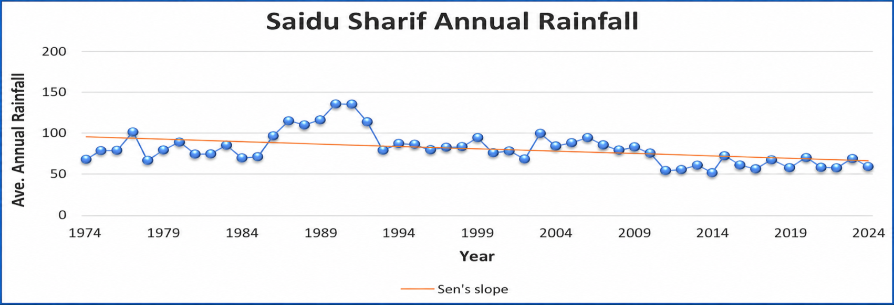
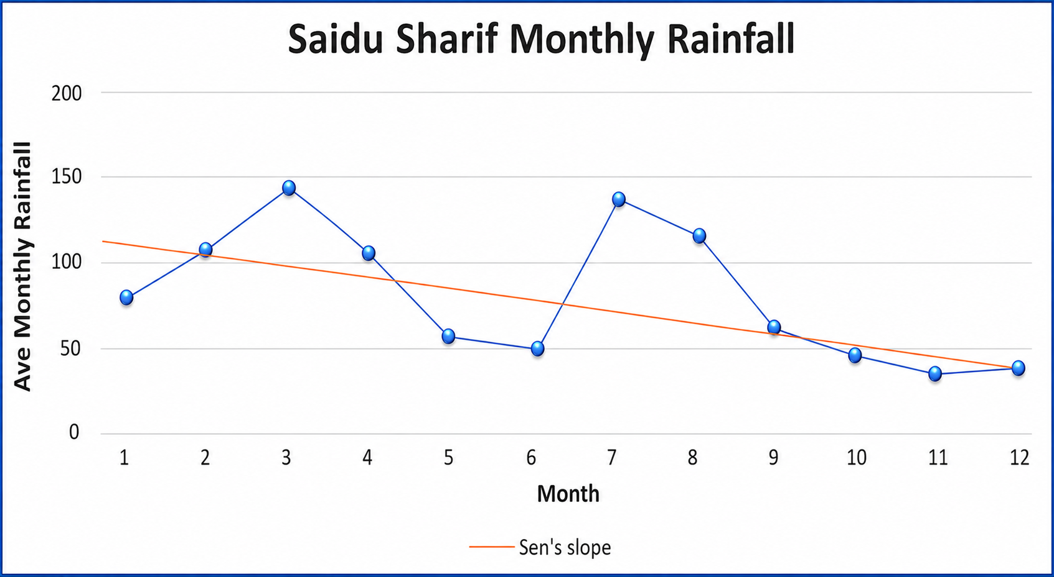
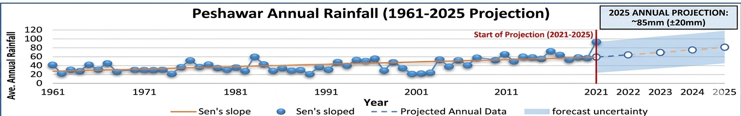
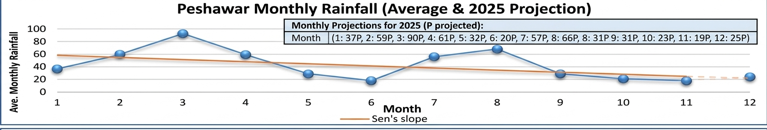

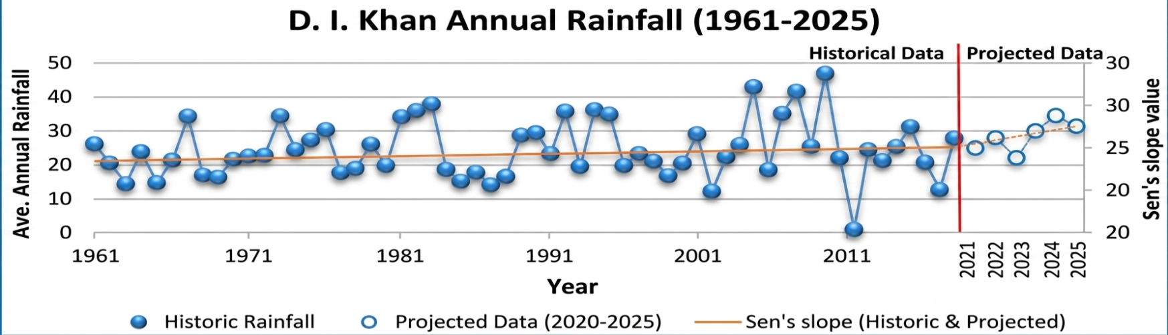

Climate change, especially the changes in annual temperature and rainfall, are taken into account since variability factors and the magnitude of fluctuations varies according to the location. The rainfall temporal analysis of Khyber Pakhtunkhwa based on PMD data of stations grid from the last 30 years shows the extent and severity of monsoon rainfall and temperature which can be seen in Appendix I
Summer Hazard Profile: Khyber Pakhtunkhwa is one of the most disaster-prone areas in this region due to the adverse impacts of climate change. Major summer hazards are; floods, heat waves, cloud bursts, wind, hail storms and landslides.
- Floods; are most frequent and prominent events in monsoon season in Khyber Pakhtunkhwa. These are often caused by heavy rainfall, rapid snowmelt or Glacial Lake Outburst Flooding (GLOFs). Floods in 2010 played havoc in the province. The combined outflow of rivers of Swat and Kabul had swollen to 400,000 cusecs in comparison to the usual outflow of 250,000 cusecs. Similarly in 2022, 309 people died and 600,000 others were displaced by floods in District Tank, D.I.Khan, Swat, Mardan, Swabi, Nowshera, Charsadda, Kohistan Upper, Kohistan Lower, Dir Upper, Chitral Upper and Chitral Lower (most affected districts)
The prominent rivers flowing across the province of Khyber Pakhtunkhwa are Indus, Kabul, Badrai, Bara, Dor, Gambila, Gomal, Haro, Jindi, Kurram, Kunar, Kunhar, Khiali, Panjkora, Swat, Siran and Zhob.
Floods in the province are categorized as;
- Riverine Floods The type of Floods in which the streams and rivers flow out of there, natural or man-made embankments, to accommodate increased outflows, upstream, are called Riverine Floods. The unprecedented Floods of 2010 and 2022 are an example of Riverine Floods. These revealed that almost ¾ of the whole province is vulnerable to riverine floods. Vulnerable districts in respect of riverine flood placed at Appendix I and the flood limits of major waterways revised by the Irrigation Department along with lag times are placed at Appendix II.

- Flash Floods The type of Floods in which there is a sudden and rapid-onset of very high discharges of water due to heavy rainfalls, upstream, are called Flash Floods. These events can lead to extensive infrastructural and human loss. The province geography, with its mountainous regions and extensive river systems, makes it particularly vulnerable to flash floods / hill torrents. Vulnerable districts in respect of flash floods are placed at Appendix I.

To determine flood levels and historical pattern of floods in the province, the rivers and streams have been categorized in three categories by the provincial irrigation department:

Category A consists of those rivers which receive floods of different magnitude frequently every year such as the rivers of Kabul, Khiali (Peshawar), Khiali Adezai, Panjkora, Kunhar, Naguman, Shah Alam, Kurram, Siran, Kohat Toi, Tochi and nullahs are Budni (Peshawar), Kalpani (Mardan) and Jabb (Abbottabad).

Category B consists of those rivers which receive less frequent floods such as the rivers of Jindi, Gomal Zam, Kaitu, Indus, Haro and nullahs are Badri, Naranji, Dalas, Mukam and local hill torrents in the Northern Areas of Khyber Pakhtunkhwa.
Category C consists of rivers which receive occasional floods as a result of heavy concentrated rainfall in their catchment areas such as the rivers of Chowdhwan Zam, Sheikh Haider Zam and nullahs are Chila, Chinkar, Gharandi, Ghari, Balar Dagi, Khudrazai and khawars are Rustam and khawar at Khyber Agency.
(Floodway Maps are placed at Appendix I)

- Urban Flooding The type of Floods which occur when city landscapes cannot absorb excess water after prolonged periods of intense rainfall, river and drains overtopped, or storm surge are called Urban Floods. During monsoon season, heavy rains coupled with cloud bursts often put enormous pressure on the drainage system and results in urban flooding in the major cities of Khyber Pakhtunkhwa i.e. Peshawar, Mardan, Kohat, Abbottabad, Swat, Mansehra and D.I. Khan. Vulnerable urban centers with respect to urban flooding hazard are shown in map placed in Appendix I

- GLOFs. The term GLOF stands for Glacial Lake Outburst Floods. The type of floods which occur due to the the rapid release of water from glacial lakes, and which can lead to sudden and catastrophic flooding downstream are called Glacial Lake Outburst Floods or GLOFs. Five districts of the province are particularly vulnerable to GLOFs due to their mountainous terrain and presence of major glaciers - Upper Chitral, Lower Chitral, Dir Upper, Kohistan, Swat.
PDMA KP with the collaboration of United Nations Development Program (UNDP) initiated a project called “Glacial Lake Outburst Floods (GLOFs)” which includes construction of small scales infrastructures in the targeted valleys of Khyber Pakhtunkhwa. This project is working in 08 valleys of the 05 districts of Khyber Pakhtunkhwa to help vulnerable communities prepare for and mitigate GLOF risks through early warning systems and community-based disaster risk management. The GLOF targeted valleys are:
- Reshun Valley, District Chitral Upper.
- Arkari Valley, District Chitral Lower.
- Madaklusht Valley, District Chitral Lower.
- Thall, Kumrat Valley, District Dir Upper.
- Gabral Valley, District Swat.
- Matiltan Valley, District Swat.
- Mankiyal Valley, District Swat.
- Gabriel, Kandia Valley, District Kohistan Upper.
The map shows the locations of vulnerable glacial lakes in Khyber Pakhtunkhwa is placed at Appendix I
Flood Risk Assessment of Khyber Pakhtunkhwa is performed by using a framework to provide an understanding for identifying vulnerabilities on the basis of 05 variables and supported by damage and loss database (provided in Appendix II) is shown in Table;
Flood Risk Ranking for Monsoon 2026
S.No. | Name of District | A: Likelihood of Food Event | B: Impact on Population | C: Impact on Livelihood | D: Impact on Physical Infrastructure |  | E: Accessibility of the Area | Risk Ranking of a District A*(B+C+D+E) | Risk Class
S.No. | Name of District | 1 = None | 1 = Very rare Impact |  |  |  |  | Risk Ranking of a District A*(B+C+D+E) | Risk Class
S.No. | Name of District | 2 = Rare | 2 = Rare Impact |  |  |  |  | Risk Ranking of a District A*(B+C+D+E) | Risk Class
S.No. | Name of District | 3 = Occasional | 3 = Substantial |  |  |  |  | Risk Ranking of a District A*(B+C+D+E) | Risk Class
S.No. | Name of District | 4 = Frequent | 4 = Major |  |  |  |  | Risk Ranking of a District A*(B+C+D+E) | Risk Class
S.No. | Name of District | 5= Most Frequent | 5 = Severe |  |  |  |  | Risk Ranking of a District A*(B+C+D+E) | Risk Class
1 | Dir Upper | 5 | 4 | 5 |  | 4 | 5 | 90 | High Threat
2 | D.I Khan | 4 | 4 | 5 |  | 5 | 4 | 72 | High Threat
3 | Chitral Lower | 5 | 2 | 5 |  | 2 | 5 | 70 | High Threat
4 | Chitral Upper | 5 | 1 | 5 |  | 2 | 5 | 65 | High Threat
5 | Swat | 4 | 5 | 5 |  | 2 | 4 | 64 | High Threat
6 | Shangla | 4 | 4 | 5 |  | 1 | 5 | 60 | High Threat
7 | Nowshera | 4 | 3 | 5 |  | 4 | 2 | 56 | High Threat
8 | Charsadda | 4 | 2 | 5 |  | 4 | 2 | 52 | High Threat
9 | Dir Lower | 3 | 4 | 4 |  | 5 | 3 | 48 | High Threat
10 | Tank | 3 | 1 | 5 |  | 5 | 4 | 45 | High Threat
11 | Peshawar | 4 | 4 | 4 |  | 1 | 1 | 40 | High Threat
12 | Kohistan Upper | 3 | 1 | 4 |  | 2 | 5 | 36 | Medium Threat
13 | North Waziristan | 3 | 2 | 2 |  | 1 | 5 | 30 | Medium Threat
14 | Mardan | 3 | 5 | 1 |  | 3 | 1 | 30 | Medium Threat
15 | Kohistan Lower | 2 | 2 | 4 |  | 3 | 4 | 26 | Medium Threat
16 | Abbottabad | 3 | 3 | 3 |  | 1 | 1 | 24 | Medium Threat
17 | Karak | 2 | 2 | 2 |  | 5 | 3 | 24 | Medium Threat
18 | Buner | 3 | 3 | 1 |  | 2 | 2 | 24 | Medium Threat
19 | Malakand | 2 | 2 | 4 |  | 2 | 3 | 22 | Medium Threat
20 | South Waziristan | 2 | 3 | 2 |  | 1 | 5 | 22 | Medium Threat
21 | Lakki Marwat | 2 | 2 | 2 |  | 5 | 2 | 22 | Medium Threat
22 | Swabi | 3 | 3 | 1 |  | 2 | 1 | 21 | Medium Threat
23 | Torghar | 2 | 1 | 4 |  | 1 | 4 | 20 | Medium Threat
24 | Kolai Pallas | 2 | 1 | 4 |  | 1 | 4 | 20 | Medium Threat
25 | Mohmand | 2 | 2 | 4 |  | 2 | 2 | 20 | Medium Threat
26 | Kurram | 2 | 2 | 2 |  | 1 | 4 | 18 | Low Threat
27 | Bannu | 3 | 3 | 1 |  | 1 | 1 | 18 | Low Threat
28 | Mansehra | 2 | 2 | 2 |  | 1 | 3 | 16 | Low Threat
29 | Khyber | 2 | 3 | 3 |  | 1 | 1 | 16 | Low Threat
30 | Bajaur | 1 | 3 | 2 |  | 1 | 3 | 9 | Low Threat
31 | Orakzai | 1 | 1 | 2 |  | 1 | 4 | 8 | Low Threat
32 | Battagram | 1 | 1 | 2 |  | 1 | 4 | 8 | Low Threat
33 | Haripur | 2 | 1 | 1 |  | 1 | 1 | 8 | Low Threat
34 | Kohat | 1 | 1 | 2 |  | 1 | 1 | 5 | Low Threat
35 | Hangu | 1 | 2 | 1 |  | 1 | 1 | 5 | Low Threat
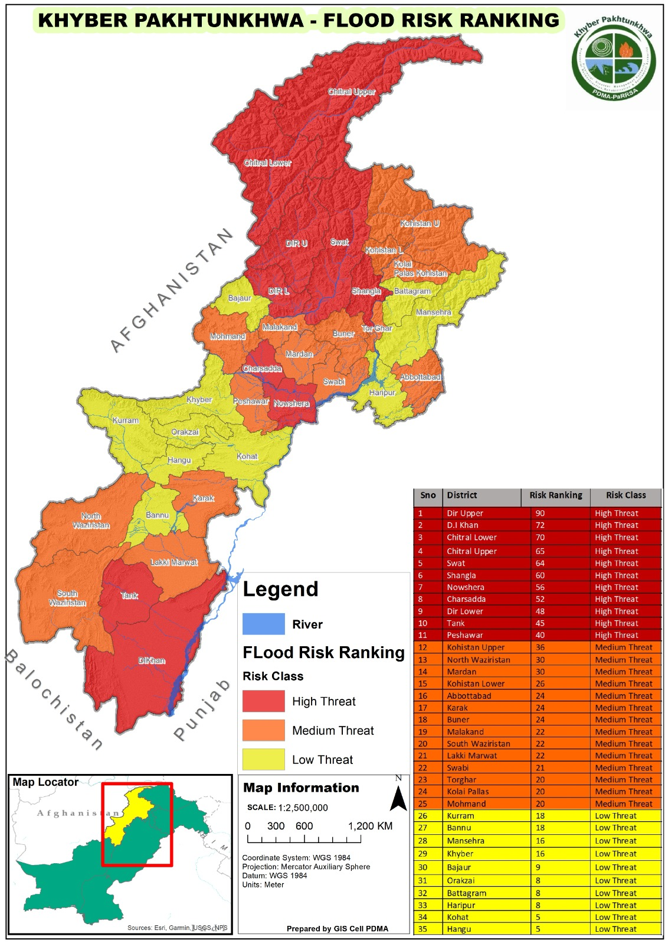
- Landslides are also known as landslips. These are several forms of ground movements, such as rock falls, shallow or deep-seated slope failures, mudflows and debris flows. Landslides often take place in conjunction with earthquakes, floods and volcanoes. Meanwhile a prolonged spell of rainfall can also cause a landslide. These landslides often result in damages and communication line disruptions. Most of the mountain regions of Khyber Pakhtunkhwa faced the challenges of landslides, triggered by flash floods in monsoon season. Districts susceptible to landslides are shown in map placed at Appendix I.

- Cloud Bursts The localized phenomenon in monsoon which results in a sudden heavy rainfall is called Cloud Burst. Cloud bursts happen when saturated clouds are unable to produce rain because of the upward movement of very warm air current. Instead of dropping down, raindrops get bigger in size and get pushed up due to the air current. Heavy Cloud Burst events were witnessed in Khyber Pakhtunkhwa on August 29th, 2020, in which 20 people were killed and nine people suffered injuries in the districts of Kohistan, Swat and Shangla. Similarly, on September 12th, 2021, at least 14 people, including eight women and children were killed after several houses collapsed in district Torghar.
Similarly, the cloudburst-induced flash floods that struck Buner, Swabi and Swat Districts during the 2025 monsoon season caused widespread devastation, resulting in significant human, infrastructural, and economic losses. The intense rainfall triggered flash floods and landslides in several parts of the districts, leading to loss of life, injuries, displacement of families, and extensive damage to public and private property. Hundreds of houses were either fully or partially damaged, while roads, bridges, irrigation channels, water supply schemes, educational institutions, agricultural land, and livestock assets also suffered considerable losses. The disaster highlighted the increasing frequency and intensity of extreme weather events associated with climate change and underscored the need for enhanced early warning systems, community preparedness, resilient infrastructure, and coordinated multi-sectoral disaster risk management measures across Khyber Pakhtunkhwa.
- Heat Waves As per Pakistan Meteorological Department (PMD), the phenomenon of Heat Wave is defined as the condition where the maximum temperature reaches to 40 ºC for the plains and 30 ºC for the hilly areas in conjunction with a deviation of 4.5 ºC to 6.4 ºC from the normal temperature, then under such a condition, a Heat Wave may formally be declared. The World Meteorological Organization defines a Heat Wave as an event where there are five or more consecutive days during which the daily maximum temperature exceeds the average maximum temperature by five degrees Celsius. The combination of heat and humidity (wet bulb temperature) exceeds the temperature of human body which may lead to heat strokes. The situation of heat wave may cause heat strokes, increasing forest fires and Food Security challenges in the province.

A Heat Wave Contingency Plan (2023) has already been prepared by the Provincial Disaster Management Authority (PDMA), Khyber Pakhtunkhwa and is available on PDMA website (www.pdma.gov.pk). Map showing vulnerable districts to heat waves is placed at Appendix I.
PMD’s Summer Seasonal Outlook 2026: issued on 2ND JUNE 2026, PMD seasonal forecast for July-August-September (JAS), 2026 articulated
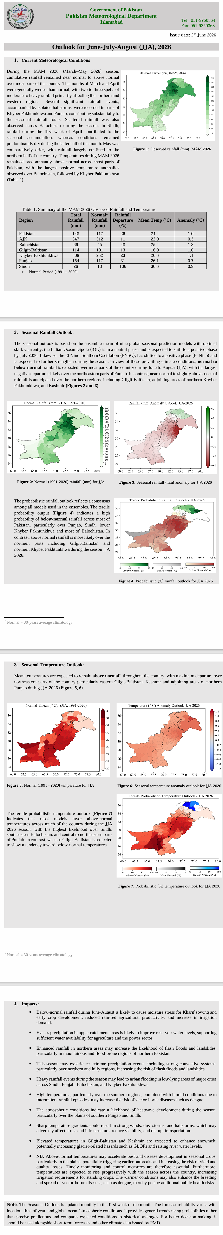
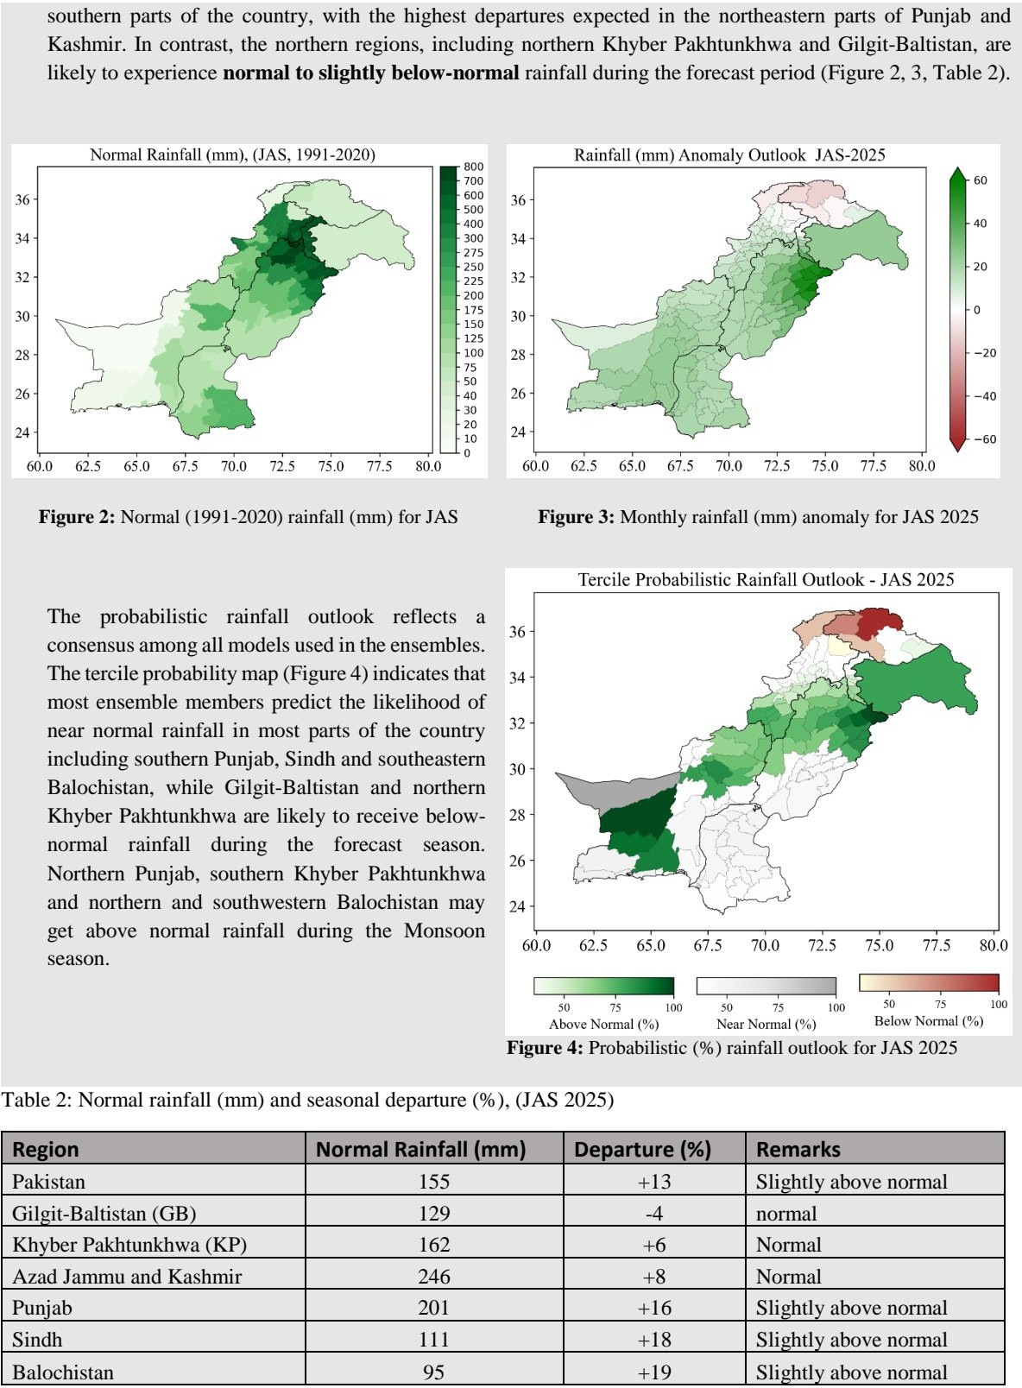
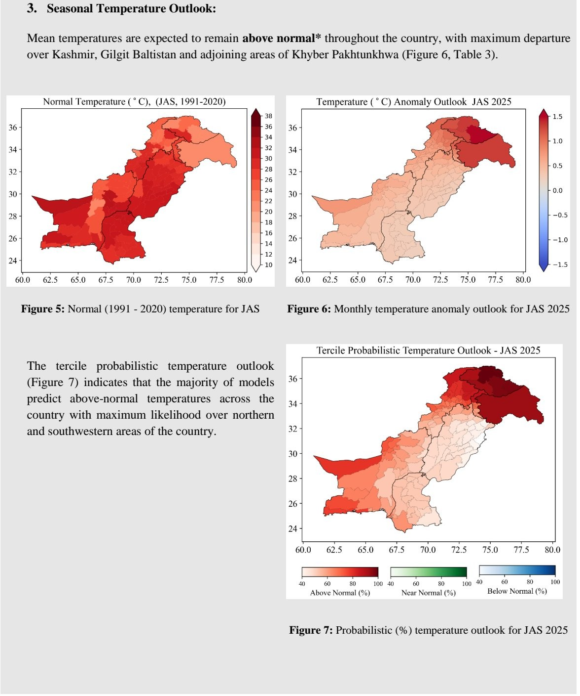
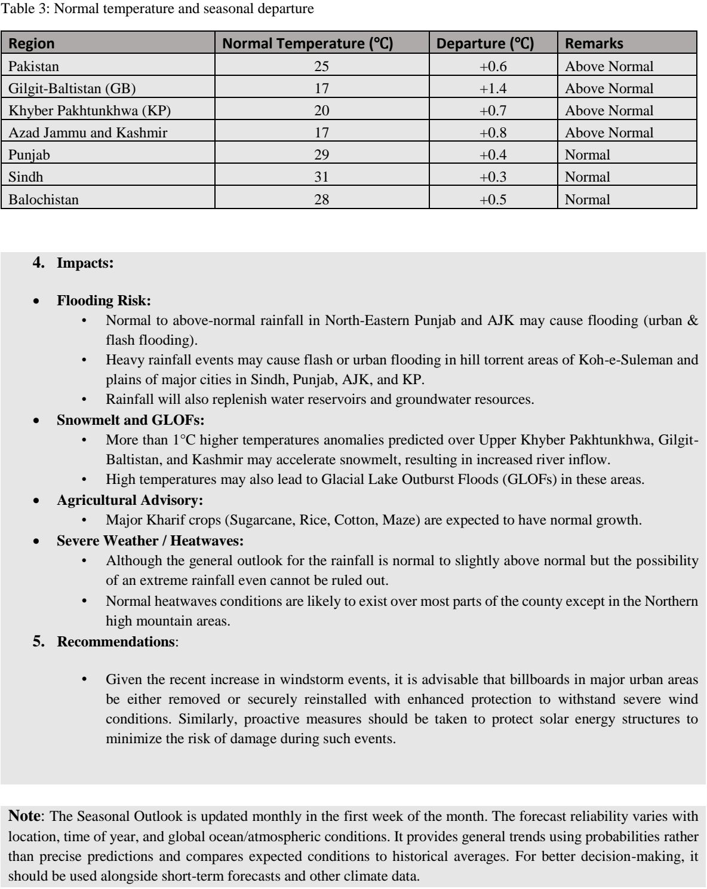
Threats and Vulnerabilities:
- Rain compounded with melting of snow may lead to high level riverine flow which may cause the Riverine Floods and Inundation in Charsadda, Nowshehra and DI Khan resulting in evacuation and crop damages. The risk may further be aggravated by the situation when Tarbela Dam achieves the maximum water conservation level before the season.
- Higher Temperature will cause “Urban Heat Islands Effect” especially in southern and central regions of Khyber Pakhtunkhwa which will lead to heat stroke effects on human health.
- Isolated heavy rains and storms will cause flash flooding in mountainous regions of the province including Upper Chitral, Lower Chitral, Tank, DI Khan, Upper Dir, Lower Dir, Swat, Buner, Shangla and Kohistan (Upper, Central and Lower) in nullahs / rivers / ravines posing a substantial risk to settlements downstream. The same cannot be rolled out in Southern Khyber Pakhtunkhwa. This may pose a risk that vehicles crossing nullahs may be swept away by fast moving water flows during flash floods.
- Amid Heat waves and dry conditions and lightning strikes during extreme weather events, there is a risk of forest fires in vulnerable forested areas.
- High Temperature and dry conditions may lead to windstorms or tornados in plain areas of Khyber Pakhtunkhwa (Central and Southern regions) which can cause blowing of billboards / hoardings and solar panels in urban areas as well as trees and powerlines.
- Due to heavy rainfalls, there is a risk of landslides occurring at mountainous areas like Mansehra, Abbottabad, Karakorum Highway, Swat, Dir, Shangla and Chitral. Risk is further compounded by higher tourist traffic in the same areas.
Likely Response Challenges
- The challenge of Early Restoration of Infrastructure: These are the service providing departments such as PHE, C&W, PKHA, TMAs and Irrigation Department. These departments are short of the Maintenance and Repair (M&R) funds which hinders their capabilities to engage contractors and private machinery for prompt response and earlier recovery of the critical services.

- Unplanned Development
Unplanned development by the private and public institutions leads to issues like urban flooding and choking of the waterways.
- Operational Challenges of District Disaster Management Units: The offices of the Additional Deputy Commissioners (Relief & Human Rights) in the province are under resourced for initiating mitigative and preparative measures and subsequently mobilizing response and earlier recovery.
- Encroachment in River Plains / Drainage / Sewage Channels in the Province
This is a long-lasting issue of the flood plains management authorities that the major rivers have been encroached upon and there are a lot of bottlenecks to remove the existing encroachment and discourage the future development in flood plains especially in the valleys like Upper Swat, Kelash, Naran and Kaghan which offer major tourism attractions.
- Multi Hazard Vulnerability Risk Assessment (MHVRA)
To associate correct priorities and carry out effective planning against likely hazards, there is a dire need to undertake detailed hazard and risk assessment in all the districts of Khyber Pakhtunkhwa.

SECTION II: ANTICIPATED CASE LOADS (IMPACT SCENARIOS)
Major Events of Floods (2010, 2022 & 2025) and their Impacts (Worst Case Scenarios): The impacts of 2025 floods, 2022 floods and 2010 floods comparison are shown in table below in relation to the affected population and humanitarian caseload.
S.No | Districts | Affected HH in Floods 2010 | Affected HH in Floods 2022 | Affected HH in Floods 2025
1 | Abbottabad | 3,651 | 471 | 160
2 | Bajaur | 4,381 | 1,148 | 900
3 | Bannu | 7,940 | 91 | 00
4 | Battagram | 20,336 | 385 | 36000
5 | Buner | 13,272 | 511 | 220000
6 | Charsadda | 87,472 | 6,720 | 875
7 | D.I Khan | 18,033 | 39019 | 131
8 | Hangu | 18,764 | 966 | 35
9 | Haripur | 15,063 | 266 | 1000
10 | Karak | 4,611 | 11,298 | 0
11 | Khyber | 13,0903 | 980 | 0
12 | Kohat | 16,705 | 0 | 0
13 | Kohistan Kolai Pallas | 25,107 | 1,260 | 0
14 | Kurram | 14,826 | 1,029 | 350
15 | Lakki Marwat | 3,505 | 8,981 | 0
16 | Lower Chitral | 4,837 | 9,541 | 2000
17 | Lower Dir | 19,714 | 5,362 | 0
18 | Lower Kohistan | 9,598 | 1,701 | 0
19 | Malakand | 6,571 | 3,185 | 300
20 | Mansehra | 3,146 | 161 | 140
21 | Mardan | 4,731 | 3,017 | 320
22 | Mohmand | 28,036 | 3,689 | 600
23 | North Waziristan | 3,524 | 742 | 0
24 | Nowshehra | 52,583 | 6,853 | 0
25 | Orakzai | 6,717 | 14 | 0
26 | Peshawar | 730 | 784 | 0
27 | Shangla | 54,065 | 455 | 89000
28 | South Waziristan | 2,190 | 315 | 3730
29 | Swabi | 125,300 | 1,736 | 10000
30 | Swat | 15,539 | 1,631 | 150000
31 | Tank | 14,894 | 27,860 | 2500
32 | Torghar | 34,315 | 84 | 270
33 | Upper Dir | 148,240 | 6,608 | 0
34 | Upper Kohistan | 6,571 | 3,031 | 50
35 | Upper Chitral | 3,395 | 2,030 | 23
Total |  | 929,261 | 151924 | 518384

The direct losses get compensated by the government through cash compensation under the Government’s Compensation Policy (reached via; https://www.pdma.gov.pk/Downloads). The humanitarian response catered by the PDMA under Relief Fund by providing Food Items (FIs) and Non-Food Items (NFIs) to the displaced populations was achieved after having the entire process analyzed under the Resource Gap Analysis.
The case load can be calculated as pre-emptive financial and logistic planning by the PDMA and Provincial Government. The presumption will help in the decision-making process. 2022 flood affected population case load has been taken as High Case Scenario, 1/3rd of 2022 flood affected population is Medium Impact Scenario while 1/9th of 2022 flood affected population is the Low Case Scenario. The Medium Case Scenario is the most probable and will be the minimum preparedness threshold for Monsoon 2026
S.No | Districts | Affected HH High Impact Flood Scenario | Affected HH Medium Impact Flood Scenario(Assumed for 2026) | Affected HH Low Impact Flood
1 | Abbottabad | 471 | 157 | 52
2 | Bajaur | 1,148 | 384 | 128
3 | Bannu | 91 | 30 | 10
4 | Battagram | 385 | 129 | 43
5 | Buner | 511 | 171 | 57
6 | Charsadda | 6,720 | 2249 | 750
7 | Dera Ismail Khan | 39019 | 13006 | 4335
8 | Hangu | 966 | 323 | 108
9 | Haripur | 266 | 89 | 30
10 | Karak | 11,298 | 3782 | 1261
11 | Khyber | 980 | 328 | 109
12 | Kohat | 0 | 0 | 0
13 | Kohistan Kolai Pallas | 1,260 | 422 | 141
14 | Kurram | 1,029 | 344 | 115
15 | Lakki Marwat | 8,981 | 3006 | 1002
16 | Lower Dir | 9,541 | 3194 | 1065
17 | Lower Kohistan | 5,362 | 1795 | 598
18 | Lower•Chitral | 1,701 | 570 | 190
19 | Malakand | 3,185 | 1066 | 355
20 | Mansehra | 161 | 54 | 18
21 | Mardan | 3,017 | 1010 | 337
22 | Mohmand | 3,689 | 1235 | 412
23 | North Waziristan | 742 | 249 | 83
24 | Nowshera | 6,853 | 2294 | 765
25 | Orakzai | 14 | 5 | 2
26 | Peshawar | 784 | 263 | 88
27 | Shangla | 455 | 152 | 51
28 | South Waziristan | 315 | 106 | 35
29 | Swabi | 1,736 | 581 | 194
30 | Swat | 1,631 | 546 | 182
31 | Tank | 27,860 | 9326 | 3109
32 | Torghar | 84 | 28 | 9
33 | Upper Dir | 6,608 | 2212 | 737
34 | Upper Kohistan | 3,031 | 1014 | 338
35 | Upper Chitral | 2,030 | 679 | 226
Total |  | 151924 | 50641 | 16880
Keeping in view the caseload of most probable scenarios (1/3 of 2022 flood), the provision of the required number of Non-Food Items (NFIs) and Food Items (FIs) to the affected population has been calculated as per NDMA guidelines. The calculations are as under:
Scenario | Required NFIs
Scenario | Tents | Plastic Matt | Blankets | Tarpaulin | Mattresses | Kitchen Set  (Water cooler, buckets, J.Cans, Cylinder & Utensils)
High Impact | 151924 | 151924 | 607696 | 151924 | 607696 | 151924
Medium Impact Probable Scenario | 50641 | 50641 | 202564 | 50641 | 202564 | 50641
Low Impact | 16880 | 16880 | 67520 | 16880 | 67520 | 16880

Financial spending or fund to be required for providing minimum NFIs and FIs against the scenarios is illustrated as follows:
Financial Calculation of FIs and NFIs Against the Presumed Scenarios
Item/Cost | High Impact Scenario (in Millions) | Medium Impact Scenario (in Millions) | Low Impact Scenario (in Millions)
Non-Food Items (NFIs) | 8416.5896 | 2805.53 | 935.18
Food Items (FIs) | 1823.088 | 607.692 | 202.56
Total | 10239.6776 | 3413.222 | 1137.74
Resources Gap Analysis has been carried out by taking into account the existing NFI stocks in PDMA and with the DDMUs against the requirement of the medium impact scenario which is a most probable scenario based on the PMD forecast is also mentioned in following tables of Resource Gap Analysis:
NFIs Stock Gap Analysis for the Medium Impact Scenario of 2026
S # | Item | PDMA Stock | Districts Stock | Total Stock | Probable Scenario Caseload | NFI Gap  Probabile Scenario Caseload
1 | Tents | 22348 | 8031 | 30379 | 50641 | -20262
2 | Tarpaulin | 669 | 5369 | 6038 | 50641 | -44603
3 | Plastic Matt | 1164 | 5835 | 6999 | 50641 | -43642
4 | Quilts/Blankets | 7029 | 6001 | 13030 | 202564 | -189534
5 | Kitchen Sets | 1672 | 2838 | 4504 | 50641 | -46137
6 | Mattresses | 5259 | 4107 | 9366 | 202564 | -193198
NFIs Stock Gap Analysis for the low impact Scenario of 2026-
S # | Item | PDMA Stock | Districts Stock | Total Stock | Probable Scenario Caseload | NFI Gap  Probabile Scenario Caseload
1 | Tents | 22348 | 8031 | 30379 | 16880 | 13499
2 | Tarpaulin | 669 | 5369 | 6038 | 16880 | -10842
3 | Plastic Matt | 1164 | 5835 | 6999 | 16880 | 9881
4 | Quilts/Blankets | 7029 | 6001 | 13030 | 67520 | -54490
5 | Kitchen Sets | 1672 | 2838 | 4504 | 16880 | -12376
6 | Mattresses | 5259 | 4107 | 9366 | 67520 | -58154

Financial spending or fund to be required for providing compensation of houses, deaths, injuries and cattle perished as per KP compensation regulations against the scenario is illustrated below:
Financial Calculation of Relief Compensation Against the Presumed Scenarios
Compensation | High Impact Scenario (in Millions) | Medium Impact Scenario Probable (in Millions) | Low Impact Scenario (in Millions)
Houses | 10201.95 | 3400.65 | 1133.55
Deaths/Injuries | 420 | 140 | 46.7
Cattle Perished | 394.62 | 131.54 | 43.84
Total | 11016.57 | 3672.19 | 1224.09

Total Funds Needed for NFIs, FIs and compensation against the presumed scenarios are as follows:
Total Funds
Item | High Impact Scenario (in Millions) | Medium Impact – Most Probable Scenario (in Millions) | Low Impact Scenario (in Millions)
Compensation | 11016.57 | 3672.19 | 1224.09
FIs and NFIs | 10239.6776 | 3413.222 | 1137.74
Total | 21256.248 | 7085.412 | 2361.83

SECTION III - ANTICIPATORY ACTIONS & RESPONSE GUIDELINES FOR SUMMER SEASON 2026
Preparedness Phase: Preparations for both natural and man-made disasters involve several key steps and considerations; some of the preparatory action initiated or coordinated by PDMA for Monsoon 2026 is as under:
- Pre-Summer Consultation with Stakeholders was carried out to ensure in time adoption of mitigation measures for the hazards of Summer Season 2026:
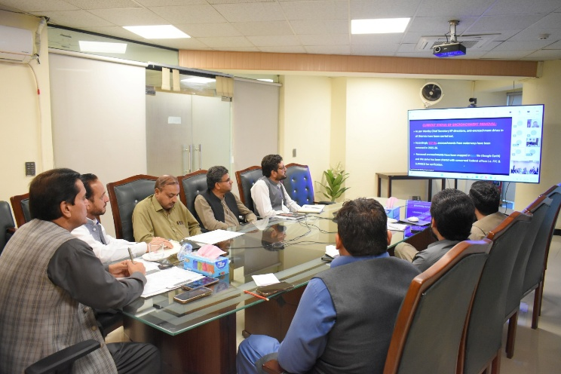
- On April 1st, 2026, an online coordination meeting was held by PDMA Khyber Pakhtunkhwa with the District Administrations of all the 36 Districts of Khyber Pakhtunkhwa. The objective of the meeting was to solicit district level inputs, assess localized risk perceptions and identify preparedness requirements for inclusion in SHCP-2026.The feedback, recommendations, and operational requirements shared by the district were systematically recorded and incorporated into planning process. (List of attendees is place at Appendix III).
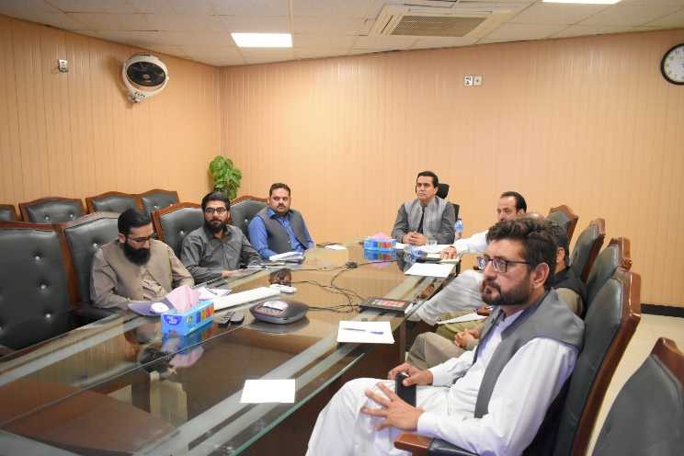
- Similarly, on April 2nd, 2026, a similar online coordination meeting was held by PDMA KPK with the Provincial and Federal Line Departments to ensure sectoral alignment and integration of departmental preparedness measures into the SHCP 2026. In continuation of the same consultative process, a separate coordination meeting was also held with National and International Humanitarian Organizations, including relevant partners, to incorporate humanitarian response perspectives and operational support frameworks. The inputs, recommendations, and technical suggestions provided by all stakeholders were duly documented and integrated into the contingency planning process (List of attendees is placed at Appendix III).

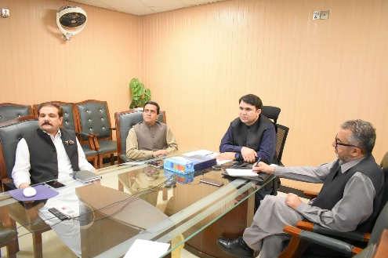
MONSOON PREPAREDNESS MEETING HELD UNDER CHAIRMANSHIP OF DG PDMA KP
PDMA UPDATES

A meeting regarding the preparedness for the monsoon Contingency Plan was held at Provincial Disaster Management Authority (PDMA) Khyber Pakhtunkhwa (KP), under the chairmanship of the Director General (DG) PDMA KP. All Additional Deputy Commissioners (ADCs) from their respective districts participated online in the session. The meeting was part of PDMA’s proactive disaster preparedness initiative aimed at strengthening coordination with district administrations to effectively define and implement contingency planning for the upcoming monsoon season.

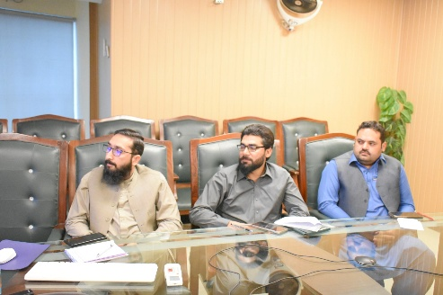

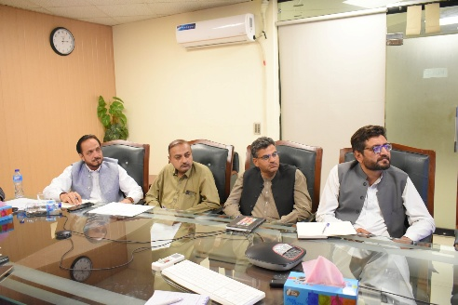

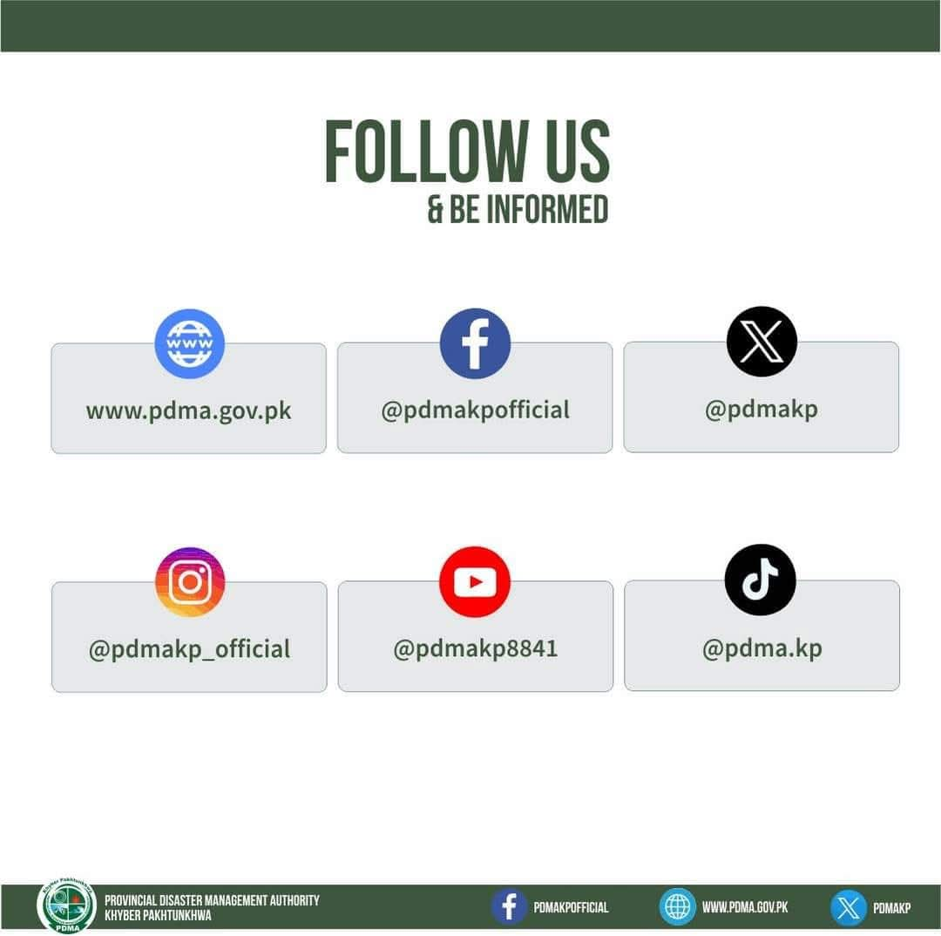
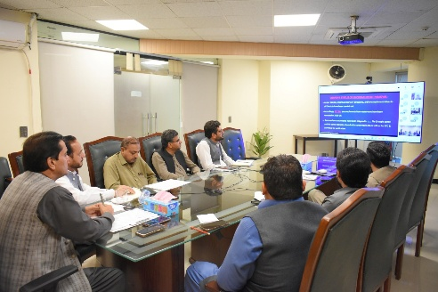
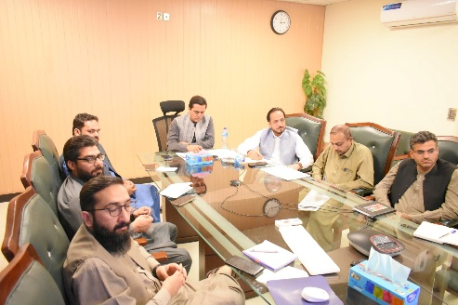

- PDMA Khyber Pakhtunkhwa issued advisories The advisories for the preparatory work before the onset of Monsoon 2026 are as follows:
- Local Government Department has been advised to carryout survey of billboards and to remove / replace those which are in dilapidated conditions and may pose threat in case of high-speed winds.
- PESCO has been advised to ensure repair and maintenance of electricity wires / towers, cutting of trees reaching the high transmission cables and fixation of hanging cables in crowded streets / localities to avoid any untoward incident during the monsoon season.
- Local Government Department has been advised to chalk out vulnerable populations in major urban cities prone to urban floods and take all necessary measures for minimizing the impacts of urban flooding, prepositioning of required equipment and resources, and clearing of choked drainage/sewerage channels and removal of waste from the sites.
- Irrigation Department has been advised for timely construction and repair of flood protection structures and the placement of funds/resources in all districts based on vulnerability assessment and adoption of easy M&R processes for immediate response in case of any untoward event.
- C&W Department has been advised to carry out vulnerability assessment of communication channels and ensure adoption of easy M&R processes and ensuring availability of resources.
- Tourism Department has been advised to monitor the tourist spots and launch awareness campaign for tourists besides identifying safe evacuation routes for them in case of any untoward incident.
- Irrigation Department has been advised to conduct Performance Audit of the real time monitoring of major rivers through telemetry gauges installed at 12 points on major rivers of Khyber Pakhtunkhwa.
- A hotline has been established by PEOC, PDMA which gives 24/7 access to general public who may access it by dialing 1700.

- Identified Camp Sites Camp Management Unit PDMA has identified camp sites in all the districts of the province wherein, the affected population will be moved in case of evacuation. List of identified camp sites is placed at PDMA website.

- Provincial Pre-Stocking In order to ensure humanitarian support to the affected population, a centralized Humanitarian Response Facility (HRF) has been established at Jalozai which will serve as a logistic base for the whole Province in case of any disaster. It has warehousing capacity of 4000 MT for general storage items, and 400 for climate controlled sensitive items. The current pre stock position of the HRF is placed at Appendix II

- District NFIs Pre-Stocking The pre-stocking of NFIs in all the Districts has been ensured with minimum availability of items before the onset of Monsoon Season. The existing position of NFI Stocks is placed at Appendix II.
- Emergency Framework Agreements In order to ensure the provision of NFIs and FIs and Transportation of the relief items, Emergency Framework Agreements have been signed by the Procurement Wing of PDMA.
- Availability of Earth Moving Machinery Earth Moving Machinery has been mapped out with districts and departments. The public machinery list is placed at Appendix II. Moreover, in most of the cases, the functions have been outsourced to the private contractors by the relevant department’s field formations.
Early Warning Phase: Following measures are to be undertaken by all the concerned to ensure that timely and effective early warning / advisories / alerts are issued to all the stakeholders.
- Weather Early Warning / Advisories. PMD will be the focal organization for providing weather based early warnings while NDMA will issue projections on perceived hazard risks and instructions for all DM stakeholders, while provincial / district DM authorities and line departments will be responsible for issuing and implementing area / region specific instructions for effective coordination / actions: -
- Seasonal outlook will be updated by PMD, at least once per month, especially highlighting a major departure from original outlook.
- Weather advisory will be issued in accordance with the developing situation by PMD.
- Specific weather advisory of PMD and NDMA will be issued by PDMA to disseminate warning to district authorities / relevant stakeholders via Fax /Telephone/WhatsApp/Twitter/Facebook and will be immediately uploaded to the PDMA website.
- PDMA will also release breaking caption / news or tickers to all major TV stations / channels including PTV. Moreover, PMD has also constructed a fully equipped studio for TV broadcast at its Headquarters. Radio broadcasts will also be used from national and FM radio stations to keep the public aware of any upcoming disaster and related advisories.
- PMD will nominate a focal person authorized to deal with weather and flood forecast which will be notified to all the concerned and will be readily available to all stakeholders, when required.
- PMD will also critically analyze and share any possibility of heat waves in the country and will timely intimate the same to DM Authorities and other relevant stakeholders.

- Flood Flows Monitoring: PDMA will issue the critical readings of the Telemetry Stations installed at the following locations for early warning and early actions by the relevant authorities and departments.
- Kalpani Nullah at Malakand Mardan road Jalala Bridge Mardan.
- Swat River at Chakdara Bridge Swat.
- Swat River Khawzakhela Bridge Swat.
- Munda Headworks at Abazi near Mohmand Agency Mohmand Agency.
- Panjkora River at Jabalot Bridge Upper Dir, Lower Dir.
- Budni Nullah Darmangi Bridge Peshawar;
- Kabul River at Adezai Bridge Shabqadar Road Peshawar, Mardan

- River Flows Monitoring by FFD, WAPDA and PID: The bulletins shared by the mentioned agencies will be interpreted and will be communicated to the other tiers for appropriate action before the onset of critical flows.

- Community Early Warning through Advisories
- Public Service Messages (PSMs) through print / electronic media be generated by PDMA and DDMUs.
- All departments concerned and local communities must be apprised about the forecast and it’s likely unfolding at the onset.
- Community must be informed about safer places, relief camps and evacuation plan by the DDMUs.
- To ward off “False Warning”, all DM authorities will ensure implementation of Clause 35 of NDMA Act 2010.
- Community based indigenous early warning system must be institutionalized as part of response mechanism in areas vulnerable to landslides and avalanches by the DDMUs through following means: -
  - Placing of around the clock lookouts especially at night or during the period of intense rain / high temperature.
  - Use of sirens or announcements on loudspeakers from mosques and vehicles for mass awareness and sensitizing local communities.
  - Practicing evacuation drills and the conduction of mock exercises and reconnaissance of vulnerable / at-risk areas.
- Issuance of SMS Alerts through Pakistan Telecommunications Authority (PTA) in only affected & threatened areas using GIS fencing by the NDMA through existing mechanism.
Priority of Districts. Priority has been established for the provinces after due deliberation / consultation with stakeholders and academic think tanks. The historical data and risk factors of the risk assessment matrix are mentioned in Section I. Priority has been set based upon the districts historic record and occurrences with greater frequency and magnitude (detail hazard risk assessment is provided in flood hazard risk assessment of Section I: -

- Priority - I Districts (High Threat): 1. Dir Upper, 2. D.I Khan, 3. Chitral Lower, 4. Chitral Upper, 5. Swat, 6. Shangla, 7. Nowshera, 8.Charsadda, 9. Dir Lower, 10, Tank, 11. Peshawar
- Priority - II Districts (Medium Threat): 1. Kohistan Upper, 2. North Waziristan, 3. Mardan, 4. Kohistan Lower, 5. Abbottabad, 6. Karak, 7. Buner, 8. Malakand, 9. South Waziristan, 10. Lakki Marwat, 11. Swabi, 12. Torghar, 13. Kolai Pallas, 14 Mohmand
- Priority - III Districts (Low Threat): 1. Kurram, 2. Bannu, 3. Mansehra, 4. Khyber, 5. Bajaur, 6. Orakzai, 7. Battagram, 8. Haripur, 9. Kohat, 10. Hangu
Response Phase (Responsibilities and Sequential Action)
- Level of Emergencies; In order to better manage any undesirable event, the following categorization of monsoon emergencies will be vital for better coordination, response, relief and rehabilitation.
- Level 1 Emergency Situation: Manageable by District Administration.
- Level 2 Emergency Situation: Affecting multiple districts but still manageable at provincial level.
- Level 3 Emergency Situation: National Level emergency situation.

In case of Level 1 Emergency Situation the District Administration and DDMUs will be responsible to carry out initial Multi-Sector Damage Assessment for identifying scale of a disaster, priority areas, relief and gaps in response and will share immediately with PDMA control room PEOC through email, fax and WhatsApp group. The District Administration will also share the Recovery Needs Assessment report with PDMA for identifying and estimating detailed cost of recovery in various sectors for initiation of recovery work in affected communities. Similarly, District Administration will be responsible for search and rescue operations in coordination with relevant stakeholders. District Administration will take lead role in removal of debris and provision of first aid health facility if required. Similarly, the District Administration will be responsible to update all the relevant stakeholders including general public regarding any significant event by utilizing all means of information and communications for dissemination of timely and accurate information depending on the severity of situation, the reports may be shared on hourly, 3-6 hourly basis.

In Level 2 Emergency Situation PDMA with concerned district administrations will coordinate initial Multi Sector Damage Assessment to identify scale of a disaster, priority areas, relief and gaps in response and will share with Provincial Government and NDMA. PDMA will similarly share Recovery Needs Assessment report with Provincial government and NDMA for identifying and estimating detailed cost of recovery in various sectors for initiation of recovery work in affected communities. PDMA will coordinate with district administration and other line departments for carrying out all necessary work regarding debris removal, provision of health facilities, evacuation, transport, security and maintenance of telecommunication systems. Similarly, the Khyber Pakhtunkhwa Provincial Disaster Management Authority with the help of information department will disseminate all updates to all stakeholders including Provincial government, NDMA and general public by utilizing all available means.
In Level 3 Emergency NDMA, PDMA and district administration will coordinate for all the matters pertinent to emergency management so as to improve disaster response management in all the districts.

- Tiers of Response. As per NDMA response plan the National response will be based on the following tiers:

  - 1st Tier. Local emergency response by DDMAs with the support of District Administration, Provincial Government and the Armed Forces of Pakistan.

  - 2nd Tier. Emergency Response by the District Administration along with the support of the Provincial Government.

  - 3rd Tier. Emergency Response by the NDMA (national efforts / national resources) in support of Provinces / State of AJ&K and ICT with / without external assistance.

- Responsibility Matrix. Responsibility Matrix highlights the basic responsibilities of departments and is followed by sequence of actions by stakeholder’s in-line with their tasks and functions in case of emergency / disaster like situation. The actions under the Plan are set in motion as soon as an early warning / alert is issued by PMD / NDMA, based on developing weather system.
Areas | Level 1 | Level 2 (added efforts) | Level 3 (added efforts)
Alert and Notification issuance/activation of control Rooms | District Administration / DDMU | PDMA PEOC round the clock | NDMA NEOC round the clock
Telecommunication systems maintenance | District Administration / DDMU | PDMA and NTC | NDMA
Evacuation | District Administration / DDMU | PDMA / Rescue 1122 / LG & RDD | NDMA / Pak Army
Transport | District Administration / DDMU | PDMA / LG&RDD/Transport Department | NDMA
Search and Rescue | District Administration/ Rescue 1122 | Rescue 1122 / Pakistan Army | Pak Army
Emergency Relief | District Administration / DDMU | PDMA | NDMA
Recovery | District Administration / DDMU | PDMA | NDMA
Debris Removal/De watering | District Administration / DDMU | LG&RDD / C&W / Irrigation Deptt | NDMA
NHA
Security | Distr admin/ Police/LEAs | Police / LEAs | Pakistan Army / LEAs
Damage Assessment | District Administration / DDMU | PDMA | NDMA

- Rescue Measures
- Detailed operational plan of Rescue 1122 Khyber Pakhtunkhwa has been formulated and is placed at Appendix II
- Additionally, availability of rescue equipment may be ensured by Rescue 1122 Khyber Pakhtunkhwa in coordination with the DDMUs.
- DDMUs shall ensure that the Rescue equipment must be strategically placed to respond to hazards in different regions.
- In addition to the equipment maintained by the Rescue 1122, DDMUs may also keep the equipment with volunteer organizations ready in an event of disaster.
- DDMUs may ensure the availability of trained operators during disaster.
- Readiness of Urban Search and Rescue (USAR) teams will be ensured by Rescue 1122 for rescue operations in collapsed buildings / landslides in respective province or other provinces (when requisitioned).
- Availability of staff of Rescue 1122, Civil Defense and especially hospitals and emergency services on holidays and during active weather systems must be ensured.
- PDMA will coordinate with respective governments / departments for aerial support in case where immediate evacuation may be needed.

- Evacuation
- Forced evacuation must be planned in case of limited warning time, by utilizing all available resources at provincial / district levels.
- DDMUs as first responders should mobilize communities for disaster response. This will encourage community involvement, strengthen their own efforts and address the issue of absence of human resource.
- Priority in rescue / evacuation will be given to vulnerable groups (age, disabled, women and children).
- Traffic arrangements: creating diversions and guidance for tourists, be made for regulating traffic on national and provincial arteries in case of damage to infrastructure by floods.
- Tourism must be curbed during high alert and risky areas.

- Relief Operations: PDMA will follow NDMA’s Guidelines on Multi-Sector Initial Rapid Assessment (MIRA), Minimum Standards of Relief in Camp and compensation assistant as per PDMA Compensation rules to the persons affected by natural and man-made disasters. Moreover, special attention may also be given to following: -
- DDMUs are to design a standardized food pack as per local requirements to meet the needs of affected persons. Items like rice, wheat bags, cooking oil and milk for babies etc should be included. However, energy biscuits and other such food items which are not part of the daily diet of local community, be avoided.
- Drinking water should be provided for hydration, along with measures to prevent heat stroke, dehydration and other summer- related illnesses by the Public Health Engineering Department.
- Water purification tablets and filtration systems for the provision of clean drinking water to affected people must be stocked in advance by the PHE.
- Special attention is paid to protect the health and safety of rescue workers and volunteers, including providing them with necessary personal protective equipment (PPE) by the Rescue 1122.
- Relief management is the most significant part of response to any disaster. The main purpose of the relief management is to provide life sustaining commodities to the affected communities through a fair and organized system; therefore, distribution method should be decided in consultation with local communities by the DDMUs.
- Based on past experiences, need must be formalized, and the list of relief goods should be available with all DDMUs and to share with PDMA for displaying on websites to facilitate donors to provide need-based relief goods in emergency.
- Relief packages should be according to the region’s cultural context and food requirements be ensured for lactating mothers, pregnant women, infants, children and elderly persons. Also, stockpiling and contingency planning should incorporate special needs of older persons and persons with disabilities, particularly with regards to equipment such as wheelchairs etc and must be able to cater for the needs of the whole family.
- Trained community-level teams should assist in planning and setting up emergency shelters, distributing relief among the affected people, identifying missing people, and addressing needs of education, health care, water supply, sanitation and food etc. Relief teams should also engage active women from within the community in the distribution of food in the relief camp.
- Minimum Initial Service Package (MISP) is an international standard of care which is normally implemented at the onset of every emergency to reduce mortality, morbidity and disability among populations (particularly women and girls) affected by crises. This can be achieved by increasing the provincial and district capacity to implement the MISP during disasters, creating a data bank of trainers and trainings, strengthening the coordination stakeholders for responding in a timely and effective manner. NDMA shall take lead with support of Humanitarian Partners.
- Dignity of all the affected persons should be especially ensured during all relief phases of rescue / relief / early recovery etc by the Social Welfare Department in consultation of Gender and Child Cell of PDMA
- Disease early warning system to be put in place by the health departments, once a situation arises. District and city administration should prepare for upcoming season in advance in coordination with health departments.
- Health authorities must ensure stockpiling of medicines, vaccines in all health facilities with placement at lowest possible tier for distribution.
- Supply chain of relief goods must be maintained and followed in true letter and spirit. DDMUs are the first tier supported by PDMAs to provide immediate relief. Similarly, second tier (PDMAs supported by NDMA) should be ready to render assistance once the stocks of DDMUs are exhausted. Third Tier of NDMA supported by national resources to extend relief support required by the provinces / regions.
  - PDMAs are responsible to collect the stocks once released by NDMA from a particular location.
  - NDMA stocks will be requisitioned only in case of extreme emergency and with sufficient reaction time.
  - Distribution of NFIs at site must be avoided. People must be motivated to come to relief camps.
- Relief Goods - Non-Food Items (NFIs)
- Logistics caseloads have been worked out on presumed scenarios for the average relief rendered during hazards experienced in respective districts (see Appendix …).
- Stockpiling of relief goods (NFIs) against the envisaged caseload present in districts have been provided as Appendix II
- As per the presumed gap mentioned in Section II Framework agreements with the vendor are in placed which will provide and mobilize the required items in minimum possible duration.
- Food items and drinking water in vulnerable areas will be provided by the DDMUs from relief funds upon the declaration of emergency, owing to possible severance of road links.

- Damage/Claim Assessment: Damage assessment will be initiated as per the notification of Claim Assessment Committees (CACs) on tehsil level as per the composition mentioned in notification in place. All the assessment data will be collected on PMRU designed dashboard for real time access and the SOPs of cash disbursement will be followed.

- Early Recovery: - This will be based on Multi Sector Initial Rapid Assessment to be facilitated by the UNOCHA upon the request received from PDMA Khyber Pakhtunkhwa
- In case of need, MIRA module will be deployed for which DDMUs will be required to provide requisite human resource, trained for the module.
- Rapid assessment will be carried out by NDMA / PDMA / UN / INGOs / NGOs to identify needs and priorities of affected and vulnerable communities.
- Initial report will be shared with Disaster Management Authorities within one week and final report within two weeks.
- Assessment team should be trained on how to identify summer hazards and their associated risks, based on local context and community knowledge.
- Assessment will consider the seasonality of the hazards and their effects on different sectors, such as agriculture, water supply, health and education. This will help identify the most urgent needs and priorities for early recovery and rehabilitation.
- Based on the assessment findings, a comprehensive early recovery plan will be developed that addresses the most urgent needs of the affected population, while also building the resilience of communities and infrastructure to future hazards by the Rehabilitation Wing of PDMA Khyber Pakhtunkhwa.
- Early recovery plan will include measures to mitigate the long-term effects of summer hazards on the environment including soil erosion, water scarcity and biodiversity loss.

- Needs & Concerns of Vulnerable Groups. Gender & Child Cell of PDMA will take the lead to ensure following aspects during all stages of flood management: -
- Relief sites and camps should ensure attention to women’s security / privacy needs like separate washrooms with locks, adequate lights, water and sanitation facilities etc.
- Women’s fair and equitable access to basic services should be ensured, particularly in health and hygiene.
- Female doctors and psychosocial support personnel should be made available for women and children.
- Mobile medical units equipped with safe delivery, post-natal facilities and referral should be in place.
- Camp management should ensure registration, profiling and mapping systems record disaggregated data on age, gender and vulnerabilities to identify people with specific needs at the earlier stages of entering in the camp site and throughout the duration of camp stay.

- Requisitioning of Armed Forces. Armed Forces will be requisitioned subject to provision of rules / regulations by PDMAs / DDMUs only in case of emergency. Aviation support will be coordinated centrally by NDMA based on request to assist in “Aid to Civil Power”. Concerned authorities utilizing services from Armed Forces as well as aviation support will bear the cost of assets used which will be processed immediately after their employment. Armed Forces can be employed for following: -
- Rescue and relief operations by field units of Pakistan Army, Pakistan Navy and Pakistan Air Force.
- Aviation support including provision of C-130 by PAF and Helicopters by Army Aviation.
- Support of rescue and medical teams of Armed Forces.
- Medical support teams of all three services.
- Search and rescue in urban areas collapsed structures and landslides / GLOFs / avalanches by USAR team of Pakistan Army.

SECTION IV: INCLUSIVENESS

Gender & Child Protection in Emergencies Perspective; Gender and Child Cell (GCC), PDMA Khyber Pakhtunkhwa

Gender & Child Protection Mainstreaming in Monsoon Contingency plan-2026.

Although the legal frameworks of Pakistan (including the constitution) support human rights and equality with a special focus on vulnerable population, various social norms and discriminatory practices can exacerbate the impact of a disaster event on women, girls, men, boys, transgender, elderly people and persons with disabilities. It is therefore critical to understand the different impacts that crises can have on most at risk population. Disaster responses must ensure that the different needs, priorities and capacities of women, men, girls and boys, and of those exposed to multiple vulnerabilities (people living with disabilities, sexual and gender minorities, senior citizens, different caste/ethnic groups, etc.), are addressed when designing, planning, implementing, monitoring and evaluating Disaster Risk Reduction (DRR) and Disaster Risk Management (DRM) efforts.

DISTRICT WISE HUMAN VULNERABILITIES DATA FOR BUILDING UP AN INCLUSIVE RESPONSE FOR ADDRESING THE SPECIFIC NEEDS OF VULNERABLE POPULATION
S. No | District | Index | Population as per census 2023 | Gender wise segregation |  |  | Children population @53% of total population | Of Person with disability@ 15% of total population | Older Persons @ 7% | Number of women of reproductive age @25% of total Population
 |  |  |  | Male | Female | Transgender |  |  |  |  | Number of Currently Pregnant Woman As Per MISP Calculator | Number of cases of GBV who will seek care @2% of Women of Reproductive Age
1 | Chitral lower | Medium | 320407 | 163603 | 156804 | 1 | 169815 | 48061 | 22428 | 80102 | 6390 | 1602
2 | Chitral Upper | Medium | 195528 | 100528 | 95000 | 1 | 103630 | 29329 | 13680 | 48882 | 3900 | 978
3 | Charsadda | High Risk | 1835504 | 950904 | 884600 | 21 | 972817` | 275326 | 128485 | 458876 | 36607 | 9178
4 | D. I Khan | High Risk | 1829811 | 959511 | 870300 | 45 | 969800 | 274472 | 128087 | 457453 | 36494 | 9149
5 | Peshawar | High Risk | 4758762 | 2426062 | 2332700 | 231 | 2522144 | 713814 | 333113 | 1144691 | 94909 | 22894
6 | Shangla | High Risk | 891252 | 459952 | 431300 | 1 | 472364 | 133688 | 62388 | 222813 | 17775 | 4456
7 | Kohistan upper | High Risk | 422947 | 216147 | 206800 | - | 224162 | 63442 | 29606 | 105737 | 8435 | 2115
8 | Kohistan Lower | High Risk | 340017 | 173617 | 166400 | 9 | 180209 | 51003 | 23801 | 85004 | 6781 | 1700
9 | Nowshera | V.High | 1740705 | 886205 | 854500 | 40 | 922574 | 261106 | 121849 | 435176 | 34717 | 8704
10 | Swat | V.High | 2687384 | 1375373 | 1312011 | 52 | 1424314 | 403108 | 188117 | 671846 | 53597 | 13437
11 | Tank | High Risk | 470293 | 241682 | 228611 | 4 | 249255 | 70544 | 32921 | 117573 | 9380 | 2351
12 | Dir Upper | High Risk | 1083566 | 537261 | 546305 | 1 | 574290 | 162535 | 75850 | 270892 | 21611 | 5418
13 | Swabi | Lower Risk | 1894600 | 958592 | 936008 | - | 1004138 | 284190 | 132622 | 473650 | 37786 | 9473
14 | Mardan | Lower risk | 2744898 | 1408896 | 1336002 | - | 1454797 | 411735 | 192143 | 686225 | 54744 | 13725
15 | Bunner | Medium | 1016869 | 712286 | 706786 | - | 752108 | 212861 | 99335 | 254217 | 20280 | 5084
16 | Abbottabad | Medium | 1419072 | 712286 | 706786 | - | 752108 | 212861 | 99335 | 354768 | 28302 | 7095
17 | Battagram | Medium | 554133 | 281222 | 272911 | - | 293690 | 83120 | 38789 | 138533 | 11052 | 2771
18 | Mansehra | Medium | 1797177 | 912066 | 885111 | - | 952504 | 269577 | 125802 | 449294 | 35843 | 8986
19 | Kohat | Lower | 1234661 | 629650 | 605011 | - | 654370 | 185199 | 86426 | 308665 | 24624 | 6173
20 | Bannu | Medium | 1357890 | 706189 | 651701 | - | 719682 | 203684 | 95052 | 339473 | 27082 | 6789
21 | Lakki | Medium | 1040856 | 526955 | 513901 | - | 551654 | 156128 | 72860 | 260214 | 20759 | 5204
22 | Hangu | Medium | 528902 | 260302 | 268600 | - | 280318 | 79335 | 37023 | 132226 | 10548 | 2645
23 | Bajour | Medium | 1287960 | 651560 | 636400 |  | 682619 | 193194 | 90157 | 321990 | 25687 | 6440
24 | Mohmand | Medium | 553933 | 281433 | 272500 | - | 293584 | 83090 | 38775 | 138483 | 11048 | 2770
25 | Orakzai | Medium | 387561 | 204861 | 182700 |  | 205407 | 58134 | 27129 | 96890 | 7730 | 1938
26 | Khyber | Medium | 1146267 | 598366 | 547901 | - | 607522 | 171940 | 80239 | 286567 | 22861 | 5731
27 | North Waziristan | Medium | 693332 | 354665 | 338667 | - | 367466 | 104000 | 48533 | 173333 | 13828 | 3467
28 | South Waziristan | Medium | 888675 | 459428 | 429247 | - | 470998 | 133301 | 62207 | 222169 | 17724 | 4443
29 | Malakand | Medium | 826250 | 412437 | 413813 | - | 437913 | 123938 | 57838 | 206563 | 16479 | 4131
30 | Dir Lower | Medium | 1650183 | 813627 | 836511 | - | 874597 | 247527 | 115513 | 412546 | 32911 | 8251
31 | Tor Ghar | Medium | 200445 | 102168 | 98227 | - | 106236 | 30067 | 14031 | 50111 | 3998 | 1002
32 | Kurrrum | Medium | 785434 | 406925 | 378509 | - | 416280 | 117815 | 54980 | 196359 | 15665 | 3927
33 | Haripur | Medium | 1174783 | 591782 | 583001 | - | 622635 | 176217 | 82235 | 293696 | 23430 | 5874
34 | Karak | Medium | 815878 | 421277 | 394601 | - | 432415 | 122382 | 57111 | 203907 | 16272 | 4078
35 | Kolai -palas | High Risk | 280162 | 142561 | 137601 | - | 148486 | 42024 | 19611 | 70041 | 5588 | 1401

X

Source: Bureau of Statistics

Foot Note:
1. Persons with Disability: The UN Convention on the rights of Persons with Disabilities (UNCRPD) states in its first article; PWDs includes those who have long term physical, mental, intellectual or sensory impairment which in interaction with various barriers may hinder their full and affective participation in society on an equal basis with others. It is recommended to find out if the respondent has any difficulty in performing certain activities (walking, seeing, hearing, cognition, self-care and communication), as well as the level of difficulty (no – no difficulty, yes – some difficulty, yes – a lot of difficulty or cannot do it at all).
2. An Older Person is defined by the United Nation as a Person who is over sixty years of age.
3. Part-1 Article -1 (UNCRC) A child means every human being below the age of 18 years.
4. Age Cohort, 0-11 months, 0-5, 6-12, 13-17, 18-29, 30-39, 40-49, 50-59, 60-69, 70-79, and 80+

GENDER SEGREGATED DATA OF HUMAN LOSSES, INJURIES AND LOSSES/DAMAGES FROM LAST MONSOON (25-June-2025 TO 30- September-2025): -

Affected Population & Tehsils/UCs/VCs
District | No. of Tehsils | No. of Union Councils (UCs) | No. of Village Councils (VCs) | Population
Abbottabad | 3 | 12 | 25 | 160
Bajaur | 5 | 0 | 2 | 900
Battagram | 2 | 4 | 14 | 36000
Buner | 4 | 8 | 21 | 220000
Charsadda | 3 | 13 | 175 | 875
DI Khan | 6 | 0 | 0 | 131
Hangu | 0 | 0 | 0 | 35
Haripur | 3 | 20 | 60 | 1000
Karak | 3 | 0 | 0 | 0
Khyber | 3 | 0 | 0 | 0
Kurram | 3 | 0 | 30 | 350
Lakki Marwat | 3 | 4 | 3 | 0
Lower Chitral | 1 | 2 | 4 | 2000
Lower Dir | 2 | 2 | 0 | 0
Malakand | 3 | 7 | 32 | 300
Mansehra | 5 | 10 | 10 | 140
Mardan | 5 | 25 | 25 | 320
Mohmand | 6 | 6 | 18 | 600
Nowshera | 2 | 16 | 16 | 0
Peshawar | 2 | 0 | 0 | 0
Shangla | 1 | 4 | 10 | 89000
South Waziristan Lower | 3 | 3 | 3 | 30
South Waziristan Upper | 2 | 2 | 2 | 3700
Swabi | 1 | 4 | 4 | 10000
Swat | 7 | 13 | 30 | 150000
Tank | 1 | 5 | 9 | 2500
Torghar | 3 | 8 | 16 | 270
Upper Chitral | 2 | 4 | 4 | 23
Upper Kohistan | 4 | 14 | 26 | 50
Total | 88 | 186 | 539 | 518384

Human Death & Injuries
District | Death |  |  |  | Injured
District | Male | Female | Child | Total | Male | Female | Child | Total
Abbottabad | 0 | 1 | 7 | 8 | 0 | 0 | 0 | 0
Bajaur | 3 | 5 | 17 | 25 | 1 | 4 | 1 | 6
Bannu | 0 | 0 | 0 | 0 | 1 | 1 | 0 | 2
Battagram | 2 | 1 | 2 | 5 | 0 | 0 | 0 | 0
Buner | 72 | 104 | 79 | 255 | 20 | 9 | 23 | 52
Charsadda | 0 | 0 | 2 | 2 | 3 | 0 | 4 | 7
DI Khan | 1 | 3 | 4 | 8 | 8 | 2 | 4 | 14
Hangu | 1 | 1 | 0 | 2 | 3 | 1 | 0 | 4
Haripur | 0 | 0 | 1 | 1 | 1 | 2 | 0 | 3
Karak | 0 | 0 | 1 | 1 | 0 | 0 | 3 | 3
Khyber | 3 | 0 | 2 | 5 | 2 | 0 | 1 | 3
Kohat | 1 | 0 | 0 | 1 | 0 | 0 | 0 | 0
Lakki Marwat | 0 | 2 | 1 | 3 | 0 | 0 | 0 | 0
Lower Dir | 0 | 2 | 3 | 5 | 0 | 0 | 0 | 0
Lower Kohistan | 1 | 0 | 1 | 2 | 1 | 0 | 0 | 1
Malakand | 1 | 1 | 6 | 8 | 1 | 1 | 3 | 5
Mansehra | 5 | 6 | 15 | 26 | 7 | 2 | 1 | 10
Mardan | 3 | 1 | 0 | 4 | 8 | 1 | 6 | 15
Mohmand | 0 | 0 | 0 | 0 | 2 | 1 | 0 | 3
North Waziristan | 0 | 0 | 0 | 0 | 2 | 1 | 0 | 3
Nowshera | 1 | 1 | 1 | 3 | 1 | 0 | 1 | 2
Peshawar | 0 | 0 | 2 | 2 | 1 | 1 | 3 | 5
Shangla | 15 | 14 | 12 | 41 | 12 | 7 | 14 | 33
South Waziristan Upper | 0 | 2 | 2 | 4 | 0 | 0 | 0 | 0
Swabi | 18 | 17 | 10 | 45 | 1 | 2 | 0 | 3
Swat | 10 | 9 | 26 | 45 | 8 | 8 | 3 | 19
Tank | 1 | 0 | 0 | 1 | 1 | 0 | 0 | 1
Torghar | 1 | 1 | 1 | 3 | 4 | 0 | 1 | 5
Upper Dir | 2 | 2 | 4 | 8 | 1 | 1 | 2 | 4
Upper Kohistan | 0 | 1 | 1 | 2 | 1 | 1 | 1 | 3
Total | 141 | 174 | 200 | 515 | 90 | 45 | 71 | 206

Cause – Wise Death
District | Roof/ Wall Collapse | Drowning | Landslide | Flooded Away
Abbottabad | 2 | 5 | 1 | 0
Bajaur | 22 | 0 | 0 | 3
Battagram | 4 | 0 | 1 | 0
Buner | 2 | 0 | 0 | 253
Charsadda | 0 | 0 | 0 | 2
DI Khan | 8 | 0 | 0 | 0
Hangu | 2 | 0 | 0 | 0
Haripur | 1 | 0 | 0 | 0
Karak | 1 | 0 | 0 | 0
Khyber | 2 | 0 | 1 | 2
Kohat | 1 | 0 | 0 | 0
Lakki Marwat | 3 | 0 | 0 | 0
Lower Dir | 5 | 0 | 0 | 0
Lower Kohistan | 1 | 0 | 1 | 0
Malakand | 4 | 1 | 0 | 3
Mansehra | 17 | 0 | 0 | 9
Mardan | 2 | 0 | 2 | 0
Nowshera | 3 | 0 | 0 | 0
Peshawar | 0 | 0 | 0 | 2
Shangla | 4 | 0 | 2 | 35
South Waziristan Upper | 3 | 0 | 0 | 1
Swabi | 44 | 1 | 0 | 0
Swat | 8 | 1 | 0 | 36
Tank | 1 | 0 | 0 | 0
Torghar | 1 | 0 | 1 | 1
Upper Dir | 3 | 1 | 3 | 1
Upper Kohistan | 1 | 1 | 0 | 0
Total | 145 | 10 | 12 | 348

Crops Damaged & Livestock Perished
District | Crops Damaged | Livestock Perished
District | (in Acres) | Small Animal | Large Animal | Total
Abbottabad | 14.1592 | 7 | 0 | 7
Bajaur | 280 | 88 | 0 | 88
Bannu | 0 | 1 | 0 | 1
Battagram | 6.342 | 40 | 4 | 44
Buner | 11203 | 3448 | 1736 | 5184
Charsadda | 570 | 0 | 0 | 0
Haripur | 1.5 | 13 | 3 | 16
Karak | 65 | 112 | 71 | 183
Khyber | 0 | 12 | 9 | 21
Kolai Pallas | 0 | 6 | 0 | 6
Kurram | 3.5 | 75 | 9 | 84
Lakki Marwat | 0 | 3 | 1 | 4
Lower Chitral | 19.81 | 15 | 4 | 19
Lower Dir | 5.3 | 53 | 12 | 65
Malakand | 11 | 6 | 2 | 8
Mansehra | 81.39 | 2 | 8 | 10
Mardan | 0 | 30 | 3 | 33
Mohmand | 2 | 1 | 1 | 2
Nowshera | 12 | 0 | 4 | 4
Orakzai | 20 | 0 | 6 | 6
Shangla | 486 | 200 | 90 | 290
South Waziristan Lower | 131 | 0 | 0 | 0
South Waziristan Upper | 150 | 3 | 0 | 3
Swabi | 21 | 27 | 18 | 45
Swat | 3459 | 334 | 264 | 598
Upper Chitral | 155 | 3 | 0 | 3
Upper Dir | 0 | 1 | 0 | 1
Upper Kohistan | 0 | 6 | 11 | 17
Total | 16697.0012 | 4486 | 2256 | 6742

Houses Damaged/ Inundated
District | Fully Damaged | Partially Damaged | Total | Inundated
Abbottabad | 3 | 38 | 41 | 0
Bajaur | 11 | 38 | 49 | 0
Bannu | 1 | 8 | 9 | 0
Battagram | 4 | 28 | 32 | 0
Buner | 454 | 921 | 1375 | 100
Charsadda | 10 | 54 | 64 | 0
DI Khan | 29 | 90 | 119 | 0
Hangu | 1 | 12 | 13 | 0
Haripur | 3 | 20 | 23 | 0
Karak | 0 | 40 | 40 | 0
Khyber | 21 | 70 | 91 | 0
Kohat | 21 | 9 | 30 | 0
Kolai Pallas | 1 | 1 | 2 | 0
Kurram | 37 | 22 | 59 | 0
Lakki Marwat | 3 | 14 | 17 | 0
Lower Chitral | 5 | 12 | 17 | 0
Lower Dir | 3 | 57 | 60 | 0
Lower Kohistan | 0 | 1 | 1 | 0
Malakand | 2 | 16 | 18 | 0
Mansehra | 50 | 55 | 105 | 103
Mardan | 5 | 23 | 28 | 0
Mohmand | 37 | 87 | 124 | 0
North Waziristan | 8 | 17 | 25 | 0
Nowshera | 2 | 52 | 54 | 0
Orakzai | 3 | 1 | 4 | 0
Peshawar | 0 | 4 | 4 | 0
Shangla | 182 | 215 | 397 | 0
South Waziristan Lower | 10 | 19 | 29 | 0
South Waziristan Upper | 9 | 5 | 14 | 1
Swabi | 28 | 57 | 85 | 0
Swat | 55 | 494 | 549 | 1097
Tank | 13 | 46 | 59 | 0
Torghar | 1 | 24 | 25 | 0
Upper Chitral | 14 | 14 | 28 | 0
Upper Dir | 6 | 7 | 13 | 0
Upper Kohistan | 45 | 10 | 55 | 0
Total | 1077 | 2581 | 3658 | 1301

Schools/ Health Facilities & Water Supply Schemes (WSS) Damaged
District | Schools Damaged |  |  | Health Facilities |  |  | Water Supply Schemes (WSS)
District | Fully | Partially | Total | Fully | Partially | Total | Fully | Partially | Total
Abbottabad | 0 | 103 | 103 | 0 | 8 | 8 | 0 | 37 | 37
Bajaur | 0 | 3 | 3 | 0 | 0 | 0 | 0 | 0 | 0
Battagram | 0 | 27 | 27 | 0 | 4 | 4 | 0 | 44 | 44
Buner | 0 | 29 | 29 | 0 | 0 | 0 | 0 | 0 | 0
Charsadda | 0 | 5 | 5 | 0 | 1 | 1 | 0 | 0 | 0
Hangu | 0 | 1 | 1 | 0 | 0 | 0 | 0 | 0 | 0
Haripur | 7 | 91 | 98 | 0 | 0 | 0 | 0 | 0 | 0
Karak | 0 | 0 | 0 | 0 | 0 | 0 | 9 | 0 | 9
Khyber | 0 | 3 | 3 | 0 | 3 | 3 | 0 | 1 | 1
Kolai Pallas | 0 | 1 | 1 | 0 | 0 | 0 | 1 | 0 | 1
Kurram | 0 | 0 | 0 | 0 | 0 | 0 | 2 | 7 | 9
Lower Chitral | 0 | 6 | 6 | 0 | 0 | 0 | 5 | 10 | 15
Lower Dir | 0 | 9 | 9 | 0 | 1 | 1 | 0 | 0 | 0
Lower Kohistan | 0 | 0 | 0 | 0 | 0 | 0 | 5 | 0 | 5
Mansehra | 6 | 30 | 36 | 0 | 19 | 19 | 0 | 0 | 0
Mohmand | 0 | 1 | 1 | 0 | 0 | 0 | 0 | 0 | 0
Shangla | 114 | 97 | 211 | 17 | 2 | 19 | 28 | 75 | 103
South Waziristan Lower | 0 | 0 | 0 | 0 | 0 | 0 | 1 | 0 | 1
Swabi | 0 | 5 | 5 | 0 | 3 | 3 | 0 | 0 | 0
Swat | 0 | 163 | 163 | 0 | 5 | 5 | 2 | 40 | 42
Torghar | 0 | 11 | 11 | 0 | 0 | 0 | 0 | 7 | 7
Upper Chitral | 0 | 1 | 1 | 0 | 0 | 0 | 0 | 6 | 6
Upper Dir | 0 | 0 | 0 | 0 | 0 | 0 | 0 | 1 | 1
Upper Kohistan | 3 | 1 | 4 | 0 | 0 | 0 | 0 | 5 | 5
Total | 130 | 587 | 717 | 17 | 46 | 63 | 53 | 233 | 286

Irrigation Channels Damaged
District | Fully | Partially | Total
Abbottabad | 1 | 2 | 3
Bannu | 0 | 2 | 2
Battagram | 2 | 17 | 19
Haripur | 1 | 0 | 1
Karak | 10 | 0 | 10
Kurram | 0 | 10 | 10
Lakki Marwat | 0 | 12 | 12
Lower Chitral | 10 | 10 | 20
Lower Dir | 0 | 16 | 16
Mansehra | 0 | 9 | 9
South Waziristan Lower | 9 | 0 | 9
Torghar | 0 | 13 | 13
Upper Chitral | 0 | 1 | 1
Upper Dir | 0 | 2 | 2
Total | 33 | 94 | 127
Shops Damaged/ Inundated
District | Fully | Partially | Total | Inundated
Bajaur | 2 | 1 | 3 | 0
Battagram | 5 | 0 | 5 | 0
Buner | 452 | 521 | 973 | 1000
Hangu | 0 | 1 | 1 | 0
Haripur | 0 | 2 | 2 | 0
Khyber | 0 | 3 | 3 | 0
Kurram | 3 | 0 | 3 | 0
Mansehra | 5 | 0 | 5 | 0
Mohmand | 14 | 0 | 14 | 0
Shangla | 3 | 0 | 3 | 0
Swabi | 3 | 0 | 3 | 0
Swat | 12 | 10 | 22 | 2459
Upper Chitral | 1 | 0 | 1 | 0
Total | 500 | 538 | 1038 | 3459
Roads, Bridges & Culverts Damaged
District | Damaged Roads | Damage Spots | Damaged Length (KM)
District | (Number) | (Number) | Damaged Length (KM)
Swat | 98 | 122 | 54.09
Buner | 58 | 102 | 118.28
Mansehra | 66 | 71 | 276.38
Shangla | 39 | 55 | 45.9
Haripur | 48 | 49 | 45.68
Swabi | 45 | 45 | 92.59
Dir Lower | 41 | 41 | 40.56
Abbottabad | 34 | 34 | 33.65
Dir Upper | 24 | 34 | 120.74
Battagram | 32 | 32 | 80.25
Khyber | 26 | 28 | 49.7
Mardan | 25 | 25 | 13.22
Bajaur | 19 | 21 | 23.6
Karak | 16 | 17 | 27.77
Malakand | 13 | 13 | 7.25
Kurram | 12 | 13 | 10.02
Torghar | 12 | 12 | 28.87
Chitral Lower | 8 | 11 | 145.7
Chitral Upper | 3 | 11 | 9.37
South Waziristan Lower | 7 | 7 | 8
Kohistan Lower | 5 | 6 | 26.3
Tank | 5 | 5 | 6.9
Kohistan Upper | 4 | 4 | 7.5
Dera Ismail Khan | 3 | 3 | 1.1
Nowshera | 3 | 3 | 20.76
South Waziristan Upper | 2 | 2 | 1.8
Charsadda | 1 | 1 | 0.4
Kohat | 1 | 1 | 1.5
Total | 650 | 768 | 1,297.86

District | Damaged Bridges | Damage Spots | Damaged Length (Meter)
District | (Number) | (Number) | Damaged Length (Meter)
Mardan | 17 | 17 | 3,130
Swat | 14 | 14 | 124.63
South Waziristan Upper | 8 | 8 | 435
Swabi | 7 | 7 | 537
Dir Upper | 7 | 7 | 340
Dir Lower | 5 | 5 | 81
Abbottabad | 4 | 4 | 127
Buner | 4 | 4 | 175
Kohistan Upper | 4 | 4 | 27
Mansehra | 4 | 4 | 283
Haripur | 3 | 3 | 470
Shangla | 3 | 3 | 115
Kurram | 3 | 3 | 10.01
Bajaur | 2 | 2 | 70
Dera Ismail Khan | 1 | 1 | 25
Malakand | 1 | 1 | 20
Nowshera | 1 | 1 | 44.5
South Waziristan Lower | 1 | 1 | 1.5
Total | 89 | 89 | 6,015.64

District | Damaged Culverts | Damage Spots | Damaged Length (Meter)
District | (Number) | (Number) | Damaged Length (Meter)
Swabi | 18 | 18 | 808
Haripur | 12 | 12 | 167.51
Swat | 9 | 12 | 138.24
Malakand | 7 | 8 | 811
Buner | 6 | 7 | 74.3
Mardan | 7 | 7 | 246.5
Khyber | 7 | 7 | 263.43
Abbottabad | 6 | 6 | 72.31
Bajaur | 6 | 6 | 112.65
Dir Lower | 4 | 4 | 25
Dera Ismail Khan | 3 | 3 | 21.33
Dir Upper | 3 | 3 | 20.5
Lakki Marwat | 2 | 2 | 32
Mansehra | 2 | 2 | 33
Battagram | 1 | 1 | 0.1
Karak | 1 | 1 | 0.6
Kohat | 1 | 1 | 55
Shangla | 1 | 1 | 30
Kurram | 1 | 1 | 30
Total | 97 | 102 | 2,941.47

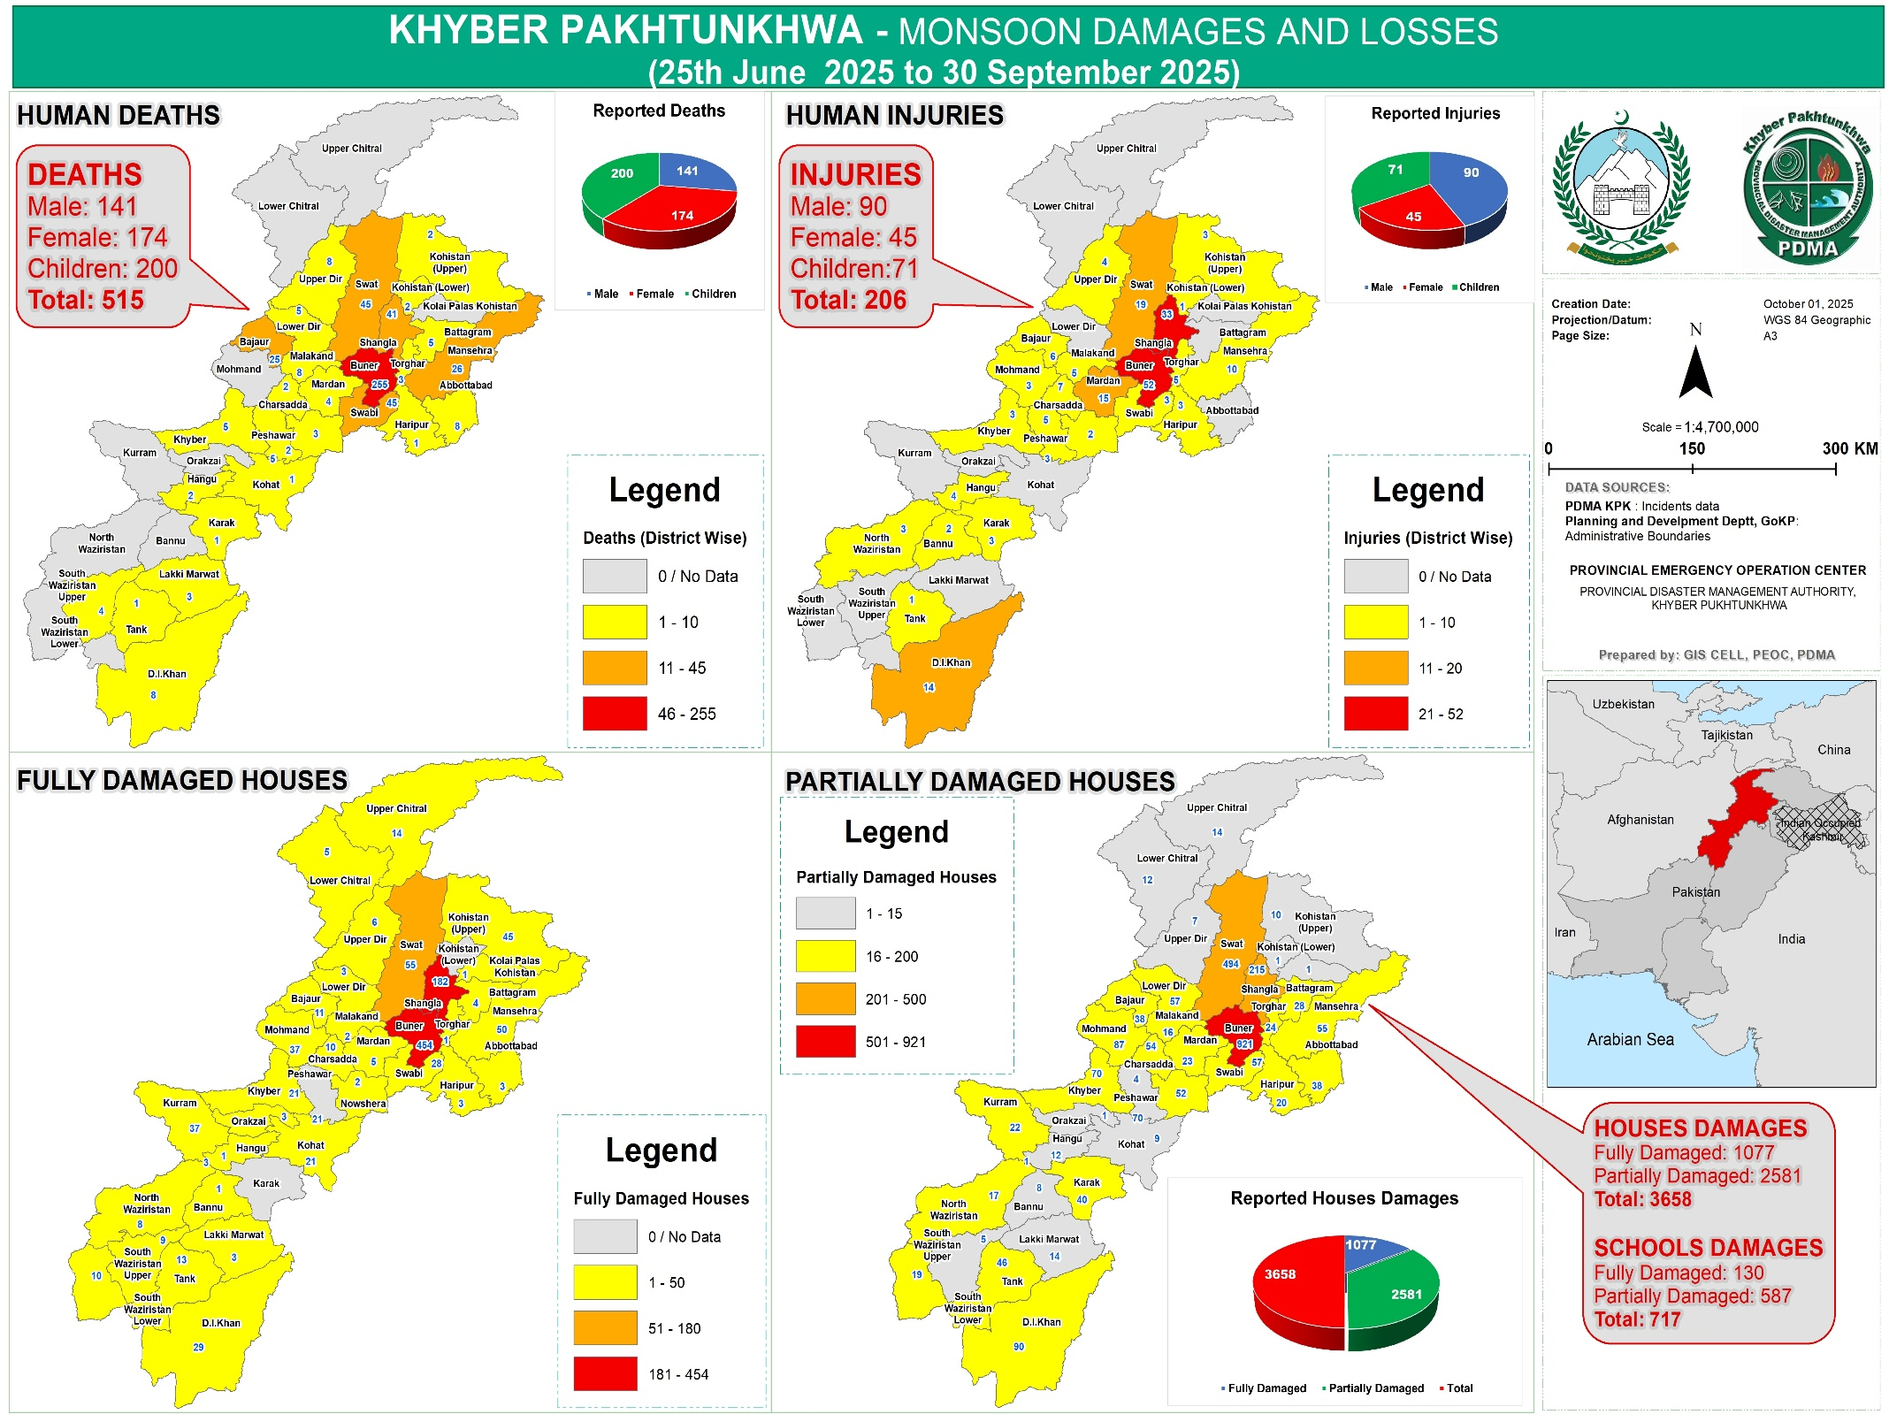

5.11.2 Gender & Child Protection Mainstreaming checklist for Monsoon Contingency Plan-2026
Sectors | Gender Mainstreaming checklist to prepare for Monsoon Contingency Plan-2026
Assessment | - Ensure that the different situations, needs, risks, priorities and capacities of women, men, girls, boys, PWD and transgender populations across all diversities and of those exposed to multiple vulnerabilities and exclusions are addressed in assessments and planning phases.  - Ensure establishment of mechanisms for the collection, analysis, use and dissemination of data disaggregated by sex, age, location and diversity.  - Provide the data to government and humanitarian agencies as well as other sectors, and use the results of gender & child protection analyses to inform humanitarian actions
Shelter including non-food relief items (NFRIs) & Child Safeguarding | - Ensure gender balance and diversity in shelter management structures. Nominate women, children and representative of excluded and vulnerable groups as camp focal points.  - Ensure women and children are represented in shelter-related decision-making process and consultation forums and in leadership positions.  - Ensure shelters have provisions for girl child and women, in particular for pregnant and lactating women, as well as NFIs for menstrual hygiene management (panties, pads, disposable wrappers, reusable cloths and bins) with a privacy partition.  - Appoint male & female staff and volunteers including children (boys and girls) for routine spot checks and community consultations as part of efforts to prevent Gender Based Violence (GBV) and provide them with necessary training on gender-specific vulnerabilities, needs, dynamics of women’s empowerment and resilience, and gender issues, including sexual/gender-based violence and general protection. Provide them with child and reader friendly information about helpline (1700) of the PDMA KP for reporting incidents of GBV
Health | - Recognize and address the specific health needs of women/children, including the unique reproductive health (25 % of total population) needs of pregnant women and adolescent girls while 15% of these women will experience pregnancy related complications and may need C section while 20% newborns will experience complications. Therefore, Minimum Initial Service Package (MISP) to be implemented at the very onset of every humanitarian emergency to.  - Prevent sexual/gender violence and respond to the needs of survivors.  - Set up referral mechanism for management and handling of the cases of sexual and gender-based violence.  - Prevent the transmission of and reduce morbidity and mortality due to HIV and other STIs:  - Prevent excess maternal and newborn morbidity and mortality (Annex I)  - Prevent unintended pregnancies.  - Plan for comprehensive SRH services, integrated into primary health care as soon as possible.  - Work with the health sector/cluster partners to address the six-health system building blocks:  - Establish mobile health units/camps equipped with safe delivery, antenatal care, MHPSS and referral support services.  - Ensure availability of FP services and commodities in collaboration with Population Welfare Department  - Ensure women are represented in health-related decision-making process and consultation forums and in leadership positions.  - Prepare WASH kits, including water purification tablets to ensure access to safe drinking water, and prioritize distribution to women and children.  - Keep in mind the specific vulnerabilities that women and girls with disabilities and the elderly face.  - Organize mobile health camps (preferably by engaging lady doctors) and ensure that men, women, boys, and girls volunteers and health workers have first aid training prior to the emergency response.  - Lobby to ensure that supplies reach affected areas through local-level support, including through women’s groups and Children and women’s rights organizations.  - Ensure availability Post-Partum Family Planning Services and Counselling
Food security | - Consult with women, men and children including excluded and vulnerable groups, on needs assessments and service delivery.  - Develop guidelines on food distribution prioritizing women and Children (girls, Boys) and persons with disabilities (PWD). Involve children and women’s groups and nutrition professionals in the development of these guidelines and the distribution of these packages.  - Information messages on safety (including food storage/essential non-food items/documentation) should be prepared and disseminated to the men, women, children and PWD.
Nutrition | - Different groups are more vulnerable to disease and malnutrition, such as small children, pregnant and lactating women, older people, and people with chronic illnesses. Older people and women may forego eating in order to ensure that there is enough food for their children to eat, and this can make their malnutrition worse. This dynamic should be considered in all nutrition related interventions.  - Ensure women are represented in nutrition-related decision-making process and consultation forums and in leadership positions.  - Develop guidelines on food distribution prioritizing women, girls and PWD. Involve women in the development and dissemination of these guidelines.  - Use the most recent data collected, including on the number of pregnant women, women having given birth recently, children nutrition or any other data, to determine the amount of food to distribute.  - Provide special and additional food and drinking water allocations for pregnant and lactating women and children, since they need additional nourishment.
Protection | - Identify and establish age and gender appropriate safe spaces for the vulnerable population including children in case of displacement, other crises situations or in pandemic context while adhering to related SOPs.  - Make provision of mental health and psychosocial support (clinical and non-clinical) services available for the people who are in need of services specially GBV survivors and at vulnerable groups (women and children) in safe spaces or through remote assistance.  - Prepare, adopt and disseminate gender and child sensitive guidelines on behavior and actions to take, as well as a safeguarding code of conduct on gender-based and sexual violence for volunteers and staff working on humanitarian response.  - Ensure women and children are represented in protection-related decision-making and consultation forums and in leadership positions, where possible.  - Establish district and provincial level robust multi sectoral coordination and referral pathways including case management services aligned with the needs of (vulnerable) population under the leadership of PDMA, Social welfare department and concerned DDMAs (guidelines for district level Gender & Child Protection in Emergencies Coordination Mechanism are developed).  - Where possible established and strengthen community-based protection mechanism so that community themselves identify, resolve and refer the protection concerns for the required support.  - Make available and distribute dignity kits for women and girls (refer to dignity kits specific points from above)  - Promote women’s involvement in ‘cash for work’ activities.  - Adopt contextualized GBV minimum standards in emergencies at the provincial level.  - Considering the COVID-19 context and SOPs, ensure availability and access to remote protection services including protection/GBV help lines, remote case management and referral pathways (Annex II) through specialized staff. In addition, make preparatory arrangement to make these services effectively functional including availability of PPEs for protection staff, trainings on Infection Prevention and Control, inform community of available services and on SOPs through IEC material and awareness raising campaigns.  - Establish mechanism for prevention and response to violence, abuse, neglect & exploitation including sexual harassment / abuse during humanitarian response.  - Information sessions by TBAs and health workers to inform the affected population of the availability of confidential services, and the importance of survivors attending these as soon as possible after an incident.  - Inform service providers of the importance of maintaining confidentiality and have them sign and abide by a code of conduct against sexual exploitation and abuse
Water, Sanitation & Hygiene | - Ensure women are represented in water, sanitation and hygiene-related decision-making process and consultation forums and in leadership positions.  - Construct separate toilets as well as bathing and changing facilities for women, with adequate privacy, locks, lights, and dustbins to dispose of menstrual pads or cloth in a safe and dignified way.  - Ensure that an adequate number of water & sanitation facilities are easily accessible for women with disabilities
Communicating with communities | - Early warning messaging should be tailored to the needs of women, girls, boys and men, including disadvantaged groups, to ensure gender sensitivity and inclusion.  - Provide information in a variety of ways including child and reader friendly to ensure greater outreach. Men are more likely to have access to phones and radio information, while other gender groups rely upon different information pathways. Sectors must keep this in mind and engage with a broad range of relevant stakeholders to provide information.  - Display of IEC material in women friendly spaces and health facilities  - Dissemination of IEC material to visible pregnant women and married women of reproductive age where multiple modes of communication are impossible, work with different gender groups in advance to ensure they all understand the trustworthiness and value of the mode of communication to be used.  - Create youth volunteer groups that are gender balanced and inclusive for messaging on emergency issues.  - Prepare communication messages to recognize, reduce and redistribute the unpaid care and household responsibilities assigned to women and girls; that safeguard their dignity; and that facilitates their access to innovative technology.  - Integrate and highlight the right to information of women, children and excluded groups in all reports and communications.  - Share community monitoring reports on the flood response and analysis disaggregated by sex/gender, age and disability analysis of previous disasters.  - Also use a variety of communication channels (written messages, pictorial messages but also verbal communication in various languages if needed) to gain a greater reach to all vulnerable groups
Education | - Establishment of schools in and off sitting of affected areas.  - Provision of learning materials and other school materials e.g. School in Box, School tents etc.

Strengthening preparedness capacity of GCC
I. Adoption of Minimum Initial Service Package (MISP)
MISP is an international standard of care which is normally implemented at the onset of every emergency to reduce mortality, morbidity and disability among populations (particularly women and girls) affected by crises. This can be achieved by increasing the Provincial and District Capacity to implement the MISP during disasters, creating a data bank of trainers and trainings, strengthening the coordination stakeholders for responding in a timely and effective manner.
- Formulate preparedness and resilience building strategy for emergencies.
Gender and Child Cell to formulate a consultation-based preparedness and resilience building strategy to better cope with emergencies. The concerned stakeholders to be trained and equipped on the strategy and its implementation framework.
- Capacity development of provincial institutions to respond to protection issues.
The capacity development efforts should have two-pronged approach, trainings and mechanisms establishment. Key interventions will include.
- Develop training manual on GBViE, PSEA and MISP in local language.
- Develop SOPs to manage S/GBV and PSEA cases including reporting, response, case management, investigation and monitoring.
- Development/printing/dissemination of material on GBViE, PSEA and MISP including manuals, SOPs, IEC material, animated videos, radio messages for different target groups including referral partners and general public.
- Capacity building of GBV, PSEA and RH referral partners on GBViE, CMR, PSEA, MISP on respective SOPs on prevention and response.
- Establish robust multi sectoral referral pathways under the lead of PDMA, social welfare department, and concerned DDMAs.
- Conduct trainings for referral partners on Infection Prevention Controls (IPC) to be better equip them to manage response activities under the COVID-19 situation.
At the system level, district and provincial level robust multi sectoral coordination and referral pathways including case management services should be in place aligned with the needs of (vulnerable) population under the leadership of PDMA, Social welfare department and concerned DDMAs (guidelines for district level Gender & Child Protection in Emergencies Coordination Mechanism are developed).

SECTION V: COORDINATION AND ROLES

- Provincial Emergency Operation Center – PEOC: aimed to provide a platform and bridge for timely and accurate coordination between Provincial Line Departments and District Administration in time of emergencies and calamities. It provides a well-coordinated response mechanism in time of a disaster. PEOC remains functional 24/7 as its role includes but is not limited to dissemination of early warning, in time coordination and communication, analysis and dissemination of all information pertaining to pre-during and post disaster, operational updates and situation reports. Following are the key functions of PEOC.
- To make all arrangements for receiving forecast data from PMD and its dissemination. The PEOC will be functional till the termination of monsoon season / emergency.
- Shall receive and transmit flood/ water level information thrice in flood season and on hourly basis during emergency.
- Shall act as a central coordination, command and control facility responsible for carrying out emergency preparedness and emergency management functions at a strategic level in an emergency situation and ensuring the continuity of response operations.
- Remote Call Management System (1700): a toll-free helpline established by PDMA as a Remote Call Management System in Provincial Emergency Operation Center-PEOC via this helpline, now the callers are being guided about various threats and issues pertaining to disaster management.

- Coordination with Line Departments: entails horizontal coordination with the relevant Provincial line departments on one side and headquarters engineers 11 corps Peshawar on the other side. PDMA also coordinates with the humanitarian community for joint efforts in prevention, mitigation, preparedness, rescue, relief, response and early recovery. On the other hand, vertical coordination occurs with District Administrations for effective early warnings, preparedness, and rescue and relief efforts at district level.

Provincial Department
PDMA – KP
(PEOC)
HQ 11 Corps
Pak Army
(Rescue)
Humanitarian Agencies – Clusters
Affected Communities
District
Administration
(DDMU)

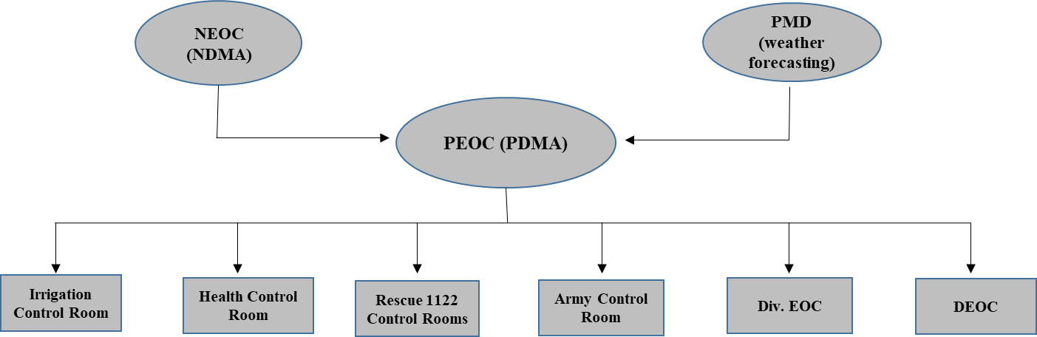

- Automatic DSR - Daily Situation Report: is issued from Provincial Emergency Operation Center twice a day. DSR is drafted on the basis of information received from respective divisional control rooms of the province. DSR is automated through Report Management System for maintaining updated Database and sharing of DSR with one click facility through email. DSR is shared with relevant departments and stakeholders for making informed decisions related to any untoward incidents/ emergency situation.

- Media & Awareness Campaigns by PDMA while using social media tools to reach wider audience in the digital world. Broachers and awareness message developed by Media Section for awareness rising are regularly shared on its Facebook and X platform where huge number of following makes it easy for wider public outreach with zero financial implications. PDMA has adapted a strategy of engaging news analysts in briefings on disaster risk reduction and impacts of climate change on communities. It results in publication of various features, stories and reports related to disaster management and guidance to general public. It has reduced the expenditure of dedicated media campaigns. The same will also be shared in WhatsApp Groups like Information Highway and PDMA Official.

- Coordination with UN Agencies (UNOCHA) and INGOs (PHF) / NGOs (NHN)
- Support of UN Agencies and INGOs / NGOs will be utilized in a coordinated manner, mostly in preparedness, relief, post disaster assessments and rehabilitation phases.
- Capabilities of each organization must be ascertained to ensure its optimal utilization. (Annex-III)
- Need based employment of UN Agencies will be regulated by NDMA and PDMAs.
- NGOs / INGOs duly cleared / approved by concerned ministries will be allowed to assist in relief and rehabilitation operations.
Roles and Responsibilities
All the stakeholders have been mobilized and sensitized for proper prevention, mitigation and preparedness measures. Some of the key roles of the departments are mentioned below.
- Provincial Disaster Management Authority Khyber Pakhtunkhwa: Prior to onset of monsoon season PDMA has dispatched relief items and released sufficient funds to all districts based on the vulnerability and requirement of the respective districts. Current fund position of the district is as.
Available and Required Fund Position of the Districts (updated in May 2026)
Sr# | District Name | Available Balance in Relief Head (Rs. In Million) | Required Funds. (Rs. In Million) | Sr# | District Name | Available Balance in Relief Head (Rs. In Million) | Required Funds. (Rs. In Million
1 | Abbottabad | 26.993 | 20 | 19 | Kolai Pallas | 49.16 | 00
2 | Bajaur | 44.177 | 43.278 | 20 | Kurram | 00 | 110.975
3 | Bannu | 00 | 10 | 21 | Lakki Marwat | 00 | 55.35
4 | Battagram | 12.42 | 00 | 22 | Malakand | 13 | 10
5 | Buner | 5.0749 | 1270 | 23 | Mansehra | 00 | 100
6 | Charsadda | 0.07216 | 20 | 24 | Mardan | 7.528 | 10
7 | Chiral Lower | 30.2689 | 20 | 25 | Mohmand | 2.753 | 00
8 | Chitral Upper | 4.756 | 10 | 26 | Nowshera | 2 | 50
9 | Dera Ismail Khan | 281.4 | 100 | 27 | Orakzai | 11.16 | 00
10 | Dir Lower | 3.7 | 20 | 28 | Peshawar | 2 | 20
11 | Dir Upper | 0.6694 | 10 | 29 | Shangla | 465.050 | 00
12 | Hangu | 0.003204 | 24.82 | 30 | Swabi | 12 | 00
13 | Haripur | 39.36 | 40 | 31 | Swat | 370 | 00
14 | Karak | 6 | 23 | 32 | Tank | 00 | 20
15 | Khyber | 00 | 60 | 33 | Torghar | 8.528 | 10
16 | Kohat | 9.51 | 40 | 34 | North Waziristan | 00 | 6.18
17 | Kohistan Lower | 21.670 | 30 | 35 | South Waziristan Lower | 00 | 50
18 | Kohistan upper | 99.68 | 00 | 36 | South Waziristan Upper | 37.8 | 00
 |  |  |  | Total |  | 1677.233564 | 2183.603

PDMA role in case of emergencies in Khyber Pakhtunkhwa is highlighted as under.
- Overall coordination for tackling any emergency situation in Khyber Pakhtunkhwa.
- Early warning of approaching weather system will be provided by PMD/FFD and communicated to all concerned by PDMA. DDMUs are expected to translate weather forecast and flood warnings into usable early warning for vulnerable communities and ensure its timely dissemination to all concerned. In case, there is continuous rise in river water level, the people residing in lower terrain Areas will be evacuated to the safer places. Threatened population will be evacuated by DDMUs as per prepared plan.
- In case, the districts fall short of meeting the humanitarian needs, PDMA will assist by making available the required stocks. In case, when disaster exceeds capacities of the Provincial Government, NDMA will be requested to make available the additional stocks from national reserves, prepositioned across the Country.
- When required, Armed Forces may be requested for assistance by PDMA Khyber Pakhtunkhwa at any stage, particularly for rescue, evacuation and emergency relief phases. Thus, the DDMUs will have to submit the request to PDMA for assistance of armed forces in aid of civil administration.
- PDMA will coordinate with key National Stakeholders including PMD, FFC, Armed Forces, Federal Agencies, DDMUs and Line Departments for management of the entire spectrum of Provincial Disaster Response.
- Rescue 1122 Khyber Pakhtunkhwa: Rescue 1122 is ready 24/7 to deal with any kind of emergency in 32 districts of Khyber Pakhtunkhwa. Following are the activities undertaken by Rescue 1122 in case of emergencies:
- Rescue 1122 will be sharing Information regarding technical and personnel expertise with PDMA and DDMUs.
- Conduct training in first aid & other activities for community members who are regular Affectees of Flood.
- Effectively train & mobilize Locals and initiate mass awareness regarding necessary first aid-rescue activities.
- Deployment of Rescue 1122 respondents at the disposal of DDMU for extending help to the flood affectees;
- Evacuation and initiation of basic first aid.
- Communicate to DEOC any additional resources required for performing.
- Rescue and Evacuation Activities.
- Taking precautionary measures to stop Fire-incidents in camps and perform Firefighting in emergency.
- Management of relief camps where required.
- Assisting District Administration and other Line Departments in Rehabilitation works.
The detailed resource mapping of Rescue 1122 in Khyber Pakhtunkhwa has been elaborated at Appendix II
- Civil Defense Khyber Pakhtunkhwa: In monsoon season emergencies, the Civil Defense will carry out functions of:
- Establishment of monsoon emergency Control Cell in respective districts.
- Information sharing regarding technical and personnel expertise with PDMA and DDMUs.
- Conduct training for volunteers in first aid & other activities.
- Keeping the volunteers/Razakaars on alert.
- Carrying out rescue operations.
- Provision of assistance in relief activities.
- Taking precautionary measures to stop Fire-incidents in camps and perform Firefighting in emergency.
- Irrigation Department: is responsible for constructing and maintaining irrigation infrastructure in the district. The activities undertaken by the department in monsoon season are as following:
- Carry out a detailed vulnerability assessment of Irrigation infrastructure, rivers, streams, nullahs and other water ways in the district, clearly identifying vulnerable structures. Past events of disasters (at least in the past 10 years) and disasters’ alerts are to be taken as key information in the vulnerability assessment.
- Monitor erosion of river/canal/nullah banks and carry out required re-enforcements, repair and maintenance and or coordinate with relevant provincial/federal authorities if repair/civil work are out of the ambit of district Irrigation Department.
- Continuously monitor water flow especially after an alert is issued by the Metrological Department.
- Designate an emergency information officer to liaise with DEOC and PEOC in preparedness and response stages.
- Maintain machinery for reinforcement of river/canal/nullahs banks during disaster.
- Sign a standby agreement with Government Contractors for using their machinery during disaster.
- Local Government, Elections and Rural Development Department
- To chalk out vulnerable places / populations in major urban cities regarding urban Flood and take all necessary measures for minimizing the impacts of urban Flood.
- Prepositioning of all necessary equipment’s and resources at the most vulnerable places.
- To carryout survey of billboards and remove / replace those which are in dilapidated conditions and are posing as hazards, to avoid any untoward events during monsoon season.
- Mitigation measures for urban Flood including but not limited to clearing of chocked sewerage / drainage channels and removal of waste from the site.
- The District Administration will follow Water Act 2020 for removal of encroachments in each district.
- Implementation of building codes in urban & rural areas.
- Sharing data of M&R funds, sorting out gaps in M&R process and funds, list of machinery and its condition in each district.
- Mobilizing of TMAs for planning / action for monsoon 2022.
- Activation of Control Room and sharing its particulars / contacts with PDMA for linking with Provincial Emergency Operation Center (PEOC), PDMA.

- Public Health Engineering Department (PHED): SOPs for PHED applies to all such government organizations providing water and sanitation services within the geographical boundaries of Khyber Pakhtunkhwa, and the responsibilities of Executive Engineer in this SOPs will apply to the heads of all such bodies.
- Carry out a detailed vulnerability assessment of drinking water and sanitation infrastructure in the district/catchment area, clearly identifying vulnerable facilities. Past events of disasters (At least in the past 10 years) and disasters’ alerts are to be taken as key information in the vulnerability assessment.
- Assess water pumps, water supply lines and sanitation lines and carry out required repair and maintenance.
- Protect water sources in flood prone areas.
- Designate an emergency information officer to liaise with DEOC and PEOC in preparedness and response stages.
- Maintain standby water pumps, generators and fuel stock to be used in disasters.
- Prepare an alternate plan of action for water supply to hospitals and health centers in the event of disaster.
- Sign a standby agreement with water tankers (or such company) based on vulnerability assessment and alerts.
- Maintain stock of chlorine and water purification tablets based on the vulnerability assessment and alerts.
- Prepare for installation of water and sanitation facilities in the temporary shelter locations identified by DDMU.
- Communication and Works – C&W Department: Construction and maintenance of road network and bridges is done by Communication and Works department which is headed by Executive Engineer in district. The activities undertaken by the department in monsoon season are as following:
- Carry out a detailed vulnerability assessment of road network and bridges in the district, clearly identifying vulnerable structures. Past events of disasters (at least in the past 10 years) and disasters’ alerts are to be taken as key information in the vulnerability assessment.
- Carry out necessary repair and maintenance of damaged/vulnerable roads and bridges and make them safer to withstand disasters.
- Plan alternate routes for vulnerable roads and bridges to facilitate evacuation and humanitarian response.
- Designate an emergency information officer to liaise with DEOC and PEOC in preparedness and response stages.
- Continuously monitor vulnerable roads and bridges during flood season and immediately inform DDMO of any damage and alternate route.
- Maintain machinery for clearing roads in the event of disasters.
- Sign a standby agreement with Government Contractors for using their machinery during disaster.
- Maintain stock of prefabricated bridges to be installed on emergency basis during disasters. The volume of stock should be based on disaster alerts, damages history and vulnerability of bridges/roads in the district.
- Health Department Health Department operates through Basic Health Unit (BHU), Rural Health Center (RHC), Tehsil Headquarter Hospital (THQ) and District Headquarter Hospital (DHQ). The activities undertaken by the department in monsoon season are as follow:
- To carry out a detailed vulnerability assessment of health infrastructure in the district, clearly identifying vulnerable hospitals. Past events of disasters (at least in the past 10 years) and disasters’ alerts are to be taken as key information in the vulnerability assessment.
- Make an evacuation plan for indoor patients from vulnerable facilities in the event of emergency especially after alert.
- Identify health facilities to serve as response bases in the event of emergency. Such bases should be in a safer location in the closer vicinity of the vulnerable areas.
- Maintain stock of life saving medicines, surgical tools and other equipment especially after disaster alert.
- Shift medical equipment (X-ray, ultrasound, ECG, MRI machines etc) to higher ground, preferably first or second floor, in the health facilities vulnerable to Flood.
- Establish/strengthen mother and child facility in the hospitals, especially in the response bases.
- Keep all ambulances operational with adequate stock of fuel.
- Designate an emergency information officer to liaise with DEOC and PEOC in preparedness and response stages.
- Liaison with public and private teaching hospitals, specialized hospitals and centers to ascertain the capacity of health response in the district.
For the expected heat wave situation in the province PDMA has chalked out a Heat wave Contingency Plan 2023 for the effective surveillance and response on the health impacts of the heat wave which includes instructions like: surveillance of the situation, declaration of emergency establishment of heatstroke centers in all the health facilities and insurance availability of essential medicines on urgent basis.
- Khyber Pakhtunkhwa Police: Police has a critical role to play in disaster and therefore preparedness measures are very important so that police force and resources can be utilized for saving lives and property of affected communities in disasters. Following shall be the responsibilities of District Police Officer for preparing police force to respond to disasters. District Police Officer shall:
- Take updates from DDMU about emergency alerts on regular basis.
- Get a copy of vulnerability assessment from DDOC, assess police stations’ safety and security in the vulnerable areas and take necessary measures to reduce vulnerability of police personnel and equipment.
- Make deployment plan for rescue and relief for vulnerable areas.
- Train police force for rescue and relief. There should be at least one team at tehsil level who are trained in rescue and relief and equipped with necessary tools.
- Regularly check wireless communication network and make it available to DDMU/Deputy Commissioner when required for communication during emergency.
- Take regular updates from Police Stations and Police Posts in the district about any disaster risk and communicate to DEOC and relevant departments and authorities.
- Keep all vehicles in running condition with enough fuel stock for deployment in disasters.
- Assist DDMU in dissemination of information about alerts through police stations and police posts in the vulnerable areas.
- Liaise with communication and works department for information of vulnerable roads/bridges, alternate routes in disasters and make traffic management plan accordingly.
- Conduct security assessment of the district and identify secure areas for humanitarian workers and organizations in the district, preferably in the closer vicinity of vulnerable areas.
- Make deployment plan for security of humanitarian workers and organizations in affected areas.
- Designate an emergency information officer to liaise with DEOC and PEOC in preparedness and response stages.
In Heat wave Contingency Plan 2023, the Provincial Police Officer Khyber Pakhtunkhwa has also been advised on the availability of necessary equipment / items on urgent basis to their field staff for protection from direct sunlight and proper arrangements in jails.
- Elementary and Secondary Education Department: has the largest network of buildings and has the greatest number of employees in the district. Schools can be used for awareness raising and information dissemination about disaster preparedness, evacuation, first aid and Do’s and Don’ts during a disaster. The activities undertaken by the department in monsoon season are as following:
- Carry out a detailed vulnerability assessment of school buildings. Past events of disasters (at least in the past 10 years) and disasters’ alerts are to be taken as key information in the vulnerability assessment.
- Identify schools for potential temporary shelter in a safe location close to vulnerable areas based on vulnerability assessment of DDMU.
- Assess identified schools’ capacity (in terms of number of families that can be housed), availability/need of drinking water, availability / need of sanitation, availability/need of boundary wall and share information with DDMU.
- Prepare a roster of teachers and staff to be deployed in rescue and relief activities during emergency.
- Designate an emergency information officer to liaise with DEOC and PEOC in preparedness and response stages.
- Agriculture and Livestock Department: Agriculture, horticulture and livestock are the main livelihood sources in rural areas of Khyber Pakhtunkhwa. Agriculture department will take following proactive steps in disaster preparedness and response at the district level.
- Carry out a detailed vulnerability assessment of the district especially flood prone areas past events of disasters (at least in the past 10 years) and disasters’ alerts are to be taken as key information in the vulnerability assessment.
- Conduct assessment of the potential diseases for crops and livestock in the given climatic condition and season (Rabi/Kharif crops), crops cultivated, cattle head types in the area and based on the history of diseases for crops and cattle head in vulnerable areas.
- Conduct capacity assessment of agriculture extension services and identify gaps in terms of staff, stock and facilities.
- Maintain stock of required chemicals and medicines for crops and livestock and plan for fumigation of crops and vaccination of cattle head after flood alert.
- Establish/designate emergency response bases for emergency in the close vicinity of vulnerable areas.
- Identify fodder suppliers, take quotations and select a supplier so that supply of fodder can be arranged in minimum possible time.
- Designate an emergency information officer to liaise with DEOC and PEOC in preparedness and response stages.
For the prevailing and expected heat wave situation in the province PDMA has chalked out a Heatwave Contingency Plan 2023 for the effective surveillance and response on the food security aspects and the crops impacts of the heatwave which included instructions like, surveillance of the situation, declaration of emergency and the availability of essential agriculture inputs to the small land holding farmers in the districts. The plan has also been included the precautionary measures to be taken by the farmers during wheat harvesting and ensure safety of livestock.

- Food Department: Food department is responsible for maintaining adequate food stock in the district and regulates market to ensure availability of adequate food items with required quality and approved rates. Food department needs to prepare for disasters by taking the following measures:
- Conduct vulnerability assessment of all government food godowns in the district especially those in the vulnerable areas. Past events of disasters (at least in the past 10 years) and disasters’ alerts are to be taken as key information in the vulnerability assessment.
- Carryout necessary repair and maintenance where needed for safety of food from disasters.
- Assess availability of food in government godowns and make necessary arrangements for storing adequate ration.
- Assess availability of food in the market and take appropriate measures to avoid food shortage in the event of disaster. Measures may include identification of food suppliers in other districts and arrangement for standby agreements for transport.
- Designate an emergency information officer to liaise with DEOC and PEOC in preparedness and response stages.
- Social Welfare Department: Social Welfare Department is the focal point for registration, monitoring and sometimes funding of voluntary organizations in the district since it is in a better position to utilize the human and material resource of such organization in different stages of disaster. Headed by Social Welfare Officer at the district level, the department will have the following responsibilities in disaster preparedness:
- Convene quarterly meetings with NGOs/CBOs working in the district to apprise them of the overall vulnerability of the district, alerts received from DOEC and to discuss the preparedness level of these organizations.
- Assess capacity of district-based NGOs/CBOs in disaster preparedness and response.
- Persuade NGOs/CBOs to allocate resources for disaster preparedness activities including capacity building of volunteers and employees, community resilience and for awareness campaign under the overall guidance of DDMU.
- Task NGOs/CBOs to prepare their own disaster management plans based on the vulnerability assessment of the district.
- Involve NGOs/CBOs in vulnerability assessment of the district by coordinating with DDMU.
- Designate an emergency information focal person so liaise between NGOs/CBOs and DDMU in disaster preparedness. NGOs/CBOs will directly report to and coordinate with DDMU in the response stage.
- Forest department has key role in disaster preparedness especially in the context of floods and land sliding. Responsibilities of Forest Department include protection of existing forests and expanding covered area. The SOPs for the Forest Department are as follows:
- Conduct detailed assessment of all areas in the district, especially the vulnerable areas, to ascertain the status of forests, level of deforestation and to identify sites for plantation.
- Make a plan for plantation in the district with a special focus in areas prone to soil erosion, sliding and Flood. Carryout plantation in spring and monsoon season in the identified areas.
- Take steps for marking vulnerable areas as ‘reserved areas’ for forests with no tolerance of cutting trees.
- Regularly check deforestation activities in the district with the involvement of local communities.
- Designate an emergency information focal person so liaise with DEOC and PEOC in disaster preparedness and response stages.
- Remove and regularly check wood logs from riverbanks to avoid obstruction of flood water.
- Communication of early warning for floods and other hazards with all stakeholders.
- Sports, Culture, Tourism, Archeology, Museum & Youth Affairs Department:
- Preparation of sector specific monsoon contingency plan including but not limited to resource mapping, coordination mechanism, tourist information centers, safe evacuation routes.
- Gathering data through tourist facilitation centers like number of tourists and vehicles enter in each district and sharing the same with Provincial Emergency Operation Center (PEOC), PDMA on daily basis during peak tourism season.
- A Control Room may be established and linked to the Provincial Emergency Operation Center (PEOC), PDMA.
- Mobilization / awareness campaign for tourist about cleanness on Tourist spot.
- Issuing alerts for tourist regarding weather forecast, land sliding and flood prone areas.
- Share the list of tourist information centers and rescue stations.
- District Disaster Management Unit (DDMU)
- Respective DDMUs, backed by PDMA would be the first responders in case of any untoward monsoon incidents.
- The Deputy Commissioners shall keep close liaison with all departments like Local Government, Health, Agriculture, Civil Defense, Irrigation, Works & Services, Education & Literacy, Police & other Law enforcement Agencies. Meetings in this regard are to be held on regular basis with concerned departments and minutes are to be shared with other Divisional Commissioners and PDMA.
- If there is likelihood of heavy rains and flood damages, emergency would be declared in the District and all Government functionaries (and NGOs) would be kept on high alert.
- Control Rooms would be established at District level in the offices of the Deputy Commissioners, DDMO and all other line departments during the Rain/Flood emergency. These Control rooms shall function round the clock.
- The Deputy Commissioners shall ensure activation of District Emergency Control Rooms at their offices round the clock which should fall under the supervision of concerned District Disaster Management Officers – DDMO. They shall also ensure preparedness at proposed relief camps and also ensure immediate evacuation of people residing in low-lying areas to safer place/ relief camps, if required. He shall also make immediate arrangements for the availability of sufficient quantity of relief Material like food, blankets, tents- plastic sheets etc.
- The Deputy Commissioner must further ensure that special attention is given to the specially enabled persons and women and children and extra ordinary measures are taken for such purpose.
- The Deputy Commissioner shall nominate the Additional Deputy Commissioner (Relief) / Assistant Commissioner (General) as focal persons to coordinate with the Tehsil/ Town level local councils for drainage of accumulated rainwater during monsoon season-2022.
- The Additional Deputy Commissioner (Relief) / Assistant Commissioner (General) shall be focal persons for the entire operations of rescue and relief. They must ensure the respective arrangements for machinery/ equipment and manpower in coordination with Civil Defense, Rescue 1122 and Police Department if needed and mobilize the village staff in the pre-and post-emergency work. They shall also ensure proper distribution of relief material among the actual needy persons.
- The Deputy Commissioners shall ensure mobilization of the NGOs and business community in the rescue and relief activities in case of emergency and shall depute volunteers on different emergency tasks.
- DDMUs would be responsible for effective and transparent relief distribution including relief provided by PDMA, NDMA and other Humanitarian Agencies/Institutions.
- DDMUs would be responsible for provision of search and rescue, medical and emergency responses.
- Camps will be established at pre-selected sites by DDMUs. All Divisions / Districts / Tehsils must be ready to handle the initial caseloads within their own mechanism and resources.

- Anticipatory Actions by Communities
In regard to flood anticipation, every flood-affected community, both individually and in the community, has its strategy that is born from hereditary experiences and knowledge. When the rainy season arrives, they make various preparations as a strategy to minimize their losses. Based on the decades of experience of the local communities and according to international best practices, in the anticipation of occurrence of a flood, there are several strategies adopted by the locals to minimize the negative impact of floods, namely.
- Community’s Internal Early Warning System: Mobilization of community early warning system and mock exercises for numerous scenarios.
- Refuge to a neighboring area where houses are flood-free: Not all the local community members adopt this strategy as most of them stay in their homes with the intent of observing floods, unless the floods rise, and they have to leave their homes. However, through the local Masjid, community awareness in this regard to migrate to a neighboring community to save human life and livestock needs to be imparted.
- Put the goods in a higher place: Flood conditions that affect the houses are very diverse depending on the physical environment. Some floods flow through people's houses, and there are also floods that inundate low-level houses (10 cm), moderate levels (30 cm) and high levels (1 meter). Also, the effort of community members is conditioned by the situation of each home. Especially food items and clean drinking water needs to be stored at a higher place in case of floods.
- Local Communities may be informed intime to properly manage their goods so as not to cause any harm in an event of a disaster.
- Protect Livestock: Raising livestock in their villages is a need-based activity for many community members. When the floods come, they should rescue the livestock in various ways such as evacuate them in flood-free locations or save in a safe place from the floods inside the house.
- Preparing rubber tires for transportation: Mostly when floods reach a height of 1 meter or above, locals should prepare giant rubber tires as a means of transportation. They can use it to transport anything, especially goods and people.

SECTION VI – APPENDICES
Appendix I: Maps
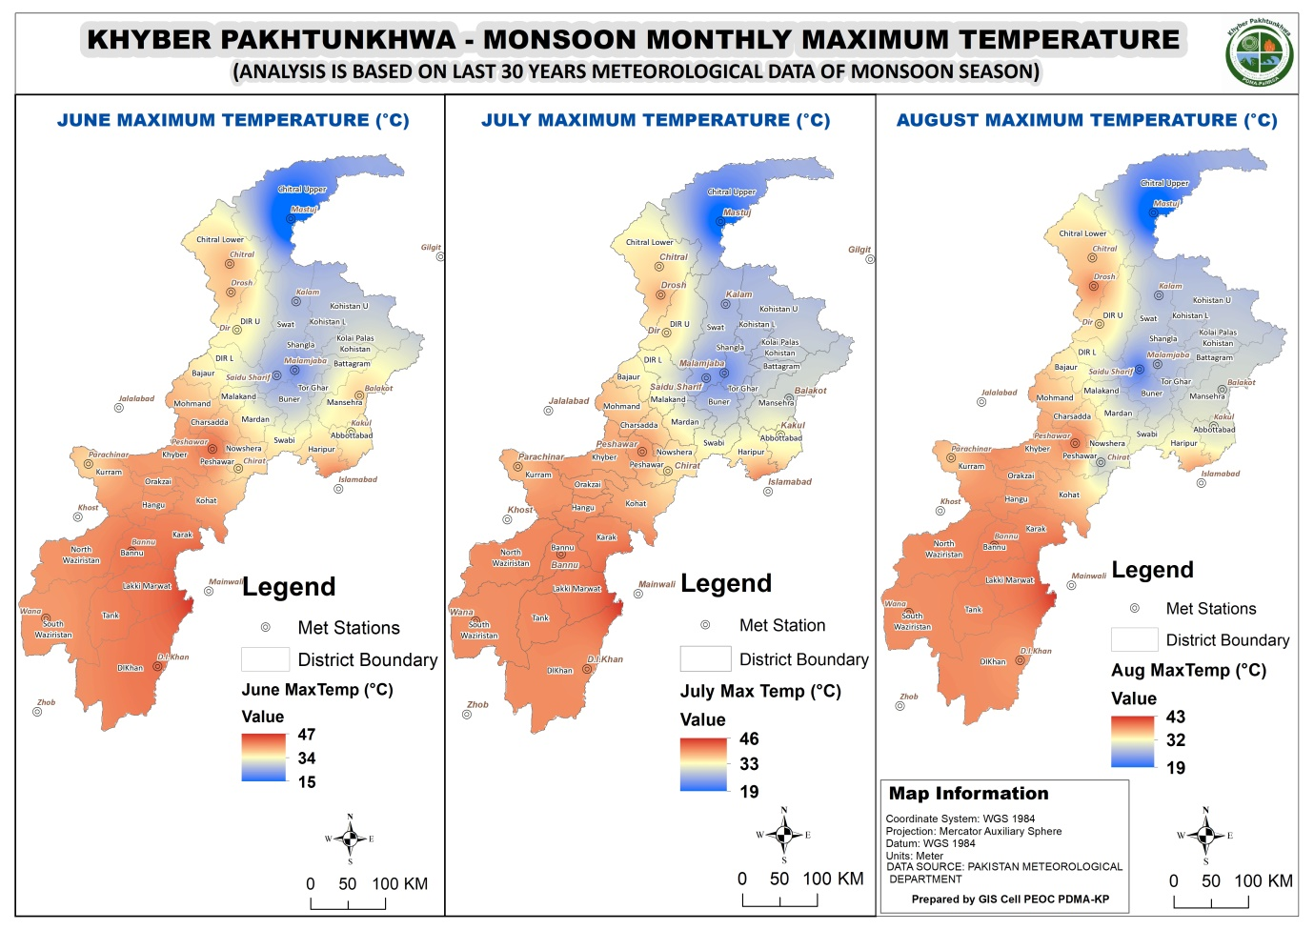
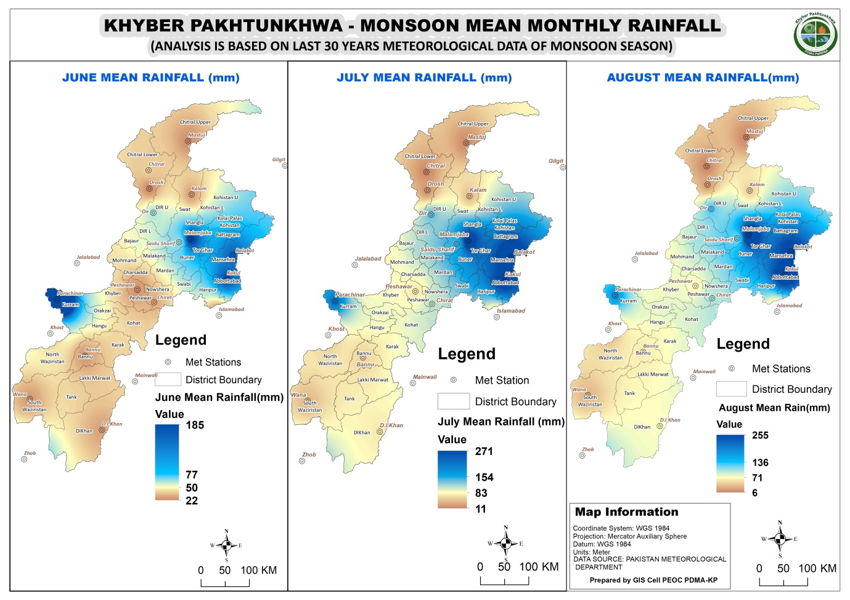

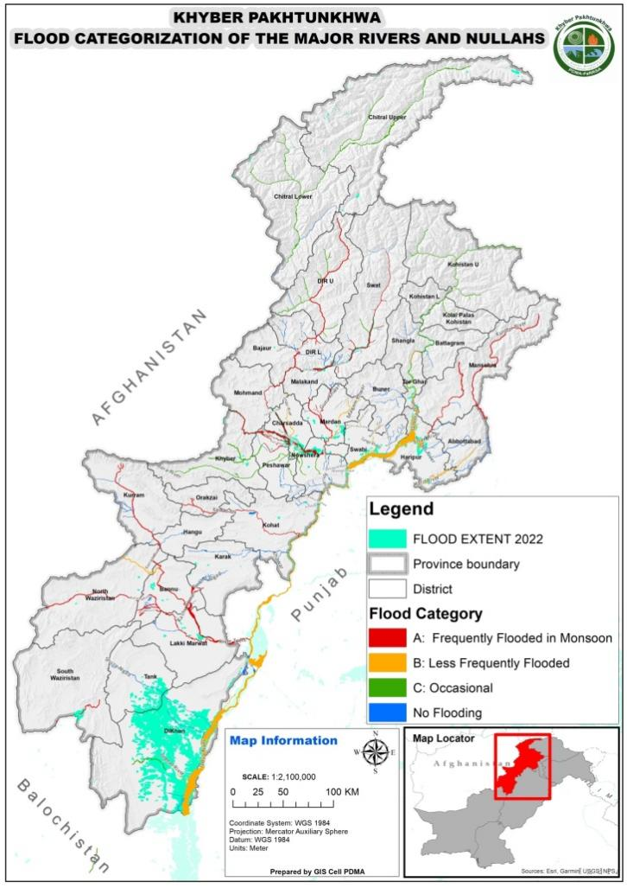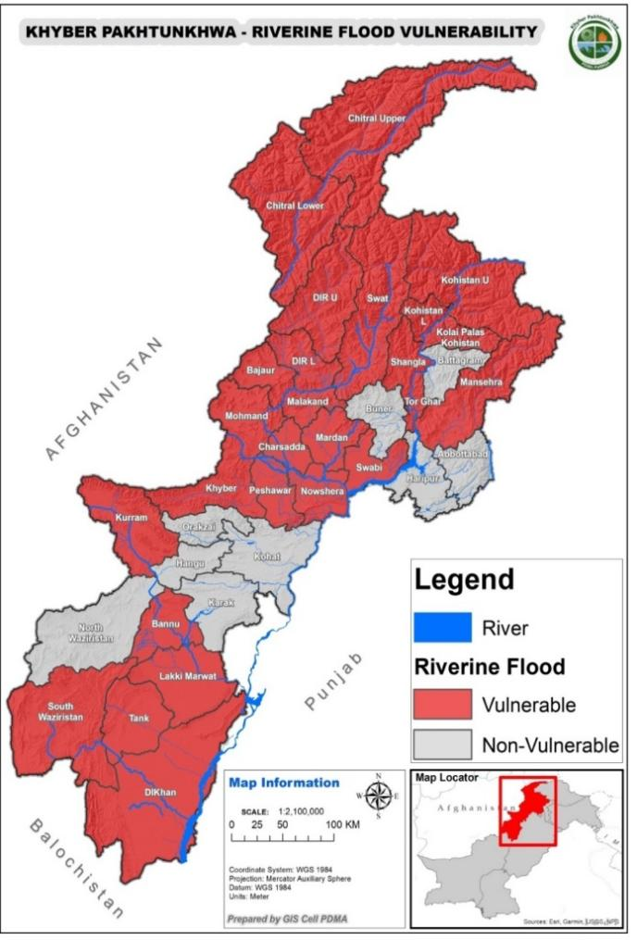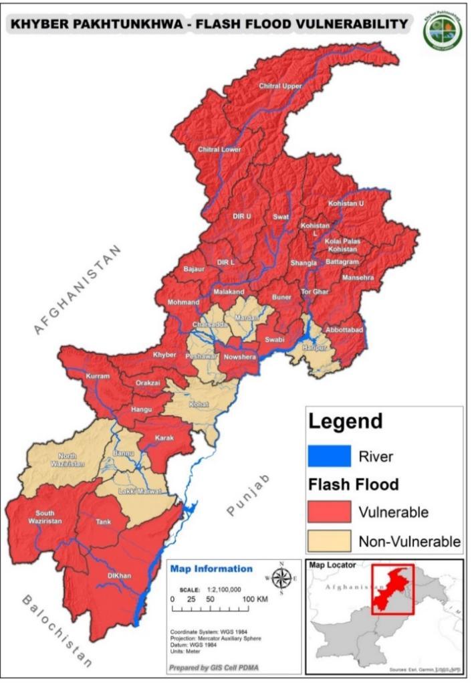
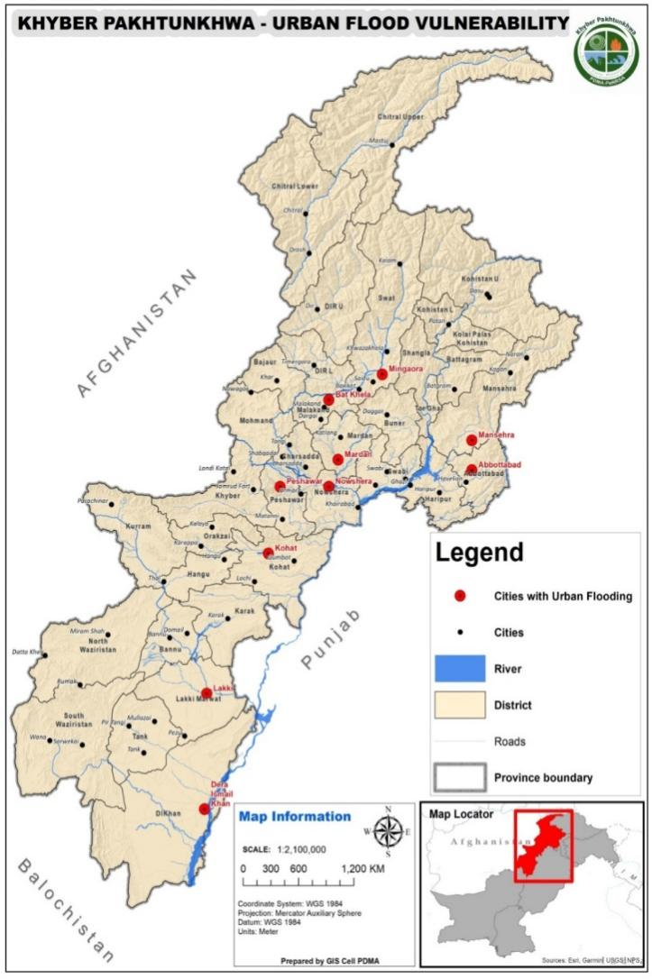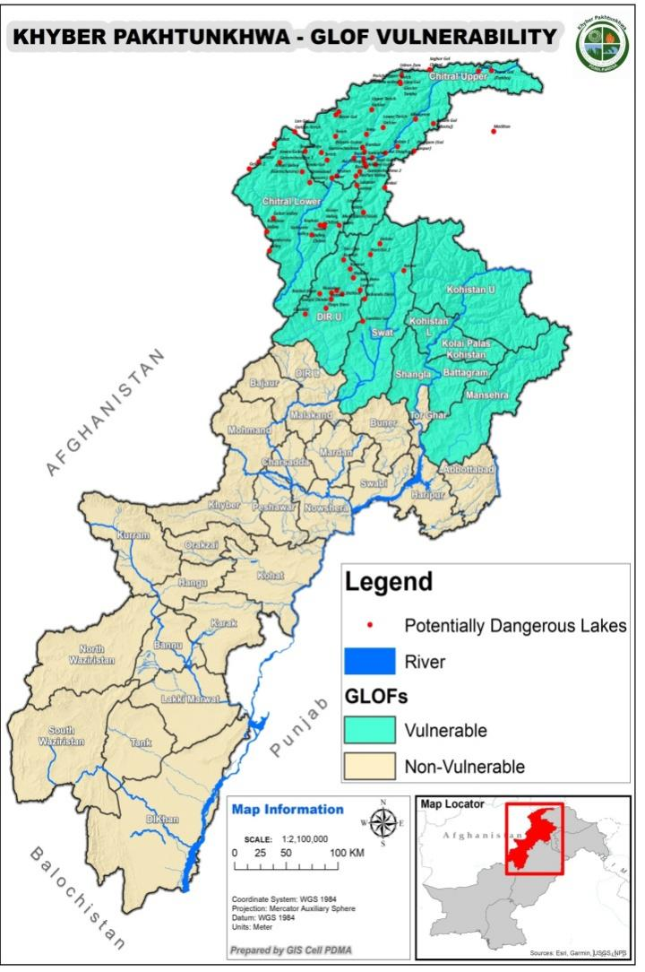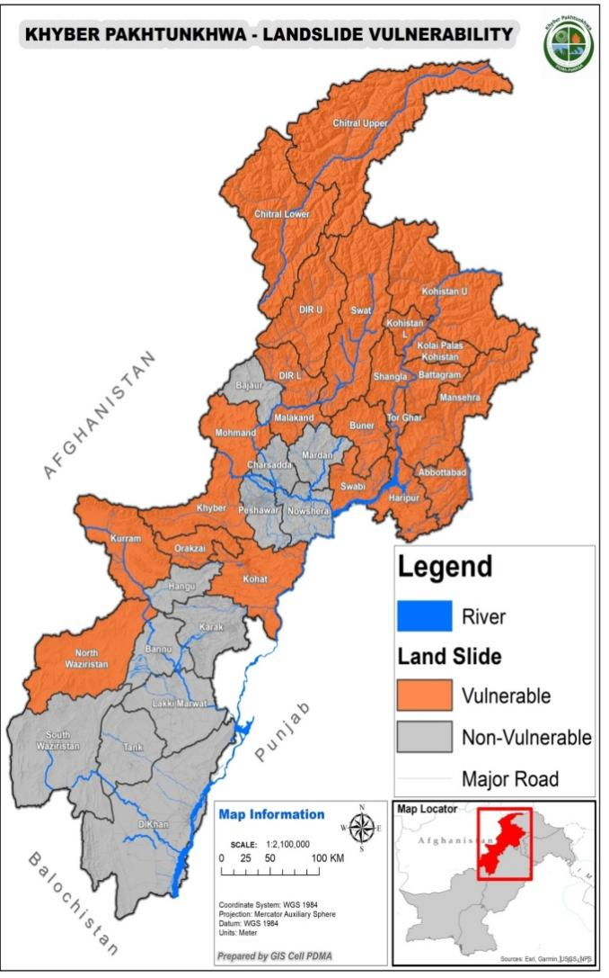

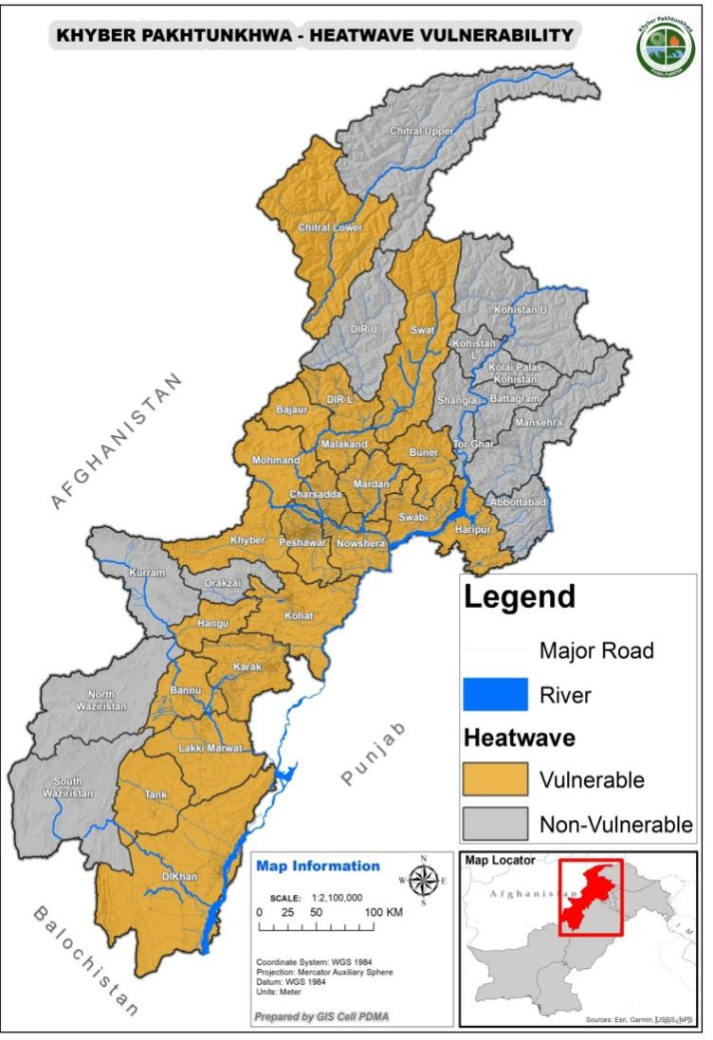
Appendix II: Important Calculations
Table 1: Discharge Limit Chart of Rivers, Khwars and Nullahs of Khyber Pakhtunkhwa (updated on 10-04-2023)
S.No. | Name of River/ Khwar /Nullah | Low Flood (cfs) | Med Flood (cfs) | High Flood (cfs) | Very High Flood (cfs) | Highest Flood Recorded (cfs) | Highest Flood Date
1 | Kabul River at Warsak | 40000 | 60000 | 100000 | 150000 | 159000 | 28-06-1905
2 | Chilla Nullah at Pabbi | 3000 | 10000 | 17500 | 25000 | 28620 | 29-08-1979
3 | Hakim Ghari Nullah at Pabbi | 2500 | 5000 | 7000 | 10000 | 10650 | 08-07-1983
4 | Khudrizai Nullah at Pabbi | 1000 | 1250 | 1500 | 2000 | 2500 | 09-08-1984
5 | Sheen Hall Khwar at Rustum | 3000 | 7500 | 10000 | 15000 | 17934 | 11-08-1988
6 | Kunhar River at Balakot | 20000 | 40000 | 60000 | 80000 | 92000 | 08-01-1992
7 | Siran River at Daryal | 15000 | 30000 | 40000 | 50000 | 55181 | 08-01-1992
8 | Dour River at Rajoya | 10000 | 25000 | 35000 | 70000 | 75970 | 08-01-1992
9 | Haro River at Jabori | 10000 | 20000 | 35000 | 55000 | 82876 | 08-01-1992
10 | Garandi Nullah at Urmar | 2000 | 3000 | 4000 | 6000 | 7000 | 19-08-2003
11 | Bara River at Chamkani | 10000 | 25000 | 30000 | 40000 | 48000 | 12-08-2007
12 | Takhta Baig Khwar at Khyber | 7500 | 15000 | 30000 | 80000 | 123000 | 04-08-2008
13 | Budni Nullah at Darmangi | 6000 | 16000 | 20000 | 45000 | 123000 | 04-08-2008
14 | Dallus Nullah at Warsak Road | 3000 | 8000 | 15000 | 18000 | 21700 | 08-08-2010
15 | Shahi Bala Khwar | 3000 | 7500 | 12000 | 15000 | 19000 | 08-08-2010
16 | Kalpani Nullah at Mardan City | 20000 | 30000 | 40000 | 60000 | 80315 | 07-01-2010
17 | Kohat Toi | 7000 | 15000 | 25000 | 40000 | 50000 | 28-07-2010
18 | Kurram River at Kurram. Ghari H/W | 30000 | 50000 | 80000 | 100000 | 200000 | 28-07-2010
19 | Gambila River at Gambila Lakki | 15000 | 25000 | 45000 | 55000 | 64024 | 28-07-2010
20 | Chikar Nullah at Pabbi | 3000 | 7500 | 12000 | 15000 | 14800 | 29-07-2010
21 | Kabul River at Nowshera | 60000 | 90000 | 140000 | 200000 | 450000 | 29-07-2010
22 | Swat River at Munda H/W | 40000 | 60000 | 80000 | 150000 | 355000 | 29-07-2010
23 | Jindi Khwar at Utmanzai | 6000 | 9000 | 16000 | 20000 | 25000 | 29-07-2010
24 | Balar Khwar at Mardan | 3000 | 10000 | 20000 | 30000 | 42000 | 29-07-10
25 | Dagi Nullah at Pabbi | 1500 | 2500 | 3500 | 4000 | 5000 | 29-7-10
26 | Indus River at Tarbela (Inflow) | 250000 | 375000 | 500000 | 650000 | 650000 | 30-07-2010
27 | Indus River at Tarbela (outflow) | 250000 | 375000 | 500000 | 650000 | 650000 | 30-07-2010
28 | Indus River at Attock Khairabad | 225000 | 375000 | 500000 | 650000 | 994600 | 30-07-2010
29 | Swat River at Chakdara | 30000 | 50000 | 70000 | 100000 | 360000 | 30-07-2010
30 | Swat River at Khaili Charsadda Road | 40000 | 60000 | 80000 | 120000 | 360000 | 30-07-2010
31 | Kalpani Nullah at Chowki Risalpur | 20000 | 40000 | 50000 | 60000 | 118604 | 30-07-2010
32 | Badri Nullah at Swabi | 7500 | 15000 | 35000 | 50000 | 60000 | 30-07-2010
33 | Naguman River Charsadda Road | 10000 | 20000 | 30000 | 50000 | 75575 | 30-07-2010
34 | Shah Alam River at Takht Abad | 5000 | 7500 | 12500 | 15000 | 20000 | 30-07-2010
35 | Naranji Nullah at Swabi | 5000 | 10000 | 20000 | 35000 | 45000 | 2010
36 | Jindi River at Charsadda | 7500 | 10000 | 15000 | 20000 | 42000 | 30-07-2010
37 | Muqam Nullah at Shahbaz garhi | 3000 | 8000 | 15000 | 30000 | 45000 | 2010
38 | Swat River at Khwazakhela | 30000 | 45000 | 60000 | 80000 | 246392 | 26-08-2022
39 | Panjkora River At Zulam Bridge (DIR) | 20000 | 30000 | 50000 | 75000 | 139510 | 26-08-2022
40 | Kabul River at Adezai Bridge | 30000 | 50000 | 70000 | 80000 | 90200 | 27-08-2022
Source: Irrigation Department, Khyber Pakhtunkhwa

Remarks:
- The discharges are calculated on the basis of flows passing through it on long term averages.
Table 2: Time Lag for Major Rivers in Khyber Pakhtunkhwa
S.No. | Location | Distance (km) | Time Lag
1 | Swat / Khiali River
I | Khawaza Khela to Amandara | 65 | 12 Hours
ⅱ | Amandara to Munda | 85 | 09 Hours
ⅲ | Munda to Charsadda Road | 40 | 6.5 Hours
2 | Kabul River
I | Warsak to Charsadda Road Peshawar | 25 | 04 Hours
ⅱ | Charsadda Road to Nowshera | 35 | 06 Hours
ⅲ | Nowshera to Indus River | 30 | 05 Hours
3 | Indus River
I | Jinnah Barrage to Chashma Barrage | 56 | 4.5 Hours
ⅱ | Chashma to D.I. Khan | 100 | 12.5 Hours
ⅲ | D.I Khan City to Ramak | 70 | 09 Hours
Source: Irrigation Department, Khyber Pakhtunkhwa

Table 3: Last 6 Years Monsoon Season Losses and Damages
Monsoon Damages Report of Last 06 Years (2018 to 2023)
District Name | M0nsoon 2018, Damages/Losses |  |  | Monsoon 2019, Damages/Losses |  |  |  | Monsoon 2020, Damages/Losses |  |  |  | Monsoon 2021, Damages/Losses |  |  |  | Monsoon 2022, Damages/Losses |  |  |  | MCP 2023, Damages/Losses |  |  |  | Total Damages (5 Years) |  |  |  | Population Impact |  | Houses Damaged
 | Deaths | Injuries | House Damages |  | Deaths | Injuries | House Damages |  | Deaths | Injuries | House Damages |  | Deaths | Injuries | House Damages |  | Deaths | Injuries | House Damages |  | Deaths | Injuries | House Damages |  | Deaths | Injuries | House Damages |  | Population Impact
Abbottabad | 1 | 0 | 2 |  | 26 | 15 | 7 |  | 18 | 13 | 65 |  | 17 | 5 | 24 |  | 7 | 0 | 77 |  | 22 | 24 | 16 |  | 91 | 57 | 191 |  | 324 |  | 382
Bajaur | 0 | 0 | 0 |  | 13 | 9 | 7 |  | 25 | 33 | 78 |  | 16 | 26 | 27 |  | 13 | 24 | 164 |  | 4 | 14 | 40 |  | 71 | 106 | 316 |  | 656 |  | 632
Bannu | 0 | 0 | 0 |  | 1 | 5 | 65 |  | 2 | 1 | 1 |  | 1 | 1 | 1 |  | 2 | 0 | 13 |  | 19 | 151 | 85 |  | 25 | 158 | 165 |  | 384 |  | 330
Battagram | 0 | 0 | 0 |  | 1 | 0 | 6 |  | 5 | 4 | 35 |  | 6 | 9 | 2 |  | 6 | 1 | 55 |  | 4 | 9 | 2 |  | 22 | 23 | 100 |  | 116 |  | 200
Buner | 10 | 7 | 17 |  | 17 | 16 | 35 |  | 34 | 24 | 244 |  | 7 | 9 | 25 |  | 5 | 5 | 83 |  | 7 | 13 | 41 |  | 80 | 74 | 445 |  | 310 |  | 890
Charsadda | 6 | 14 | 28 |  | 20 | 23 | 20 |  | 5 | 18 | 41 |  | 3 | 7 | 47 |  | 3 | 12 | 995 |  | 1 | 1 | 5 |  | 38 | 75 | 1136 |  | 234 |  | 2272
Dera Ismail Khan | 3 | 3 | 3 |  | 6 | 6 | 70 |  | 9 | 11 | 109 |  | 3 | 2 | 81 |  | 43 | 91 | 75338 |  | 6 | 4 | 64 |  | 70 | 117 | 75665 |  | 410 |  | 151330
Hangu | 2 | 4 | 2 |  | 10 | 6 | 7 |  | 6 | 15 | 5 |  | 0 | 0 | 2 |  | 8 | 12 | 181 |  | 7 | 18 | 33 |  | 33 | 55 | 230 |  | 182 |  | 460
Haripur | 2 | 2 | 0 |  | 5 | 4 | 22 |  | 4 | 5 | 23 |  | 3 | 2 | 3 |  | 2 | 1 | 38 |  | 3 | 3 | 12 |  | 19 | 17 | 98 |  | 124 |  | 196
Karak | 1 | 0 | 0 |  | 6 | 15 | 11 |  | 1 | 22 | 8 |  | 5 | 8 | 97 |  | 18 | 9 | 1621 |  | 13 | 26 | 52 |  | 44 | 80 | 1789 |  | 280 |  | 3578
Khyber | 0 | 0 | 0 |  | 4 | 4 | 1 |  | 6 | 5 | 17 |  | 3 | 9 | 8 |  | 17 | 57 | 209 |  | 15 | 16 | 13 |  | 45 | 91 | 248 |  | 280 |  | 496
Kohat | 1 | 3 | 5 |  | 10 | 12 | 8 |  | 2 | 8 | 3 |  | 5 | 8 | 1 |  | 2 | 5 | 2 |  | 1 | 4 | 0 |  | 21 | 40 | 19 |  | 132 |  | 38
Kolai Palas | 0 | 0 | 0 |  | 0 | 0 | 0 |  | 2 | 0 | 30 |  | 0 | 0 | 0 |  | 1 | 0 | 180 |  | 0 | 5 | 0 |  | 3 | 5 | 210 |  | 36 |  | 420
Kurram | 0 | 0 | 0 |  | 0 | 17 | 12 |  | 3 | 0 | 2 |  | 3 | 0 | 4 |  | 12 | 17 | 149 |  | 1 | 10 | 6 |  | 19 | 44 | 173 |  | 258 |  | 346
Lakki Marwat | 1 | 2 | 30 |  | 4 | 0 | 37 |  | 1 | 0 | 35 |  | 5 | 11 | 55 |  | 15 | 1 | 1284 |  | 14 | 66 | 338 |  | 40 | 80 | 1779 |  | 322 |  | 3558
Lower Dir | 15 | 5 | 4 |  | 9 | 14 | 8 |  | 18 | 17 | 20 |  | 14 | 10 | 3 |  | 21 | 26 | 1365 |  | 4 | 41 | 28 |  | 81 | 113 | 1428 |  | 394 |  | 2856
Lower Kohistan | 0 | 0 | 0 |  | 2 | 2 | 1 |  | 12 | 10 | 7 |  | 6 | 15 | 7 |  | 21 | 8 | 766 |  | 14 | 3 | 18 |  | 55 | 38 | 799 |  | 234 |  | 1598
LowerChitral | 3 | 2 | 34 |  | 8 | 12 | 44 |  | 0 | 3 | 63 |  | 1 | 2 | 4 |  | 10 | 15 | 243 |  | 0 | 24 | 236 |  | 22 | 58 | 624 |  | 186 |  | 1248
Malakand | 2 | 2 | 3 |  | 5 | 18 | 14 |  | 12 | 21 | 133 |  | 6 | 19 | 11 |  | 6 | 9 | 462 |  | 8 | 13 | 15 |  | 39 | 82 | 638 |  | 260 |  | 1276
Mansehra | 2 | 0 | 1 |  | 12 | 10 | 7 |  | 12 | 5 | 4 |  | 17 | 3 | 3 |  | 23 | 11 | 23 |  | 19 | 9 | 123 |  | 85 | 38 | 161 |  | 272 |  | 322
Mardan | 19 | 30 | 212 |  | 13 | 14 | 6 |  | 38 | 92 | 207 |  | 14 | 24 | 65 |  | 31 | 27 | 437 |  | 8 | 13 | 12 |  | 123 | 200 | 939 |  | 660 |  | 1878
Mohmand | 0 | 0 | 0 |  | 8 | 2 | 3 |  | 36 | 33 | 46 |  | 3 | 1 | 9 |  | 8 | 19 | 541 |  | 4 | 7 | 47 |  | 59 | 62 | 646 |  | 246 |  | 1292
North Waziristan | 0 | 0 | 0 |  | 4 | 12 | 16 |  | 2 | 14 | 19 |  | 6 | 9 | 88 |  | 5 | 14 | 106 |  | 1 | 2 | 4 |  | 18 | 51 | 233 |  | 154 |  | 466
Nowshera | 4 | 1 | 1 |  | 7 | 17 | 4 |  | 5 | 51 | 16 |  | 4 | 20 | 24 |  | 3 | 7 | 987 |  | 6 | 8 | 36 |  | 29 | 104 | 1068 |  | 272 |  | 2136
Orakzai | 0 | 0 | 0 |  | 2 | 3 | 6 |  | 15 | 11 | 64 |  | 2 | 2 | 0 |  | 11 | 7 | 2 |  | 6 | 3 | 4 |  | 36 | 26 | 76 |  | 156 |  | 152
Peshawar | 5 | 13 | 25 |  | 6 | 55 | 29 |  | 13 | 48 | 13 |  | 10 | 20 | 10 |  | 8 | 23 | 129 |  | 7 | 16 | 12 |  | 49 | 175 | 218 |  | 474 |  | 436
Shangla | 16 | 17 | 17 |  | 21 | 31 | 41 |  | 47 | 17 | 70 |  | 13 | 10 | 6 |  | 20 | 10 | 73 |  | 16 | 13 | 11 |  | 133 | 98 | 218 |  | 488 |  | 436
South Waziristan | 0 | 0 | 0 |  | 4 | 1 | 1 |  | 11 | 27 | 5 |  | 3 | 8 | 0 |  | 18 | 31 | 45 |  | 12 | 13 | 5 |  | 48 | 80 | 56 |  | 276 |  | 112
Swabi | 5 | 2 | 23 |  | 12 | 20 | 10 |  | 24 | 23 | 229 |  | 2 | 6 | 6 |  | 7 | 13 | 248 |  | 4 | 10 | 7 |  | 54 | 74 | 523 |  | 274 |  | 1046
Swat | 9 | 9 | 10 |  | 25 | 42 | 22 |  | 42 | 38 | 106 |  | 6 | 19 | 12 |  | 38 | 33 | 239 |  | 13 | 9 | 11 |  | 133 | 150 | 400 |  | 566 |  | 800
Tank | 0 | 0 | 0 |  | 2 | 13 | 4 |  | 3 | 4 | 15 |  | 4 | 1 | 29 |  | 5 | 11 | 3981 |  | 0 | 0 | 135 |  | 14 | 29 | 4164 |  | 86 |  | 8328
Torghar | 0 | 0 | 0 |  | 2 | 4 | 9 |  | 7 | 1 | 74 |  | 15 | 7 | 6 |  | 0 | 1 | 13 |  | 0 | 0 | 11 |  | 24 | 13 | 113 |  | 98 |  | 226
Upper Dir | 10 | 16 | 14 |  | 22 | 37 | 68 |  | 11 | 18 | 74 |  | 5 | 3 | 37 |  | 24 | 23 | 982 |  | 8 | 12 | 55 |  | 80 | 109 | 1230 |  | 382 |  | 2460
Upper Kohistan | 0 |  | 0 |  | 10 | 2 | 0 |  | 7 | 0 | 114 |  | 0 | 2 | 2 |  | 6 | 3 | 433 |  | 1 | 2 | 6 |  | 24 | 9 | 555 |  | 66 |  | 1110
UpperChitral | 4 | 2 | 35 |  | 0 | 1 | 4 |  | 3 | 0 | 38 |  | 2 | 0 | 37 |  | 3 | 2 | 303 |  | 1 | 0 | 123 |  | 13 | 5 | 540 |  | 36 |  | 1080

Table 4: Relief Items in the districts

# | District | Tents | Mattresses/ Dharis | Mats Plastic various size | Plastic Sheets/Tarpaulin | Water Cooler/Jerry Cans | Quilts | Water Cans | Pillow | Blankets | sand bags | Bucket | Kitchen Set | Hygiene Kit | Bed Sheet | Generator | Life Saving Jackets | Net Mosquito | De-Watering Pumps | Cylinder
1 | Abbottabad | 100 | 50 | 50 | 50 | 0 | 100 | -- | 80 | 100 | 0 | 50 | 100 | 150 | -- | -- | 25 | 12 | -- | --
2 | Bannu | 70 | __ | 37 | 20 | 35 | 21 | __ | 127 | 43 | __ | 43 | 72 | 34 | __ | 0 | 15 | __ | 0 | 53
3 | Chitral Upper | 1090 | 383 | -- | -- | -- | 709 | --- | --- | 1781 | -- | --- | 495 | 320 | --- | 08 | 39 | --- | --- | ---
4 | DI Khan | 2090 | 1313 | __ | 1690 | __ | 1000 | __ | 928 | 2150 | __ | 900 | 390 | 1030 | __ | __ | 502 | 300 | 9 | __
5 | Hangu | 210 | 668 | 586 | 768 | --- | 1552 | --- | 717 | --- | --- | 420 | 385 | 360 | --- | --- | --- | --- | --- | ---
6 | Haripur | 240 | 338 | 110 | 110 | 235 | 430 | --- | 400 | 250 | --- | 6 | 70 | 0 | --- | 3 | 0 | --- | 0 | 0
7 | Khyber | 13 | 0 | 3 | 0 | 0 | --- | ---- | 0 | 49 | --- | 0 | 0 | 0 | --- | --- | 0 | ---- | --- | 0
8 | Kolai Palas | --- | --- | --- | --- | --- | --- | --- | --- | --- | --- | --- | --- | --- | --- | --- | --- | --- | --- | ---
9 | Kuram | 26 | 20 | 60 | 80 | 6 | 0 | __ | 100 | 0 | 0 | 0 | 19 | 40 | __ | __ | 0 | 0 | 0 | 2
10 | Malakand | 305 | __ | 209 | 247 | 126 | 153 | __ | 191 | 243 | 200 | __ | 105 | 179 | __ | __ | __ | 292 | 2 | 18
11 | Mardan | 321 | 266 | 184 | 243 | 180 | 290 | -- | 299 | 312 | -- | -- | 136 | 125 | --- | ---- | 10 | 164 | --- | ---
12 | Orakzai | 130 | 175 | 220 | --- | 0 | 212 | --- | --- | 0 | --- | --- | 38 | --- | --- | --- | --- | --- | ---- | ----
13 | Shangla | 1051 | 122 | 479 | __ | __ | 42 | __ | 105 | 3597 | __ | __ | 267 | __ | __ | __ | __ | 529 | __ | Nil
14 | Toorghar | 145 | 294 | 316 | 306 | 95 | 297 | -- | 153 | 510 | -- | -- | 203 | -- | -- | -- | 55 | 100 | 2 | --
15 | Peshawar | 103 | 40 | 75 | __ | 48 | 152 | __ | 100 | 54 | __ | 40 | 43 | 27 | __ | 3 | 115 | 400 | 7 | __
16 | Kohistan Upper | 165 | --- | --- | --- | --- | --- | --- | --- | 1500 | --- | --- | --- | 30 | --- | --- | --- | --- | --- | ---
17 | Tank | 148 | 147 | 117 | 170 | __ | __ | __ | 100 | 150 | __ | 37 | __ | __ | __ | __ | __ | __ | __ | __
18 | Mansehra | --- | --- | --- | --- | --- | --- | --- | --- | --- | --- | --- | --- | --- | --- | --- | --- | --- | --- | ---
19 | Kohistan Lower | 210 | 100 | 200 | --- | --- | 550 | --- | 100 | 3000 | --- | --- | --- | 100 | --- | --- | 40 | 2000 | --- | ---
20 | Lower Dir | 243 | __ | 555 | 380 | 990 | 830 | __ | __ | 7141 | __ | 0 | 246 | 141 | __ | __ | 0 | 215 | 0 | 150
21 | Upper Dir | 203 | 204 | --- | --- | 167 | --- | --- | --- | 552 | --- | --- | 125 | 128 | --- | --- | 34 | --- | --- | ---
22 | Swabi | 0 | 46 | 44 | 68 | 0 | 117 | --- | 76 | 171 | --- | 0 | 0 | 0 | --- | 0 | 34 | 87 | 0 | 0
23 | Nowshera | 109 | 42 | 25 | 150 | 28 | 24 | --- | --- | 85 | 800 | --- | 23 | 115 | 200 | --- | 80 | 200 | 3 | 84
24 | Charsadda | 355 | 363 | 1026 | 425 | 1377 | 299 | __ | 278 | 854 | __ | 233 | 211 | 240 | __ | __ | 80 | 339 | 3 | __
25 | Karak | 207 | __ | 86 | 92 | 62 | 136 | __ | 35 | 120 | __ | 0 | 106 | 160 | __ | 0 | 15 | __ | 3 | 0
26 | Kohat | 192 | 95 | 50 | 119 | 114 | 100 | __ | 130 | 127 | __ | 3 | 65 | 99 | __ | __ | 20 | 240 | __ | __
27 | North Wazriristan | 359 | 0 | 287 | 325 | 241 | --- | --- | 250 | --- | --- | 0 | 39 | 53 | --- | --- | --- | 0 | 2 | 0
28 | South Waziristan lower | 129 | 48 | 108 | 104 | 0 | 104 | --- | 104 | 185 | --- | 0 | 0 | 44 | --- | --- | 0 | 200 | 0 | 0
29 | South Waziristan upper | --- | --- | --- | --- | --- | --- | --- | --- | --- | --- | --- | --- | --- | --- | ---- | --- | --- | --- | ---
30 | Buner | 800 | 80 | 705 | __ | __ | 0 | __ | 403 | 560 | __ | __ | 280 | __ | __ | __ | __ | 73 | __ | 105
31 | Bajaur | 112 | 0 | 271 | 0 | 0 | 110 | __ | 0 | 150 | __ | 110 | 0 | 141 | __ | 0 | __ | __ | 0 | __
32 | Swat | 670 | 301 | --- | --- | --- | 344 | --- | --- | 1666 | --- | --- | 184 | 198 | --- | 12 | 102 | --- | --- | ---
33 | Chitral Lower | 150 | 50 | --- | --- | --- | 100 | --- | --- | 1500 | --- | --- | 100 | 100 | --- | --- | --- | --- | --- | ---
34 | Mohmmand | 670 | 156 | 176 | 170 | 130 | 262 | __ | 0 | 256 | 100 | __ | 176 | 178 | __ | __ | __ | 160 | 3 | 130
35 | Lakki Marwat | 110 | 110 | 250 | 70 | __ | 140 | __ | 270 | 200 | __ | 0 | 80 | 90 | __ | __ | 10 | 600 | __ | 0
36 | Battagram | 114 | 50 | 40 | 75 | 0 | 20 | __ | 38 | 85 | __ | __ | 20 | 0 | __ | __ | __ | 70 | __ | __
Total |  | 8031 | 4107 | 5835 | 5369 | 3487 | 6001 | 4505 | 4505 | 16980 | 1100 | 1792 | 2838 | 2931 | 200 | 932 | 926 | 3805 | 34 | 542

Table 5: Required Food Items/NFIs of the District
# | District | Tents | Mattresses/Dharis | Mats Plastic various size | Plastic Sheets/Tarpaulin | Water Cooler/Jerry Cans | Quilts | Water Cans | Pillow | Blankets | sand bags | Bucket | Kitchen Set | Hygiene Kit | Bed Sheet | Generator | Life Saving Jackets | Net Mosquito | De-Watering Pumps | Cylinder
1 | Abbottabad | 200 | 150 | 200 | 250 | 150 | 200 | --- | 200 | 200 | 100 | 150 | 200 | 200 | --- | --- | 50 | 150 | --- | ---
2 | Bannu | 400 | 200 | 300 | 300 | 200 | 200 | --- | 50 | 200 | --- | 20 | 100 | 100 | --- | 10 | 40 | --- | 10 | 100
3 | Chitral Upper | --- | --- | --- | --- | --- | --- | --- | --- | --- | --- | --- | --- | --- | --- | --- | --- | --- | --- | ---
4 | DI Khan | 1000 | 1000 | --- | 2000 | --- | 1000 | --- | 1000 | 1000 | --- | 1000 | 1000 | 1000 | --- | --- | 1000 | 1000 | 100 | ---
5 | Hangu | 200 | 0 | 100 | 0 | --- | 0 | --- | 0 | --- | --- | 0 | 115 | 0 | --- | --- | --- | --- | --- | ----
6 | Haripur | 0 | 0 | 100 | 100 | 50 | 0 | --- | 0 | 0 | --- | 100 | 0 | 50 | --- | 0 | 50 | --- | 2 | 50
7 | Khyber | 1000 | 500 | 300 | 2000 | 200 | --- | --- | 500 | 500 | --- | 200 | 200 | 200 | --- | --- | 100 | --- | --- | 200
8 | Kolai Palas | --- | --- | --- | --- | --- | --- | --- | --- | --- | --- | --- | --- | --- | --- | --- | --- | --- | --- | ---
9 | Kuram | 200 | 300 | 500 | 1400 | 600 | 300 | --- | 200 | 300 | 1000 | 500 | 200 | 300 | --- | --- | 200 | 1000 | 5 | 100
10 | Malakand | 0 | 0 | 150 | 250 | 300 | 50 | __ | 50 | 0 | 50 | 200 | 100 | 100 | __ | __ | __ | 50 | 0 | 150
11 | Mardan | --- | --- | --- | --- | --- | --- | --- | --- | --- | --- | --- | --- | --- | --- | --- | --- | --- | --- | ---
12 | Orakzai | 0 | 50 | 200 | __ | 300 | 100 | __ | __ | 100 | __ | __ | 50 | __ | __ | __ | __ | __ | __ | __
13 | Shangla | __ | 380 | __ | __ | __ | 500 | __ | 300 | __ | __ | __ | 200 | __ | __ | __ | __ | __ | __ | 200
14 | Toorghar | 50 | __ | __ | __ | 50 | __ | __ | 150 | __ | __ | __ | __ | __ | __ | __ | __ | __ | __ | __
15 | Peshawar | 500 | 400 | 100 | 100 | 50 | 100 | __ | 100 | 100 | 0 | 100 | 100 | 200 | __ | 5 | 100 | 400 | 5 | __
16 | Kohistan Upper | 1000 | 500 | --- | --- | --- | 2500 | --- | --- | 5000 | --- | --- | 1000 | 600 | --- | 3 | 500 | --- | --- | ---
17 | Tank | __ | __ | __ | __ | __ | __ | __ | __ | __ | __ | __ | __ | __ | __ | __ | __ | __ | __ | __
18 | Mansehra | --- | --- | --- | --- | --- | --- | --- | --- | --- | --- | --- | --- | --- | --- | --- | --- | --- | --- | ---
19 | Kohistan Lower | 300 | 300 | 300 | 300 | 300 | 1000 | --- | 300 | 1000 | --- | 300 | 300 | 200 | --- | --- | 20 | 2000 | --- | 200
20 | Lower Dir | 150 | __ | 1000 | 1000 | __ | 1000 | __ | __ | __ | __ | 500 | 300 | 400 | __ | __ | 120 | 1000 | 8 | __
21 | Upper Dir | --- | --- | --- | --- | --- | 150 | --- | --- | --- | --- | --- | 75 | 70 | --- | 8 | 20 | --- | --- | ---
22 | Swabi | 0 | 200 | 100 | 50 | 100 | 100 | --- | 100 | 0 | --- | 100 | 100 | 100 | --- | 10 | 50 | 200 | 10 | 0
23 | Nowshera | 250 | 250 | 250 | 500 | 250 | 250 | __ | __ | 250 | 0 | __ | 500 | 250 | 500 | __ | 300 | 500 | 5 | 250
24 | Charsadda | 145 | 137 | --- | 75 | --- | 201 | --- | 222 | --- | --- | 267 | 289 | 260 | --- | --- | 120 | 161 | 7 | ---
25 | Karak | 100 | 100 | 200 | 100 | 200 | 100 | __ | 100 | 100 | __ | 100 | 100 | 100 | __ | 6 | 30 | __ | 10 | 50
26 | Kohat | 400 | 120 | 200 | 150 | 270 | 300 | --- | 500 | 200 | --- | 100 | 150 | 200 | --- | 5 | 150 | 500 | 5 | 50
27 | North Wazriristan | 600 | 500 | 500 | 500 | 500 | __ | __ | 0 | __ | __ | 300 | 500 | 500 | __ | __ | __ | 1500 | 5 | 500
28 | South Waziristan lower | 400 | 400 | 400 | 205 | 200 | 400 | __ | 400 | 400 | __ | 200 | 200 | 200 | __ | __ | 50 | 100 | 200 | 200
29 | South Waziristan upper | --- | --- | --- | --- | --- | --- | --- | --- | --- | --- | --- | --- | --- | --- | --- | --- | --- | --- | ---
30 | Buner | 1900 | 1000 | 700 | __ | __ | 500 | __ | 1500 | 340 | __ | __ | 400 | __ | --- | ---- | --- | 1500 | --- | 800
31 | Bajaur | 100 | 500 | 500 | 2000 | 300 | 300 | __ | 300 | 150 | __ | 300 | 500 | 300 | __ | 5 | __ | __ | __ | 200
32 | Swat | 200 | 500 | --- | --- | --- | 500 | --- | --- | 500 | --- | --- | 500 | 500 | --- | --- | 500 | --- | --- | ---
33 | Chitral Lower | 300 | 200 | --- | --- | --- | 300 | --- | --- | --- | --- | --- | 200 | 200 | --- | --- | --- | --- | --- | ---
34 | Mohmmand | 330 | 844 | 824 | 830 | 830 | 738 | __ | 1000 | 744 | __ | __ | 824 | 822 | __ | __ | __ | 840 | 10 | 830
35 | Lakki Marwat | 120 | 250 | 100 | 150 | __ | 200 | __ | 0 | 100 | __ | 200 | 200 | 130 | __ | __ | 30 | 0 | __ | 200
36 | Battagram | 150 | 200 | 100 | 200 | 200 | 100 | __ | 100 | 200 | __ | __ | 100 | 100 | __ | __ | __ | 100 | __ | __
Total |  | 6395 | 6131 | 6224 | 9610 | 5239 | 5239 | 0 | 5522 | 3484 | 1050 | 3167 | 5013 | 4212 | 500 | 31 | 1300 | 7851 | 272 | 3780
Table 6: Resource Mapping of the Districts 2026

Resource Mapping of The District
# | District | Dozers |  | Tractors Trolleys +  Blade |  | Shazore |  | Trucks |  |  | Fire brigade |  | Ambulances |  | Recovery vehicle |  | Water Bozer |  | Fire Extinguisher |  | Shovel Tractor |  | Rescue Vehicle |  | Fire Vehicle |  | Wheel Loader |  | OBM Boat |  | Excavator |  | Chain Dozer D-65 |  | SUZUKI PICKUP |  | Water Tanker |  | Heavy Dewatering pump |  | Dumpers |  | Compactor |  | Disaster Recovery Vehicle |  | De-Watering pump
 |  | G | P | G | P | G | P | G |  | P | G | P | G | P | G | P | G | P | G | P | G | P | G | P | G | P | G | P | G | P | G | P | G | P | G | P | G | P | G | P | G | P | G | P | G | P | G | P
1 | Abbotabad | 3 | - | 7 | - | - | - | - |  | - | - | - | 4 | - | 1 | - | 1 | - | - | - | - | - | 1 | - | 2 | - | 11 | - | - | - | 1 | - | - | - | 1 | - | - | - | - | - | - | - | - | - | - | - | 4 | -
2 | Bannu | 1 | - | 12 | - | - | - | 1 |  | - | 11 | - | 18 | 8 | 1 | - | - | - | - | - | - | - | 1 | - | - | - | - | - | - | - | 1 | 2 | - | - | - | - | 2 | - | - | - | - | - | - | - | 1 | - | 9 | -
3 | Battagram | 8 | - | 11 | - | - | - | - |  | - | 1 | - | 7 | - | 1 | - | 1 | - | 1 | - | - | - | 1 | - | - | - | - |  | 1 | - | 8 | - | - | - | - | - | - | - | - | - | 3 | - | - | - | - | - | 9 | -
4 | Chitral (U) | 1 | - | 4 | 23 | - | - | 2 |  | - | 2 | - | 6 | - | 1 | - | 1 | - | - | - | - | - | 1 | - | - | - | - | - | - | - | 1 | 18 | 2 | - | 4 | - | - | - | - | - | - | - | - | - | - | - | 2 | -
5 | DI.khan | - | - | 50 | 11 | - | - | - |  | - | 4 | - | 23 | - | - | - | - | - | - | - | - | - | - | - | 1 | - | - | - | 7 | - | 10 | 7 | - | - | - | - | - | - | - | - | - | - | - | - | - | - | 9 | -
6 | Hangu | - | - | 3 | - | - | - | 2 |  | - | 6 | - | 8 | - | - | - | 1 | - | - | - | - | - | 1 | - | 2 | - | - | - | - | - | - | - | - | - | 2 | - | 1 | - | - | - | - | - | - | - | - | - | 4 | -
7 | Haripur | - | - | 13 | - | - | - | - |  | - | 5 | - | 2 | - | - | - | 1 | - | - | - | - | - | - | - | - | - | - | - | - | - | - | - | - | - | 2 | - | - | - | - | - | - | - | 1 | - | - | - | - | -
8 | Khyber | - | - | 1 | 2 | - | - | - |  | - | 2 | - | 17 | - | - | - | - | - | - | - | - | - | 2 | - | 2 | - | - | - | - | - | 1 | 2 | - | - | - | - | - | - | - | - | 2 | 5 | 2 | - | 1 | - | 10 | -
9 | Karak | - | - | 7 | 41 | - | - | 2 |  | 5 |  | - | 18 | 15 | - | - | - | - | - | - | - | - | - | - | - | - | - | - | 3 | - | 4 | 20 | - | - | - | - | - | - | - | - | 5 | 31 | - | - | - | - | 3 | -
10 | Kolai Palas | - | - | - | 2 | - | - | - |  | - |  | - | - | - | - | - | - | - | - | - | - | - | - | - | - | - | - | - | - | - | - | 3 | - | - | 1 | - | - | - | - | - | - | 3 | - | - | - | - | - | -
11 | Kohistan-L | - | - | - | - | - | - | - |  | - | 1 | - | 2 | - | 2 | - | 1 | - | - | - | 1 | 1 | 1 | - | 1 | - | - | - | - | - | 1 | - | - | - | - | - | 1 | - | - | - | - | - | - | - | - | - |  | -
12 | Kohistan-U | 2 | 3 | - | - | - | - | - |  | - | 3 | - | 3 | - | - | - | - | - | - | - | - | - | 2 | - | - | - | - | 13 | 1 | - | - | 18 | - | - | - | - | - | - | - | - | 1 | 70 | - | - | - | - | 1 | -
13 | Kurram | - | 3 | 12 | 6 | - | - | 3 |  | - |  | - | 16 | 13 | - | - | 1 | - | - | - | - | - | - | - | 2 | - | - | - | - | - | - | 14 | - | - | - | - | 3 | - | - | - | - | - | - | - | 1 | - | - | -
14 | Dir (Lower) | 2 | - | 15 | 5 | - | - | 7 |  | - | 7 | - | 31 | - | - | - | 1 | - | - | - | - | - | 2 | - | 3 | - | - | - | 11 | - | - | - | - | - | 4 | - | 1 | - | 1 | - | - | 2 | - | - | - | - | 4 | -
15 | Malakand | - | - | 18 | - | - | - | - |  | - | 6 | - | 33 | - | 1 | - | - | - | - | - | - | 2 | 1 | - | - | - | - | - | 2 | - | - | 2 | - | - | 6 | - | 1 | - | - | - | - | - | - | 1 | - | - | 6 | -
16 | Mardan | - | - | 13 | 4 | - | - | - |  | - | 1 | - | 36 | - | 2 | - | 2 | - | 13 | - | 32 | - | 4 | - | - | - | - | - | 1 | - | 5 | - | - | - | 1 | - | 2 | - | - | - | 3 | 2 | - | - | - | - | 2 | -
17 | Nowshera | - | - | 22 | 12 | - | - | 5 |  | - | 8 | - | 39 | 2 | - | - | 3 | - |  | - | 4 | - | - | - | 2 | - | - | - | - | 16 | - | - | - | - | 20 | - | 1 | 4 | 10 | - | - | 5 | - | - | - | - | 19 | 3
18 | Orakzai | - | - | - | - | - | - | - |  | - | - | - | - | - | - | - | - | - | - | - | - | - | - | - | - | - | - | - | - | - | - | - | - | - | - | - | - | - | - | - | - | - | - | - | - | - | - | -
19 | Peshawar | - | - | 35 | - | - | - | 4 |  | - |  | - | - | - | 2 | - | - | - | - | - | 9 | - | - | - | - | - | - | - | 1 | - | - | - | - | - | 25 | - | 22 | - | 1 | - | - | - | 1 | - | 1 | - | 14 | -
20 | Shangla | - | - | 13 | - | - | - | - |  | - | 4 | - | 11 | - | 1 | - | 1 | - | - | - | - | - | 1 | - | 2 | - | - | - | 3 | - | 2 | - | - | - | 11 | - | 3 | - | - | - | - | - | - | - | - | - | 7 | -
21 | Tank | - | - | - | - | - | - | - |  | - | - | - | 4 | - | 1 | - | 1 | - | - | - | - | - | - | - | 1 | - | - | - | 1 | - | - | - | - | - | - | - | - | - | - | - | - | - | - | - | 1 | - | 4 | -
22 | Torghar | - | - | 9 | 2 | - | - | - |  | - | - | - | 4 | - | - | - | - | - | - | - | - | - | 2 | - | 1 | - | - | - | 4 | - | 2 | - | - | - | - | - | - | - | - | - | - | - | - | - | - | - | 4 | -
23 | Upper Dir | 3 | - | 38 | - | - | - | 2 |  | - | 2 | - | - | - | - | - | - | - | - | - | - | - | - | - | - | - | 1 | - | - | - | 27 | - | - | - | - | - | - | - | - | - | 12 | - | - | - | - | - | - | -
24 | Bajaur | - | 5 | - | 14 | - | - | - |  | 4 | - | - | - | - | - | - | - | - | - | - | - | - | - | - | - | - | - | 01 | - | - | - | 16 | - | - | - | - | - | - | - | - | - | 3 | - | - | - | - | - | -
25 | Buner | 1 | - | 1 | - | - | - | - |  | - | - | - | 2 | - | 2 | - | - | - | - | - | - | - | - | - | 2 | - | 1 | - | - | - | 1 | - | - | - | - | - | - | - | - | - | - | - | - | - | - | - | - | -
26 | Charsadda | 14 | - | - | 6 | - | - | - |  | - | - | - | 21 | - | - | - | - | - | - | - | - | - | 3 | - | 3 | - | - | - | 9 | - | - | 7 | - | - | - | 5 | - | 6 | - | - | 9 | 4 | - | - | - | - | 15 | -
27 | Kohat | 1 | - | 4 | - | - | - | - |  | - | - | - | - | - | - | - | - | - | 7 | - | 17 | - | - | - | - | - | - | - | - | - | - | - | 4 | - | - | - | 1 | - | - | - | - | - | 1 | - | - | - | 2 | -
28 | Lakki Mrwt | - | - | 6 | - | - | - | - |  | - | 3 | - | 22 | - | 1 | - | - | - | - | - | - | - | 2 | - | 4 | - | 5 | - | 2 | - | - | - | - | - | 2 | - | 1 | - | - | - | 1 | - | - | - | - | - | - | -
29 | Mansehra | - | - | 17 | - | - | - | 4 |  | - | - | - | 11 | - | - | - | 2 | - | - | - | 2 | - | 1 | - | 10 | - | 2 | - | 4 | - | 9 | - | - | - | - | - | - | - | - | - | 3 | - | 2 | - | - | - | - | -
30 | Mohmand | - | - | - | - | - | - | - |  | - | 3 | - | 8 | - | - | - | - | - | - | - | - | - | 1 | - | - | - | 1 | - | - | - | - | - | - | - | - | - | 4 | - | - | - | - | - | 1 | - | - | - | 1 | -
31 | S Waziristan(L) | - | - | 4 | - | - | - | 1 |  | - | - | - | 6 | - | - | - | 2 | - | - | - | - | - | - | - | 2 | - | - | - | - | - | 1 | - | - | - | - | - | - | - | - | - | - | - | - | - | 1 | - | - | -
32 | S Waziristan(U) | - | - | 1 | - | - | - | 2 |  | - | - | - | 11 | - | - | - | 1 | - | - | - | 8 | - | 1 | - | 2 | - | - | - | 1 | - | - | - | 1 | - | - | - | 3 | - | - | - | - | - | 2 | - | - | - | 6 | -
33 | Swabi | - | - | 26 | - | - | - | - |  | 2 | 5 | - | 8 | - | 1 | - | 16 | - | - | - | - | - | 2 | - | 5 | - | 7 | - | 6 | - | - | 9 | - | - | - | 5 | - | - | 5 | - | 10 | - | - | - | - | - | 7 | -
34 | N Waziristan | - | - | 2 | - | - | - | 1 |  | - | 1 | - | 17 | - | - | - | 2 | - | 20 | - | - | - | 1 | - | 2 | - | - | - | 2 | - | - | - | - | - | - | - | 1 | - | - | - | - | - | - | - | 1 | - | 3 | -
35 | Swat | 5 | - | 27 | - | - | - | 7 |  | - | 2 | - | 41 | - | 1 | - | 2 | - | - | - | 5 | - | - | - | 9 | - | 8 | - | 5 | - | 21 | - | - | - | - | - | 1 | - | - | - | 32 | - | 7 | - | - | - | 11 | -
36 | Chitral (L) | - | - | 5 | - | - | - | - |  | - | 6 | - | 7 | - | - | - | 6 | - | - | - | - | - | - | - | - | - | - | - | - | - | 2 | 7 | - | - | - | - | - | - | - | - | - | - | - | - | - | - | - | -
 | Sub-Total | 41 | 11 | 376 | 128 |  |  | 43 |  | 11 | 83 |  | 436 | 384 | 18 |  | 46 |  | 41 |  | 78 | 3 | 31 |  | 58 |  | 36 | 14 | 64 | 16 | 97 | 125 | 7 |  | 79 | 10 | 48 | 10 | 17 |  | 81 | 125 | 17 | 1 | 7 |  | 156 | 3
 | Grand Total | 52 |  | 50 |  | --- |  |  | 54 |  | 83 |  | 474 |  | 18 |  | 46 |  | 41 |  | 81 |  | 31 |  | 58 |  | 50 |  | 80 |  | 222 |  | 7 |  | 89 |  | 58 |  | 17 |  | 206 |  | 18 |  | 7 |  | 159

Table 7: CBDRM / VDMCS of the Districts of KP 2026
S.No | Division wise District Name |  | Total | Notified | Un-notifid
 | Bannu | Bannu | 19 | 19 | 0
 | Bannu | Lakki Marwat | 33 | 33 | 0
 | Bannu | N Waziristan | 81 | 81 | 0
 | Bannu | S Waziristan Lower | 17 | 17 | 0
 | DIK | D.I.K | Nil | Nil | Nil
 | DIK | Tank | Nil | Nil | Nil
 | Hazara | Abbottabad | 209 | 209 | 0
 | Hazara | Battagram | 90 | 90 | 0
 | Hazara | Haripur | 155 | 155 | 0
 | Hazara | Upper Kohistan | 64 | 64 | 0
 | Hazara | Lower Kohistan | 10 | 10 | 0
 | Hazara | Torghar | 40 | 40 | 0
 | Hazara | Mansehra | 29 | 36 | 0
 | Hazara | Kolai-Palas | Nil | Nil | Nil
 | Kohat | Hangu | 14 | 14 | 0
 | Kohat | Karak | 14 | 14 | 0
 | Kohat | Kohat | 13 | 13 | 0
 | Kohat | Kuram | 0 | 0 | 0
 | Kohat | Orakzai | 1 | 1 | 0
 | Malakand | Bajaur | 6 | 6 | 16
 | Malakand | Buner | 105 | 105 | 0
 | Malakand | Upper Dir | 62 | 62 | 0
 | Malakand | Lower Dir |  | 12 | 0
 | Malakand | Malakand | 7 | 7 | 0
 | Malakand | Shangla | 98 | 98 | 0
 | Malakand | Swat | 59 | 59 | 0
 | Malakand | Upper Chitral | 39 | 39 | 0
S.No | Division wise District Name |  | Total | Notified | Un-notifid
28 |  | Lower Chitral | 56 | 56 | 0
29 | Mrd | Mardan | 9 | 6 | 3
30 | Mrd | Swabi | 15 | 15 | 0
31 | Peshawar | Charsadda | 61 | 61 | 0
32 | Peshawar | Khyber | 31 | 31 | 0
33 | Peshawar | Mohmand | 12 | 12 | 12
34 | Peshawar | Nowshera | 22 | 22 | 0
35 | Peshawar | Peshawar | 25 | 25 | 0

Table 8: Details of Encroachment of the Districts of KP 2026
S.No. | Division wise District Name |  | Total | removed | remaining | S.No. | Division wise District Name |  | Total | removed | remaining
 | Bannu | Bannu | 8 | 5 | 3 | 29 | Mrd | Mardan | 11 | 5 | 4
 | Bannu | Lakki Marwat | Nil | Nil | Nil | 30 | Mrd | Swabi | 45.8 | 45.8 | 0
 | Bannu | N Waziristan | Nil | Nil | Nil | 31 | Peshawar | Charsadda | 22 | 12 | 8
 | Bannu | S Waziristan Lower | Nil | Nil | Nil | 32 | Peshawar | Khyber | Nil | Nil | Nil
 | DIK | D.I.K | 86 | 86 | 0 | 33 | Peshawar | Mohmand | Nil | Nil | Nil
 | DIK | Tank | 5 | 5 | 0 | 34 | Peshawar | Nowshera | 32 | 0 | 32
 | Hazara | Abbottabad | 40 | 1 | 39 | 35 | Peshawar | Peshawar | 67 | 13 | 54
 | Hazara | Battagram | 11.2Kanal | 11.2Kanal | 0
 | Hazara | Haripur | 7 | 7 | 0
 | Hazara | Upper Kohistan | Nil | Nil | Nil
 | Hazara | Lower Kohistan | Nil | Nil | Nil
 | Hazara | Torghar | Nil | Nil | Nil
 | Hazara | Mansehra | 16 | 14 | 02
 | Hazara | Kolai-Palas | 00 | 00 | 00
 | Kohat | Hangu | 4 | 4 | 0
 | Kohat | Karak | 65 | 65 | 0
 | Kohat | Kohat | 16 | 16 | 0
 | Kohat | Kuram | 5 | 1 | 4
 | Kohat | Orakzai | 0 | 0 | 0
 | Malakand | Bajaur | 23 | 23 | 0
 | Malakand | Buner | 91.6 kanal | 27 kanal | 64.6 kanal
 | Malakand | Upper Dir | 18 | 15 | 03
 | Malakand | Lower Dir | 122.61 kanal | 37.3 kanal | 85.54 kanal
 | Malakand | Malakand | 3 kanal | 3 kanal | 00
 | Malakand | Shangla | Nil | Nil | Nil
 | Malakand | Swat | 137 k | 121 k | 16 k
 | Malakand | Upper Chitral | Nil | 01 | Nil
 | Malakand | Lower Chitral | Nil | Nil | Nil

Table 9: Details Of Drainage System of the Districts of KP 2026

S.No. | Division wise District Name |  | Total Drains | DE silted Drains | Remaining Drains | S.No. | Division wise District Name |  | Total Drains | DE silted Drains | Remaining Drains
1 | Bannu | Bannu | 37 | 5 | 30 | 29 | Mrd | Mardan | 446Km | 446Km | 0
2 | Bannu | Lakki Marwat | 80Km | 80Km | 0 | 30 | Mrd | Swabi | 12 | 12 | 0
3 | Bannu | N Waziristan | 333 | 333 | 0 | 31 | Peshawar | Charsadda | 8275 | 6469 | 1806
4 | Bannu | S Waziristan Lower | 10 | 10 | 0 | 32 | Peshawar | Khyber | 166 | 86 | 80
5 | DIK | D.I.K | 29 | 4 | 25 | 33 | Peshawar | Mohmand | Nil | Nil | Nil
6 | DIK | Tank | 15 | 5 | 10 | 34 | Peshawar | Nowshera | 285 | 90 | 195
7 | Hazara | Abbottabad | 153 | 153 | 0 | 35 | Peshawar | Peshawar | 69 | 52 | 17
8 | Hazara | Battagram | 580 | 580 | 0
9 | Hazara | Haripur | 4 | 38 | 4
10 | Hazara | Upper Kohistan | 8 | 8 | 0
11 | Hazara | Lower Kohistan | Nil | Nil | Nil
12 | Hazara | Torghar | 20 | 20 | 0
13 | Hazara | Mansehra | 4 | 4 | 0
14 | Hazara | Kolai-Palas | 0 | 0 | 0
15 | Kohat | Hangu | 1121 | 787 | 334
16 | Kohat | Karak | 245 | 245 | 0
17 | Kohat | Kohat | 27 | 25 | 2
18 | Kohat | Kuram | 69 | 51 | 18
19 | Kohat | Orakzai | 715 | 617 | 98
20 | Malakand | Bajaur | 60 | 6 | 56
21 | Malakand | Buner | 91km&12m | 65km&12m | 26km
22 | Malakand | Upper Dir | 187 | 150 | 37
23 | Malakand | Lower Dir | 100 | 72 | 28
24 | Malakand | Malakand | 3Kanal | 3Kanal | 0
25 | Malakand | Shangla | 832 | 832 | 0
26 | Malakand | Swat | 296 km | 296 km | 0
27 | Malakand | Upper Chitral | 24 | 24 | 0
28 | Malakand | Lower Chitral | 20 | 18 | 02
STOCK POSITION AT PDMA WAREHOUSE HRF (03-06-2026)
# | ITEMS/DESCRIPTION | Qty | # | ITEMS/DESCRIPTION | Qty | # | ITEMS/DESCRIPTION | Qty
1 | Family Size Tents | 16768 | 29 | Water Bladders | 10 | 57 | Hammer | 96
2 | Winterize Tent | 5580 | 30 | Plastic Sheet | 1164 | 58 | Walking Stick | 35
3 | Latrine Tents | 2959 | 31 | Wooven Plastic Sheet | 197 | 59 | Modular Soap Dispenser | 132
4 | Tarpaulin Sheet | 669 | 32 | Cane Milk | 47 | 60 | Spade/Shawel | 585
5 | Kitchen Sets | 1672 | 33 | Ceiling Fans | 100 | 61 | Fire Blankets | 160
6 | Hygiene Kits | 2107 | 34 | Sprayer Machine | 170 | 62 | Toilet Roll | 50
7 | Blankets | 7029 | 35 | Folding Bed | 63 | 63 | Wooden Stove | 14
8 | Mattress | 5259 | 36 | Gas Cylinder | 9790 | 64 | China Rubber Tank | 1
9 | Quilts | 778 | 37 | Dead Body Bags | 190 | 65 | Donkey Pumps | 4
10 | Mats | 13150 | 38 | Hand Station Wash | 3 | 66 | Bowls | 87
11 | Pillows | 0 | 39 | Oil Burner / Stove | 437
12 | Mosquito Nets | 8156 | 40 | Prayer Mats | 101
13 | Solar Lamp | 870 | 41 | Sand Bags Empty | 43700
14 | Search Light | 2225 | 42 | Towel | 170
15 | Dewatering Pump | 44 | 43 | Buckets | 817
16 | Latrine Slabs | 2963 | 44 | Sweaters | 1170
17 | Life Ring | 20 | 45 | Cloth Sanitory Napkins | 1017
18 | Sleeping Bags | 1750 | 46 | Serrenda Cloth | 30
19 | Life Saving Jackets | 6023 | 47 | Baby Diapers Cloth | 11485
20 | Pedestal Fans | 26 | 48 | Laundry Soap (Fatty Acid) | 159
21 | Generator | 62 | 49 | Saw Cutter | 8
22 | Wheelchairs | 231 | 50 | Tiolet Seat Covers | 20
23 | Stretcher | 105 | 51 | Silver Tub | 49
24 | Fax Machine | 21 | 52 | Crockery Tea cups | 36
25 | Scanner | 3 | 53 | Food Mats | 30
26 | Water Pump | 8 | 54 | Hand Crank Radio | 155
27 | Water Purification Plant | 3 | 55 | Jackets (Jarsi) | 100
28 | Water Purification Unit | 1 | 56 | Kit Box | 24

Table 6: Rescue 1122 Resource Plan for Monsoon 2026
MONSOON CONTINGENCY PLAN 2026
Khyber Pakhtunkhwa Emergency Rescue Service (Rescue 1122)
      - Background
The monsoon season in Khyber Pakhtunkhwa presents significant operational challenges for the Emergency Rescue Service Rescue 1122. Heavy rainfall, flash floods, cloudbursts, and urban flooding increase the risk of drowning incidents, landslides, electrical hazards, road accidents, and damage to infrastructure including fuel storage and electrical systems.
In view of recurring monsoon-related emergencies, a comprehensive Monsoon Contingency Plan is essential to ensure timely response, effective coordination, and safety of both the public and rescuers.
2. Overview – Monsoon Season 2025
The monsoon season 2025 remained highly problematic across several districts of KP. Major incidents included:
• Swat incident resulting in casualties
• Cloudbursts in District Bajaur and Buner
• Urban flooding in Peshawar, Nowshera, Charsadda, and Swabi
• Heavy rainfall and associated emergencies in Shangla and Mansehra

Measure | Total
Temporary Water Rescue Points Established | 60
Volunteers (Divers) | 113
Staff Deployed | 2,288
Vehicles/Boats Deployed | 226
Total Victims Handled | 6,865
Victims Rescued Alive | 6,416
Dead Bodies Recovered | 443
Injured Persons Treated | 1,135

3. Monsoon Contingency Plan 2026
1. Objective
To ensure effective preparedness, coordinated response, and safety of the public and rescuers during the monsoon season 2026 across Khyber Pakhtunkhwa.
2. Pre-Monsoon Preparations (Timeline: March – June 2026)
A. Headquarters Level Activities
• Budget & Finance: Early approval and allocation of required budget for fuel, equipment maintenance, and procurement.
• Coordination & Liaison: Close liaison with PMD (Pakistan Meteorological Department), PDMA, local government, district administrations, and law enforcement agencies.
• Risk Assessment: Review of 2025 flood reports, identification of newly emerged vulnerable areas, and updating of risk maps.
• Resource Mapping: Identification and preparation of backup teams from non- vulnerable districts for rapid deployment.
• Strategic Planning: Development of deployment plans for resources and manpower based on updated risk maps.
B. District Level Activities
1. Coordination
• Coordination meetings with District Administration, WAPDA, Irrigation Department, and allied departments.
• Activation and review of District Emergency Response Plans (DERP).
- Equipment and Infrastructure Preparedness
• Repair & Maintenance: Comprehensive inspection, repair, and maintenance of all water rescue equipment (life jackets, ropes, throw bags).
• Marine Fleet: Inspection, servicing, and maintenance of all boats and Outboard Motor (OBM) engines. • Water Rescue Points: Survey, establishment, and strengthening of temporary water rescue points near rivers, nullahs, and flood-prone areas identified in 2025.
• Station Safety: Physical inspection of rescue stations located near riverbanks for structural integrity and flood risk.
• Communications: Testing and certification of communication systems (VHF radios, satellite phones) and emergency control rooms.
3. Stock and Logistics
• Inventory: Ensure availability of life jackets, rescue ropes, stretchers, dewatering pumps, generators, flashlights, first aid kits, and other emergency supplies.
• Resupply: Stockpile fuel reserves and arrange emergency lighting at key response locations.
4. Training and Capacity Building
• Refresher Courses: Conduct refresher training for all boat operators and rescue divers.
• Drills: Organize mock drills for flood and water rescue scenarios, including night rescue simulations.
• Joint Exercises: Perform simulation exercises for inter-agency coordination with PDMA, Pak Army, and civil administration.
• Specialized Training: Reinforce safety protocols for electrical hazards (post- flooding) and waterborne disease prevention.
5. Public Awareness
• Community Engagement: Launch community awareness campaigns regarding flood safety, do's and don'ts, and emergency contact numbers.
• Evacuation Planning: Publicize identification of evacuation routes and safe assembly points in every vulnerable union council.
• Media Coordination: Establish protocol with local media for early warning dissemination and public alerts.
3. During the Monsoon Season (Timeline: July – September 2026)
A. Headquarters Level
• Monitoring: Continuous monitoring of PMD weather updates, alerts, and river flow data from the Indus River System Authority (IRSA).
• Field Visits: Regular visits by senior officers to monitor preparedness in vulnerable districts.
• Backup Activation: Activation of standby emergency backup teams from non- vulnerable districts for immediate mobilization.
• Central Command: Centralized 24/7 monitoring and coordination through the Central Control Room. B. District Level
• Surveillance: Close monitoring of rivers, nullahs, and flood-prone areas, especially during periods of heavy rainfall.
• Staffing: Increase staff deployment and ensure 24/7 duty rosters where necessary.
• Communication: Maintain constant communication with district administration, allied agencies, and the Central Control Room.
• Rapid Response: Immediate mobilization of water rescue teams to high-risk locations based on early warnings or incident reports.
4. Response to Waterborne Emergencies
• Responder Safety: Exercise extreme caution while responding during heavy rainfall due to hazardous road conditions, reduced visibility, and fast-moving water.
• Electrical Hazards: Use non-conductive equipment and maintain a safe distance from fallen power lines or submerged electrical sources.
• Pumping Operations: Deploy dewatering pumps immediately in urban flooding situations to clear water from inundated areas.
• PPE Compliance: Mandatory use of life jackets, helmets, and safety ropes by all rescuers operating near or in water.
• Evacuation: Identification of evacuation points and safe, dignified relocation of affected persons to relief camps.
• Medical Triage: Establish medical triage points at rescue sites to provide immediate first aid and stabilize injured victims for transport.
5. Post-Monsoon Activities (Timeline: October – November 2026)
A. Headquarters Level
• Data Compilation: Compilation of district-wise flood reports, response data, and damage assessments.
• Reporting: Sharing final reports and analysis with the Government of Khyber Pakhtunkhwa and relevant stakeholders (PDMA).
• Financial Review: Conduct a financial assessment and resource gap analysis to identify needs for the next fiscal year.
B. District Level
• Asset Recovery: Inspection, cleaning, and maintenance of all equipment, vehicles, and boats.
• Fleet Maintenance: Repair or replacement of damaged boats and OBM engines.
• Re-stocking: Stock-taking and replenishment of used equipment and consumables.
• After-Action Review: Conduct after-action review meetings at district and regional levels to capture lessons learned and best practices.
• Plan Revision: Revision of the Monsoon Contingency Plan for 2027 based on feedback and lessons learned from the 2026 season.
 | Stations Detail
S.NO | District | Total Staff | Health  Drivers | Station | Key Point
1 | Peshawar | 771 | 34 | 15 | 2
2 | Mardan | 680 | 14 | 8 | 2
3 | DI Khan | 168 | 14 | 5 | 1
4 | Swat | 359 | 23 | 9 | 0
5 | Abbottabad | 149 | 16 | 7 | 0
6 | Nowshera | 329 | 22 | 7 | 0
7 | Kohat | 135 | 10 | 5 | 0
8 | Haripur | 93 | 11 | 3 | 1
9 | Upper Chitral | 38 | 4 | 2 | 0
10 | Lower Chitral | 94 | 7 | 2 | 0
11 | Charsadda | 250 | 17 | 2 | 1
12 | Swabi | 233 | 18 | 3 | 2
13 | Karak | 152 | 16 | 3 | 4
14 | Malakand | 206 | 9 | 2 | 0
15 | Hangu | 91 | 3 | 2 | 0
16 | Bajaur | 175 | 7 | 2 | 1
17 | Mansehra | 83 | 15 | 3 | 0
18 | Buner | 141 | 10 | 3 | 0
19 | Khyber | 192 | 6 | 2 | 0
20 | Kohistan Upper | 38 | 0 | 1 | 0
21 | Kohistan Lower | 26 | 3 | 1 | 0
22 | Shangla | 11 | 9 | 2 | 0
23 | Dir Upper | 139 | 16 | 3 | 1
24 | Dir Lower | 130 | 18 | 3 | 0
25 | Bannu | 188 | 3 | 4 | 2
26 | Mohmmand | 121 | 6 | 3 | 3
27 | Lakki Marwat | 220 | 15 | 4 | 6
28 | Kurram | 70 | 4 | 2 | 2
29 | Tank | 49 | 9 | 2 | 2
30 | Orakzai | 68 | 8 | 2 | 0
31 | Batagram | 55 | 8 | 1 | 0
32 | South Waziristan | 57 | 8 | 2 | 0
33 | North Waziristan | 110 | 10 | 1 | 0
34 | Tor Ghar | 25 | 0 | 1 | 0
 | TOTAL | 6,020 |  | 117 | 30

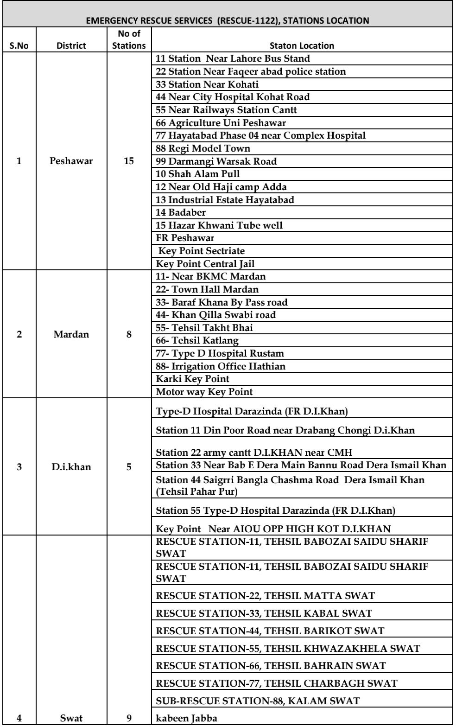
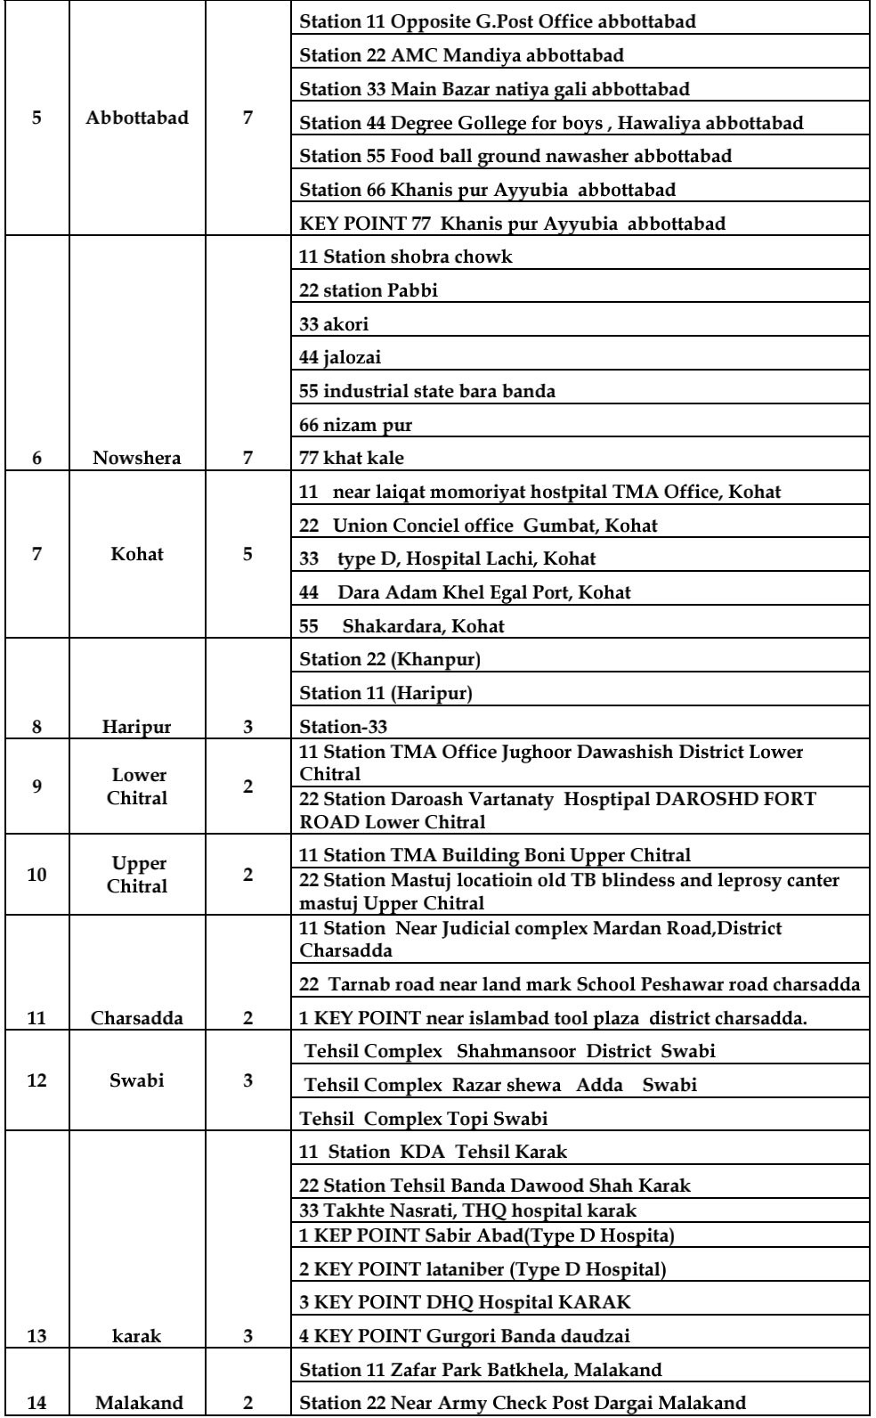
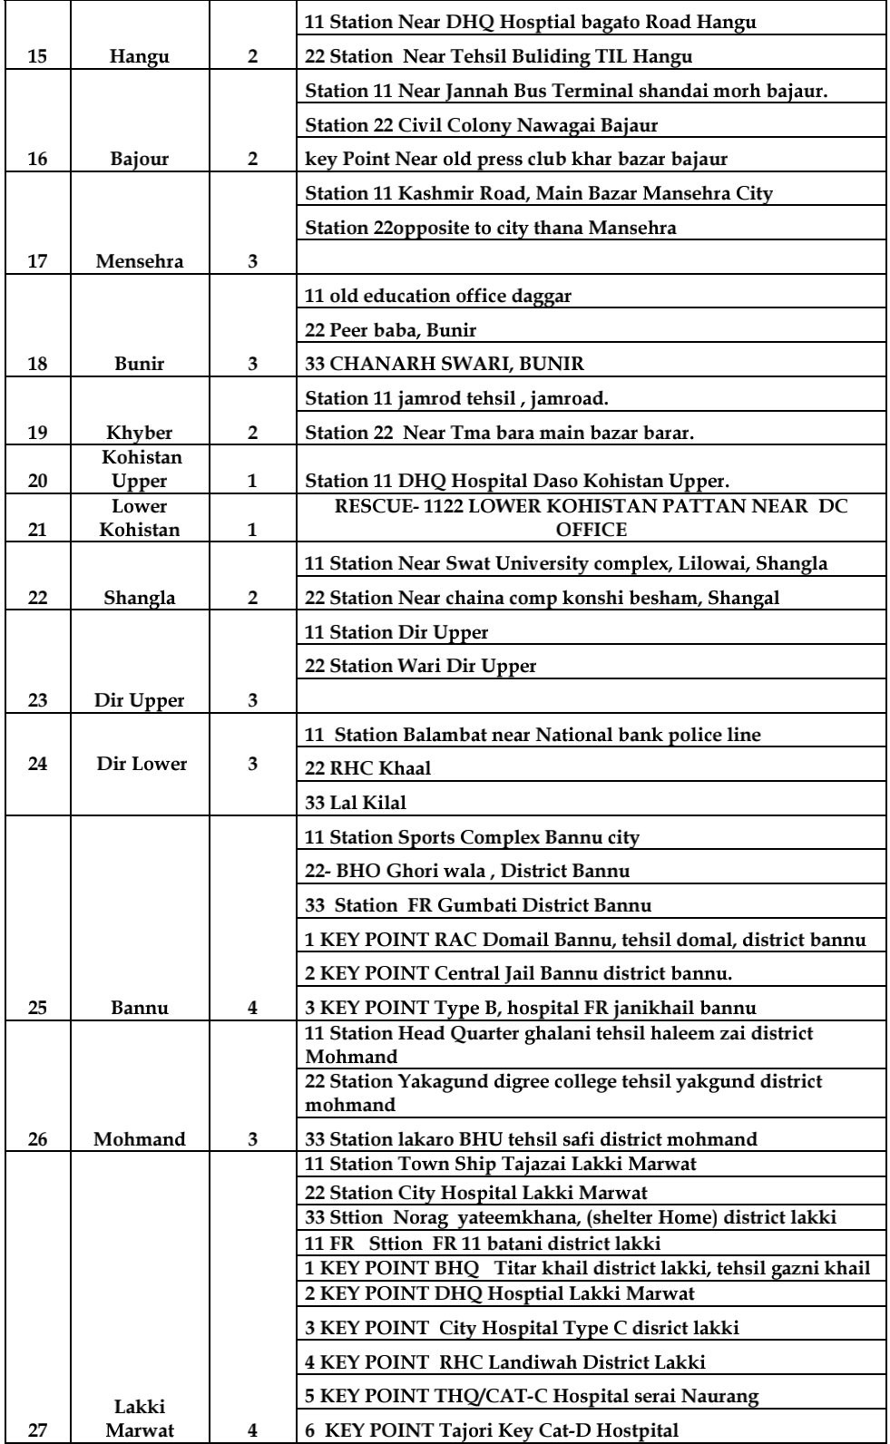
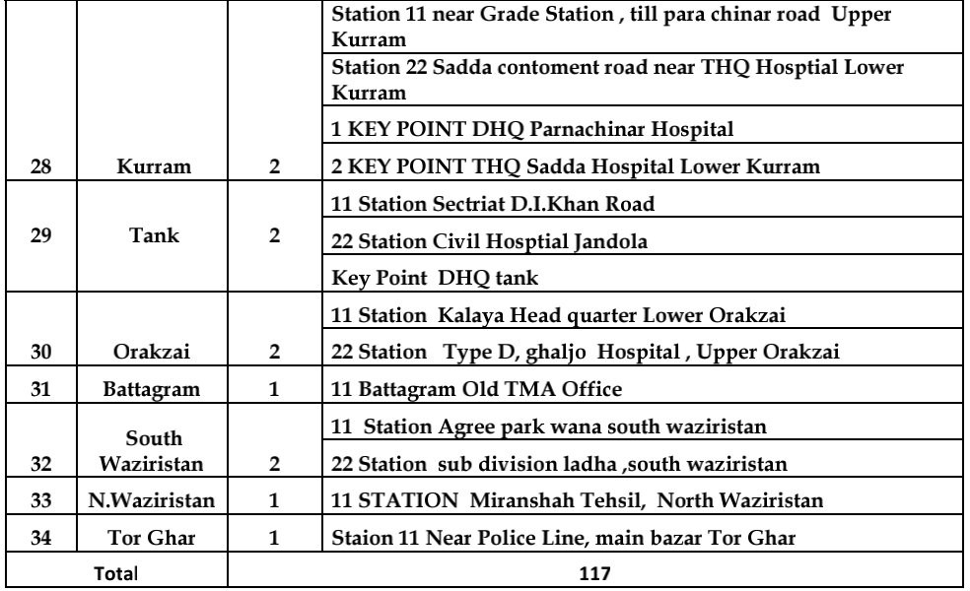

Appendix III: Stakeholders Consulted in Monsoon Contingency Planning 2026
List A: Provincial and Federal Line Departments Consulted for Monsoon Contingency Planning 2026
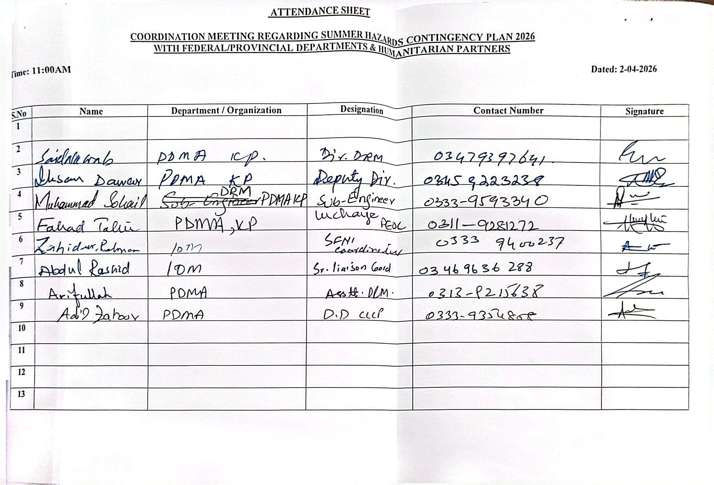

List D: ADC (Relief and Human Rights) Consulted for Monsoon Contingency Planning 2026
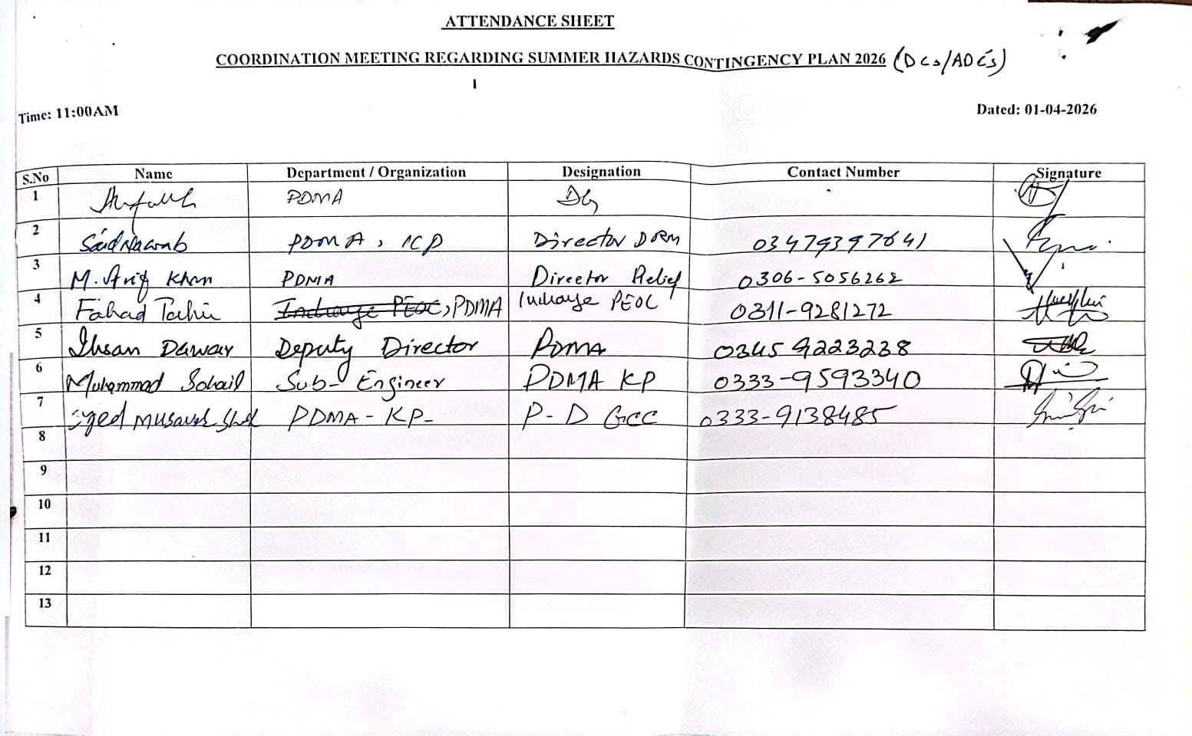

Appendix IV: Heat wave Public Guidance of NDMA
In Pakistan, extreme heat events have become increasingly common and severe due to the impacts of climate change. Temperatures regularly soar above normal levels, leading to prolonged periods of intense heat that pose significant health risks to the population. The scorching heatwaves not only affect physical health but also strain infrastructure, particularly in urban areas where access to cooling facilities may be limited. Vulnerable groups such as the elderly, children and those with pre-existing health conditions are at heightened risk during these heatwaves. Additionally, the socio-economic disparities exacerbate the impact with marginalized communities often lacking adequate resources to cope with extreme heat. However, proactive measures can be taken to mitigate these risks. This includes raising awareness about heat-related illnesses and promoting heat safety practices such as staying hydrated, seeking shade and avoiding strenuous activities during peak heat hours.
Guidelines for Dealing with Heat waves are as under: -
- Stay Informed; Keep yourself updated with weather forecasts and heatwave warnings issued by the Pakistan Meteorological Department (PMD) or relevant authorities. Stay connected with news channels, radio or weather apps for real-time information.
- Stay Hydrated. Drink plenty of water throughout the day, even if you do not feel thirsty. Avoid drinks with caffeine, alcohol or excessive sugar, as they can lead to dehydration. Coconut water, electrolyte drinks and herbal teas are good options to replenish electrolytes.
- Dress Appropriately. Wear lightweight, loose-fitting and light-colored clothing to reflect sunlight and allow air circulation. Use a wide-brimmed hat or an umbrella when outdoors to shield yourself from direct sunlight.
- Avoid Sun Exposure. Limit outdoor activities, especially during peak sunlight hours (usually from 10 a.m. to 4 p.m.). If you must go outside, seek shade whenever possible and use sunscreen with high SPF to protect your skin from harmful UV rays.
- Stay Cool. Use fans, air conditioners or coolers to maintain a comfortable indoor temperature. Take cool showers or baths to lower your body temperature. Use damp towels or ice packs on pulse points such as wrists, neck and forehead to cool down quickly.
- Check on Vulnerable Individuals. Keep an eye on children, the elderly, pregnant women and those with chronic illnesses as they are more susceptible to heat-related illnesses. Ensure they stay hydrated and cool, and never leave them unattended in parked vehicles.
- Know the Signs of Heat-related Illnesses. Be aware of symptoms such as heat exhaustion (excessive sweating, weakness, dizziness, nausea) and heatstroke (high body temperature, confusion, loss of consciousness). Seek medical attention immediately if you or someone else experiences these symptoms.
- Stay Connected. Keep in touch with friends, family and neighbors, especially those who live alone or are vulnerable. Encourage community support and check on each other regularly during heatwaves.

- Plan Ahead. Prepare an emergency kit with essential items such as water, non-perishable food, medications, first-aid supplies and a flashlight in case of power outages. Have a backup plan for staying cool if your usual cooling methods fail.

- Follow Government Guidelines. Adhere to any specific guidelines or directives issued by local authorities during heatwave emergencies. Stay informed about emergency shelters, cooling centers and other resources available in your area.

Sr. | District | Organization Name | Sector | Focal Person Name |  | Focal Person Contact No.
 |  |  |  | District Level | Provincial Level | District Level | Provincial Level
1 | Peshawar | UNOCHA |  |  | Shama Asad |  | 3149087122
2 |  | UNRCO |  |  | Muhammad Amjad Ghani |  | 3455003639
3 |  | UNICEF | PME |  | Zaheer Ahmed Durrani |  | 3218125669
4 |  | UNHCR | Protection |  | Nasir Azam (Primary) |  | 300 0652162
5 |  | UNHCR | Protection |  | Sahibzada Younas (backup) |  | 300 0540570
6 |  | UNWFP | Food Security |  | Maria Daud |  | 3458559338
7 |  | UNWFP | Food Security |  | Said Rehman |  | 3468564284
8 |  | UNDSS |  |  | Yasir Ul Hussain |  | 3455006236
9 |  | FAO | Food Security & Agriculture |  | Asghar Khan |  | 3449701129
10 |  | UN Women | Women Empowerment/ Co Chair Women Protection & Empowerment (WPE) |  | Shahida Shah | 3358444465
11 |  | UNFPA | GBV |  | Mahjabeen Qazi |  | 3005871923
Annex-III
Mapping of Humanitarian Partners
12 |  | WHO | Health |  | Sarwat Ayoub |  | 3463406600
13 |  | ILO |  |  | Jamshaid Iqbal |  | 3008151800
14 |  | IOM | Shelter & NFI |  | Abdul Rasheed |  | 3469636288
15 |  | IOM | Shelter & NFI |  | Zahid Ur Rehman |  | 3339400237
16 |  | ICRC |  |  | Aimal Jalal |  | 3008569840
17 |  | Alkhidmat Foundation |  |  | Adnan |  | 3459082495
18 |  | IRC | Protection and GBV | Nehar Muhammad |  | 331666061
19 |  | Handicap International France | MHPSS, Education |  | Muhammad Abrar Khan |  | 3008560375
20 | Peshawar | IRC | Protection and GBV | Nehar Muhammad |  | 3316660061
21 | Chakdara | IRC | Protection and GBV | Yasir Khan |  | 3459533965
22 | Nowshera | IRC | Health, Livelihood, Protection and GBV | Saeed Gul |  | 3339321006
23 | Haripur | IRC | Health, Livelihood, Protection and GBV | Ghulam Yahya |  | 3158182865
24 | Buner | IRC | WASH / Health | Shahid Ali |  | 3459696766
25 | Peshawar | International Medical Corps | MHPSS & Livelihood supported by GIZ | Syed Muhammad Shakeel | Rafiullah Khalil | 03339380786 | 3339410106
26 | Charsadda | International Medical Corps | General Protection (Health& MHPSS) supported by UNHCR
27 | Nowshera
28 | Kohat
29 | Haripur
30 | Peshawar | International Medical Corps | General Protection (Health& MHPSS) supported by UNHCR | Syed Muhammad Shakeel | Dr. Nosheen & Rafiullah |  | 3330878988, 3339410106
31 | Haripur
32 | Mansehra
33 | Nowshera
34 | Kohat
35 | Mardan
36 | Swabi
37 | Chitral
38 | Nowshera | International Medical Corps | WASH | Syed Muhammad Shakeel | Darshan Kotak |  | 3322812686
39 | Khyber Pakhtunkhwa All Districts | EHSAR Foundation | Health | Mukhtiar Ahmad | Kazim Ullah Khan | 3139785301 | 3005834200
40 |  | NHN |  |  | Kazim Ullah Khan |  | 3005834200
41 |  | PHF / IRC | Protection and GBV |  | Farhat Abbas (PHF Provincial LEAD) |  | 3455009575
42 |  | PRCS KP |  |  | Syed Ali Hassan |  | 3005949255

43 | Sawat | On Secondment to UNOCHA | District Coordinatior for Malakan Division | Shujat Ali |  | 3459519737
44 | Shangla
45 | Buner
46 | Malakand
47 | Upper Dir
48 | Lower Dir
49 | Upper Chitral
50 | Lower Chitral
51 | Bajaur
52 | Kurram | On Secondment to UNOCHA | District Coordinatior for Merged Districts | Umer Dil |  | 3349066003
53 | Khyber
54 | Mohmand
55 | North Waziristan
56 | Orakzai
57 | South Waziristan
58 | Merged Districts | PRCS | Chairman | Imran Wazir |  |  | 03000111710
59 | KP | Environmental Protection Society (EPS) | All |  | Masroor Ahmad Hussain |  | 3349307630
60 | Peshawar | Blessing Welfare & Development Organization (BWDO) | Social Protection (MHPSS) | Qurat ul ain Ayaz |  |  | 3339573889
61 | Peshawar | Health Education and Development Society (HEADS) | Education, WASH, FSL, Health, Protection, DRR, Climate Resilience | Raza Ullah Jan |  | 3005795491
62 | Tank | Health Education and Development Society (HEADS) | Education, WASH, FSL, Health, Protection, DRR, Climate Resilience | Syed Irfan Shah |  | 3000999150
63 | Chirtal | Health Education and Development Society (HEADS) |  | Sayed Ali Shah |  | 3453000036
64 | Dir Upper | Peace and Development Organization (PADO) | Food Security Support | Abdul Rauf Afridi | Furqan Ullah | 3359567744 | 3339566066
65 | Dir Lower | Peace and Development Organization (PADO) | Food Security Support
66 | Kohistan Upper | Peace and Development Organization (PADO) | Food Security Support
67 | Kohistan Lower | Peace and Development Organization (PADO) | Food Security Support
68 | Torghar | Peace and Development Organization (PADO) | Food Security Support
69 | Battagram | Peace and Development Organization (PADO) | Food Security Support
70 | Swat | Peace and Development Organization (PADO) | Food Security Support
71 | Buner | Peace and Development Organization (PADO) | Food Security Support
72 | Swabi, Mardan, Charsadda, Chitral | Takal Welfare Organization (TWO) | WASH, Education, Climate Resilience | M. Sabir | M. Dawood | 3453998959 | 3452256354
73 | Peshawar | Foundation for Development | DRR,Climate change,Food security | Shumaila Murtaza | Azmat Khan | 3347643864 | 3457776661
74 | KP | Rural Development Organization (RDO) | All Sectors | Hakim Zada | Hakim Zada | 3339697173 | 3339697173
75 | Charsadda | Rural Development Organization (RDO) | Livelihood, Protection and Governance
76 | Buner | Rural Development Organization (RDO) | Infrastructure, Governance and Environment
77 | Charsadda | Integrated Social Services Program (ISSP) | WASH, FSL, Shelter & NFIs, | Naveed Jan | Ikram Ullah | 3459338076 | 3005858865
78 | Swat | Integrated Social Services Program (ISSP) | WASH, FSL, Shelter & NFIs, | Waqar Ali Khan | Ikram Ullah | 3005858865 | 3005858865
79 | Peshawar | Integrated Social Services Program (ISSP) | WASH, FSL, Shelter & NFIs, | Ikram Ullah | Ikram Ullah | 3005858865 | 3005858865
80 | Mardan | Integrated Social Services Program (ISSP) | WASH, FSL, Shelter & NFIs, | Nasir Ali | Ikram Ullah | 3335490588 | 3005858865
81 | Dir upper and Lower | Integrated Social Services Program (ISSP) | WASH, FSL, Shelter & NFIs, | Haider Said | Ikram Ullah | 3009074755 | 3005858865
82 | Haripur | Welfare Association Jared (WAJ) | Protection, GBV, Governance, Food Secuity, Livelihood,DRR, Climate Resilience | Omar Javed | Mukhtar Javed | 3145006044 | 3100553662
83 | Abbottabad | Welfare Association Jared (WAJ) | GBV, Governance,DRR, Climate Resilience
84 | Mansehra | Welfare Association Jared (WAJ) | Protection, GBV, Governance, Food Secuity, Livelihood,DRR, Climate Resilience
85 | Battagrtam | Welfare Association Jared (WAJ) | Protection, GBV, Governance, Food Secuity, Livelihood,DRR, Climate Resilience
86 | Torgahr | Welfare Association Jared (WAJ) | Governance,DRR, Climate Resilience

 | KP( Peshawar, Nowshera, Charsadda , S |  |  |  | Tariq Hayat | 3477691255 | 3339191159
91 | Haripur & Abbottabad | AAR Japan  (Association for Aid & Relief japan) | Education | Ms.Sibgha Mukhtar | Seema Farooq | 333507427 | 3359559417
92 | Peshawar, Haripur | Poverty Eradication Initiative (PEI) | Health, WASH, Education, AI solutions | Shaista Bibi | Shaista Bibi | 3365670771 | 3365670771
93 | Peshawar | Centre of Excellence for Rural Developemnt (CERD) | Health and Nutrition | Taj Ali |  | 3339110042
94 | Swabi | Centre of Excellence for Rural Developemnt (CERD) | Child Protection | Khalid Khan |  | 3339110070
95 | Mardan | Centre of Excellence for Rural Developemnt (CERD) | Nutrition | Imran Khan |  | 3339110099
96 | Swat and Shangla | Centre of Excellence for Rural Developemnt (CERD) | Nutrition | Shahi Mulk |  | 3469568827
97 | Kohistan Upper, Lower and Kolai Palas | Center of Excellence for Rural Development CERD | Nutrition | Abida | Abdul Sumad | 3129704975 | 3028059109
98 | Kohistan Upper, Lower and Kolai Palas | Centre of Excellence for Rural Developemnt (CERD) | Livelihood and Nutrition | Arif Aziz | Abdul Sumad | 3339110060 | 3028059109
99 | Upper Chirtal | HUJRA Village Support Organization (HVSO) | DRR & Climate Change | Ikram Ullah | Saleem Ahmed | 3459743090 | 3339472172
100 | Swat | HUJRA Village Support Organization (HVSO) | DRR-FSL and Climate Change, Health, Education, WASH, Governance and Rule of Law |  | Saleem Ahmed |  | 3339472172
101 | Upper Kohistan | HUJRA Village Support Organization (HVSO) | HEALTH (Vaccination and Immunization) | Dr. Muneeb | Saleem Ahmed | 3329600585 | 3339472172
102 | Peshawar | HUJRA Village Support Organization (HVSO) | DRR-FSL and Climate Change, Health, Education, WASH, Governance and R | Ansa Kiran |  | 3489623944
103 | Dera Ismail Khan | VEER development Organization | Education, WASH, FSL, Health, Protection, DRR, Climate Resilience | Hani Fazal | Abid pervaiz | 3357211272 | 3078556858
104 | North Waziristan | Comprehensive Health and Education Forum International (CHEFI) | Inclusive DRR, Emergency Relief & Rehabilitation, Inclusive Health, Inclusive Education, WASH, Environment/Climate Change, Livelihood, Food Security | Fakhar-ud-din | Sohail Ayaz Khan | 3335191048 | 3038886666
105 | Charsadda | Comprehensive Health and Education Forum International (CHEFI) | Inclusive DRR, Emergency Relief & Rehabilitation, Inclusive Health, Inclusive Education, WASH, Environment/Climate Change, Livelihood, Food Security
106 | Mardan | Comprehensive Health and Education Forum International (CHEFI) | Inclusive DRR, Emergency Relief & Rehabilitation, Inclusive Health, Inclusive Education, WASH, Environment/Climate Change, Livelihood, Food Security
107 | Buner | Comprehensive Health and Education Forum International (CHEFI) | Inclusive DRR, Emergency Relief & Rehabilitation, Inclusive Health, Inclusive Education, WASH, Environment/Climate Change, Livelihood, Food Security
108 | Haripur | Comprehensive Health and Education Forum International (CHEFI) | Inclusive DRR, Emergency Relief & Rehabilitation, Inclusive Health, Inclusive Education, WASH, Environment/Climate Change, Livelihood, Food Security
109 | Peshawar | Malteser International | Integrated Health, Nutrition and MHPSS | Dr Gulshan | Dr Gulshan Rasheed | 3458508482 | 3458508482
110 | Charsadda | Malteser International | Integrated Health, Nutrition and MHPSS
111 | Nowshera | Malteser International | Integrated Health, Nutrition and MHPSS | Fahad Subhan | Dr Gulshan Rasheed | 3005977199 | 3458508482
112 | Mardan | Malteser International | Integrated Health and Nutrition | Dr Nayab | Dr Gulshan Rasheed | 3110931575 | 3458508482
113 | Buner | Malteser International | Integrated Health and Nutrition | Asad Shah | Dr Gulshan Rasheed | 3339700773 | 3458508482
114 | Lower Chitral | Malteser International | Integrated Health and Nutrition | Dr Aqsa | Dr Gulshan Rasheed | 3489215345 | 3458508482
115 | Khyber Pakhtunkhwa All Districts | Step Towards Empowerment of Pupil (STEP) | DRR, Emergency Relief & Rehabilitation, Education, WASH, Environment/Climate Change, Livelihood, Food Security & Governance and Rule of Law | Gulnaz Raqeeb | Muhammad Ismail Khan | 3219875975 | 3339846572
116 | Dera Ismail Khan | Hamdam Development Organization | WASH, NFI, Health, Climate Change | Abdul Ghafoor |  | 3467876188
117 | Tank | Hamdam Development Organization
118 | Peshawar | State Development Organization -SDO | Education | Waqar Ahmed | Jehangir Khan | 3155585958 | 3219198214
119 | Nowshera | State Development Organization -SDO | Education
120 | Karak | Khwendo Kor | Youth Leadership (Climate Change) | Sundas | Rizwana Bibi | 3071107561 | 3339646015
121 | Mardan | Khwendo Kor | Education | Maqbool | Rizwana Bibi | 3467876190 | 3339646015
122 | Bannu | Khwendo Kor | Climate Change and Livelihood and income generation | Qazi Assad U Rehman | Rizwana Bibi | 3339601025 | 3339646015
123 | Dir Lower | Khwendo Kor | Education | Ahmad Faraz | Rizwana Bibi | 3459368085 | 3339646015
124 | Peshawar | Khwendo Kor | Climate Change and Livelihood and income generation | Nuzhat Amin | Rizwana Bibi | 3496059953 | 3339646015
125 | Peshawar | Secours Islamique France (SIF) | Food Security & Livelihood | M Asif | Anis Gul | 3339988585 | 3335087897
126 | Charsada | Secours Islamique France (SIF)
127 | Nowshera | Secours Islamique France (SIF)
128 | Mardan | Secours Islamique France (SIF) | Livelihood | Touseef | Anis Gul | 3367762752 | 3335087897
129 | Sawabi | Secours Islamique France (SIF)
130 | Malakand | Secours Islamique France (SIF)
131
132 | Bunner | Secours Islamique France (SIF)
133 | Haripur | Secours Islamique France (SIF)
134 | Dir Upper | Secours Islamique France (SIF) | Climate Change and Livelihood and income generation
135 | Dir Lower | Secours Islamique France (SIF)
136 | Chitral Lower | Secours Islamique France (SIF) | Climate Change and Livelihood and income generation | Owais | Anis Gul | 3455369232 | 3335087897
137 | Chitral Upper | Secours Islamique France (SIF)
138 | Mansehra | Global Educational, Economic and Social Empowerment | Food Security & Livelihood, Climate Change | Khalid Waheed Qures | Kashif Hafeez | 3339896000 | 3012843824
139 | Haripur | Global Educational, Economic and Social Empowerment | Food Security & Livelihood
140 | Abbottabad | Global Educational, Economic and Social Empowerment | Food Security & Livelihood
141 | Battagram | Global Educational, Economic and Social Empowerment | Food Security & Livelihood
142 | Mardan | Center of Excellence for Rural Development CERD | Nutrition | Javira | Imran Khan | 3426044536 | 3339110099
143 | Swat | Center of Excellence for Rural Development CERD | Nutrition | Naseem | Shahi Mulak | 3039241534 | 3469568827
144 | Chitral Lower | Center of Excellence for Rural Development CERD | Nutrition | Khadija | Muhammad Raiz | 3468122431 | 3462989515
145 | Dir Upper | Center of Excellence for Rural Development CERD | Nutrition | Mehnaz | Noor Alam | 3247127450 | 3149012074
146 | Peshawar | Center of Excellence for Rural Development CERD | Nutrition | Hiba Zafar | Taj Ali | 3365825365 | 3339110042
147 | Peshawar | Fast Rural Development Program (FRDP) | Food Security & Livelihood | Sanya Saleem | Sanya Saleem | 3195799142 | 3195799142
148 | Nowshera | Fast Rural Development Program (FRDP) | Education, WASH, Food Security & Livelihood
149 | Charsadda | Fast Rural Development Program (FRDP) | Food Security & Livelihood, WASH
150 | Mardan | Fast Rural Development Program (FRDP) | WASH, Food Security & Livelihood
151 | Swabi | Fast Rural Development Program (FRDP) | WASH, NFI & Health
152 | Shangla | NIDA-Pakistan | FNS | Saifur Rahman | Muhammad Arif | 3468155516 | 3449685354
153 | Upper Kohistan | NIDA-Pakistan | Health
154 | Lower Kohistan, Kolai Pallas | NIDA-Pakistan | FNS, WASH, DRR, Education + CCA | Abdullah | Muhammad Arif | 3419087156 | 3449685354
155 | Khyber | NIDA-Pakistan | Food System, FNS | Shehzad Elahi | Muhammad Arif | 3349127662 | 3449685354
156 | Hangu | NIDA-Pakistan | Relief Distribution | Allauddin | Muhammad Arif | 3032354434 | 3449685354
157 | Kurrum | NIDA-Pakistan | Relief Distribution | Zahir Khan | Muhammad Arif | 3009159416 | 3449685354
158 | Charsadda | NIDA-Pakistan | Climate Smart Agriculture, DRR, WASH, Livelihood, Health | Zahoor | Muhammad Arif | 3459526139 | 3449685354
159 | Nowshehra | NIDA-Pakistan | Education | Farman | Muhammad Arif | 3335550674 | 3449685354
160 | Peshawar | NIDA-Pakistan | Education | Khaista rehman | Muhammad Arif | 3038356283 | 3449685354
161 | Swabi | NIDA-Pakistan | Education | Ayaz | Muhammad Arif | 3429548464 | 3449685354
162 | Haripur | NIDA-Pakistan | Education | Pervaiz | Muhammad Arif | 3005620321 | 3449685354
163 | Chitral Upper | NIDA-Pakistan | Relief Distribution | Anwar Baig | Muhammad Arif | 3460980195 | 3449685354
164 | Chitral Upper | NIDA-Pakistan | WASH, Health, DRR,
165 | Dir Upper | NIDA-Pakistan | Climate Smart Agriculture, DRR, WASH, Livelihood, Health | Khan Bacha | Muhammad Arif | 3018522324 | 3449685354
166 | D.I.Khan | Direct Focus Community Aid (DFCA) | Health | Shamsul Hadi |  | 3005899623
167 | Tank | Direct Focus Community Aid (DFCA) | Health
168 | Bannu | Direct Focus Community Aid (DFCA) | Health
169 | North Waziristan | Direct Focus Community Aid (DFCA) | Health
170 | South Waziristan | Direct Focus Community Aid (DFCA) | Health

Appendix V: Important Contacts
Secretary RR & SD
Sr. No. | Name, Designation | Office | Mobile | Fax
 | Mr. Sohail Khan, Secretary RR & SD. | 091- 9212058 | 0332-1714723 | 091-9210371
 | Mr. Zia-Ur-Rehman, Additional Secretary RR & SD. | 091-9213250 | 0348-8988551 | 091-9210371
PDMA, KHYBER PAKHTUNKHWA
PDMA Headquarter, Peshawar
Sr# | Name | Designation | Office | Cell | Fax
1 | Mr. Arif Ullah Awan | Director General | 091-9213855 | 0300-5929888 | 091-9219637
2 | Mr. Naeem Ullah | Director (HR & Admn) | 091-9211805 | 0334-8821909 | 091-9219637
3 | Mr. Muhammad Ali | Director (Relief) | 091-9213890 |  | 091-9219637
4 | Mr. Ihsan Dawar | D.Director (DRM) | 091-9219628 | 0345-9223238 | 091-9219637
5 | Mr. Waseem Kundi | Director (Rehab) | 091-9216221 | 0332-9126212 | 091-9219637
6 | Ms. Uzma Mukarram | Director (CEW) | 091-9219080 | 0335-6115599 | 091-9219637
7 | Mr. Abdur Rehman | DD (Finance) |  | 0333-0918171 | 091-9219637
8 | Mr. Amjad Khan | DD/PD (PEOC) |  | 0333-9115439 | 091-9219637
9 | Mr. Imran Khan | AD (Admn) | 091-9212060 | 0345-9456782 | 091-9219637
10 | Mr. Zia Ur Rehman | AD (Warehouse) |  | 0312-3339611 | 091-9219637
11 | Mr. Fahad Tahir | Incharge (PEOC) |  | 0311-9281272 | 091-9219637
12 | Mr. Anwar Shahzad | Media Specialist |  | 0313-9656965 | 091-9219637
13 | Provincial Emergency Operation Centre |  | 091-9219635,9219636  Helpline-1700 |  | 091-9219637
14 | Terbela Hydrology Control Room |  | 0995-350070
15 | Weather Forecasting/ Advisory |  | 091-9212080

DIVISIONAL REPORTING OFFICERS OF PDMA
 | Name | Designation | Divisions | Contact No
1 | Muhammad Umar Khan | Reporting Oﬃcers | Mardan | 0345-9373099
2 | Salman Mulk | Reporting Oﬃcers | Malakand | 0334-9023996
3 | Maqsood Anwar | Reporting Oﬃcers | Kohat | 0345-9052824
4 | Ibrahim | Reporting Oﬃcers | Hazara | 0333-9055254
Commissioners
Sr# | District | Name | Office | Fax | Mobile
1 | Malakand | Mr. Masood Ahmad | 0946-9240226,0946-9240185 | 094  -9240229-178,0946-9240223(House) | 0315-9807882
2 | Hazara | Mr. Fayaz Ali Shah | 0992-9310111/9310222/9310444 | 0992-9310500 | 0301-8184566
3 | Mardan | Mr. Javed Marwat | 0937-9230572-73 | 0937-9230578 | 0313-5020202
4 | Pesahwar | Mr. Riaz Khan Mehsud | 091- 9211337 | 091-9214085 | 0300-8599055
5 | Kohat | Mr. Mohtasim Billah Khan | 0922-9260002/0922-9260001 | 0922-9260105 | 0344-9229860
6 | Bannu | Capt. (Retd) Khalid Mehmood | 0928-9270044/0928-621144/09289270220 | 0928-9270041 | 0341-3111555
7 | D.I.Khan | Mr. Dawood Khan | 0966-9280351 | 0966-9280352 | 0333-9107765

Deputy Commissioners
S.No. | District | Name of Officer | Office | Residence | Fax | Mobile | Whatsapp No.
1 | Abbottabad | Mr. Sarmad Saleem Akram | 0992-9310200/01-24 | 0992-9310464 | 0992-9310202 | 0300-5595089 | 0300-5595089
2 | Bannu | Muhammad Fahim | 0928-9270032 | 0928-9270032 | 0928-9270079 | 0332-3649000 | 0332-3649000
3 | Battagram | Mr. Ishtiaq Ahmad | 0997-310030 | 0997-310136 | 0997-310051 | 0344-9193095 | 0344-9193095
4 | Buner | Mr. Kashif Qayyum | 0939-510450 | 0939-510888 | 0939-510427 | 0314-9009056 | 0314-9009056
5 | Charsadda | Dr. Azmat Ullah Wazir | 091-9220024 | 091-9220020 | 091-9220021 | 0333-9302515 | 0333-9302515
6 | Lower Chitral | Muhammad Hashim Azim | 0943-412055/412519/412368 | 0943-412519 | 0943-412421 | 0333-9328084 | 0333-9328084
7 | Upper Chitral | Muhammad Imran Khan | 0943-470355 |  | 0943-470356 | 0333-0506962 | 0333-0506962
8 | D.I.Khan | Mr. Abdul Nasir | 0966-9280116 | 0966-9280022 | 0966-9280110 | 0300-8814808 | 0300-8814808
9 | Dir Lower | Muhammad Arif Khan | 0945-9250003/09459250031 | 0945-9250002 | 0945-9250001 | 0301-5946675 | 0301-5946675
10 | Dir Upper | Mr. Naveed Akbar | 0944-880394 | 0944-880104 | 0944-881130 | 0300-5920011 | 0300-5920011
11 | Hangu | Mr. Gohar Zaman | 0925-621175 | 0925-623968 | 0925-620050 | 0333-3333592 | 0333-3333592
12 | Haripur | Mr. Waseem Ahmad | 0995-920200 | 0995-611149 | 0995-615412 | 0321-9673755 | 0321-9673755
13 | Karak | Mr. Asad Sarwar | 0927-210125/828, 0333-9713050 ishtaiq | 0927-210825 | 0927-210925 | 0344-9028877 | 0344-9028877
14 | Kohat | Mr. Raheem Ullah | 0922-9260268 | 0922-9260031 | 0922-9260032 | 0307-8400085 | 0307-8400085
15 | Upper Kohistan | Mr. Tariq Ali Khan | 0998-407002 | 0998-407193 | 0998-407001 | 0346-9312955 | 0346-9312955
16 | Lower Kohistan | Mr. Tariq Mehmood | 0998-405091 | 0998-405113 | 0998-405092 | 0344-5156496 | 0304-8499984
17 | Kolai Pallas | Mr. Noor ul Amin | 9984052200 |  |  | 0304-9011110 | 0304-9011110
18 | Lakki Marwat | Mr. Hameed Ullah | 0969-538330-1 | 0969-538331 | 0969-538333 | 0334-9181315 | 0334-9181315
19 | Malakand | Mr. Fayaz Sherpao | 0932-452080 | 0932-452043 | 0932-452105 | 0334-0983339 | 0334-0983339
20 | Mansehra | Mian Behzad Adil | 0997-920174 | 0997-920174 | 0997-305513 | 0345-5339552 | 0345-5339552
21 | Mardan | Mr. Wasif Rehman | 0937-9230048 | 0937-9230048 | 0937-9230303 | 0345-5503355 | 0345-5503355
22 | Nowshera | Mr. Irfan Ullah | 0923-9220099 | 0923-9220098 | 0923-9220159 | 0333-5755069 | 0333-5755069
23 | Peshawar | Mr. Sana Ullah | 091-9212302 | 091-9211338 | 091-9211418 | 0345-9519119 | 0345-9519119
24 | Shangla | Muhammad Abdullah | 0996-850005/850911 | 0996-850008 | 0996-850006 | 0340-5522005 | 0340-5522005
25 | Swabi | Mr. Tariq Ullah | 0938-920006/920013 | 0938-221220 | 0938-221500 | 0346-9849986 | 0346-9849986
26 | Swat | Mr. Saleem Jan | 0946-9240340/337 | 0946-9240338 | 0946-9240329 | 0300-5943386 | 0300-5943386
27 | Tank | Mr. Tanwir Khan | 0963-511326 | 0963-511326 | 0963-510300 | 0304-9016456 | 0304-9016456
28 | Tor Ghar | Mr. Anwar Zeb | 0997-541001 (Faisal Latif) 0346-9708912  PS to DC | 0340-0562010 | 0997-580188 | 0300-5949969 | 0300-5949969
29 | Bajaur | Mr. Shahid Ali | 0942-220559 | 0942-220558 | 0942-220388 | 0346-9293209 | 0346-9293209
30 | Kurram | Mr. Ashfaq Khan | 0300-9040564 | 0926-310599 | 0926-310520/311797 | 0332-9689510 | 0332-9689510
31 | Mohmand | Mr. Yasir Hassan | 0924-290001 (Adc 0924-290189) | 0924-290002 | 0924-290075 | 0333-5032744 | 0333-5032744
32 | North Waziristan | Mr. Yousaf Karim | 0928-300798 | 0928-300798 | 0928-300642/300600 | 0345-9770025 | 0345-9770025
33 | South Waziristan Upper | Mr. Asmat Ullah Wazir | 0963-510364/510386 | 0963-510386 | 0963-510442  (0965-210296/210748 WANA) | 0301-9098999 | 0301-9098999
34 | Orakzai | Mr. Irfan Ud Din | 0925-690008/3 | 0925-680003 | 0925-690007 | 0333-9191313 | 0333-9191313
35 | Khyber | Mr. Balil Shahid Rao | 9211901/4 | 9211904 | 9211900 | 0311-1451678 | 0311-1451678
36 | South Waziristan Lower | Mr. Mussarat Zaman | 0965-210748 | 0965-210748 | 0965-210296 | 0305-8820123 | 0305-8820123

Contact list of NDMA and other PDMA’S
SR. NO. | NAME AND DESIGNATION | OFFICE NO/ FAX NO | CELL NO/ Fax NO
1 | Chairman, NDMA. | 051-9222373 | 051-9087801
1 | Chairman, NDMA. | 051-9212444 | 051-9087801
1 | Chairman, NDMA. | Fax no: 051-9202407/9204197  9204179 | 051-9087801
2 | National Emergency Operation Center | UAN: 111157157,  Ph: 051-9030727-28-29
3 | PDMA, Sindh. | Ph: 021-35381810
3 | PDMA, Sindh. | Fax 021-99332007
4 | PDMA, Punjab. | 042-99203164-5
4 | PDMA, Punjab. | Fax no: 042-99204405
5 | PDMA, Balochistan. | Ph: 081-9241118
6 | SDMA, Muzaffarabad, Kashmir. | Ph: 05822-921536
6 | SDMA, Muzaffarabad, Kashmir. | Fax: 05822-921643
7 | Gilgit Baltistan Disaster Management Authority (GBDMA). | Fax: 05822-921643
7 | Gilgit Baltistan Disaster Management Authority (GBDMA). | 05811-922030
7 | Gilgit Baltistan Disaster Management Authority (GBDMA). | 051811-920874
7 | Gilgit Baltistan Disaster Management Authority (GBDMA). | Fax no: 05811-920875

Rescue 1122 HQ Officers
Designation | Phone
Director General | 091-9222483-4  Fax 9222487
DG Rescue Academy/ Director Operation & Co ordinations (kpk) | 091-9222486 / Fax 9222537
Director Admin | 091-9222488

Director General Health Office
Musavir Khan | 03139558414 |  | Focal Person
Communication and Works Department
Mubeen Akhunzada | 0311-1304448 |  | Focal Person
Local Govt. Department
Ahmad Sher | 0344-9620588 |  | Focal Person
WATER & SANITATION SERVICES COMPANY SWAT Govt. of Khyber Pakhtunkhwa
Focal Person |  |  |  | Control Room
Muhammad Tahir Khan |  | 0344-9888912 |  | Helpline: 1334

CHIEF ENGINEER (NORTH) IRRIGATION DEPARTMENT TELEPHONE DIRECTORY FLOOD SEASON, 2025
District | Appointment | Office cell | Resident
Peshawar | Chief Engineer (North) | 091-9212123
Peshawar | Superintending Engineer (H/Q) | 091-9212113
Dir | Executive Engineer |  | 0945-9250068
Dir | SDO Balambat |  | 0945-9250110
Dir | SDO, Dir Chakdara

CHIEF ENGINEER (SOUTH) IRRIGATION DEPARTMENT TELEPHONE DIRECTORY FLOOD SEASON, 2025
Dis: | Designation | Office cell/Fax No.
Peshawar | Chief Engineer (South) | 9212116
-do- | Superintending Engineer, South (H/Q) | 9212174
-do- | Administrative Officer | 9212118

ENVIRONMENTAL PROTECTION AGENCY
Sr. No. | Designation | Contact
1 | DG | 9210263
2 | Director | 9210966

Development Authorities
Sr. No. | Department | Contact No.
1 | Peshawar Development Authority | 091-9217135
2 | Kaghan Development Authority | 0997-303722
3 | Galyat Development Authority | 0992-9310240
4 | Upper Swat Development Authority | 0946-920232

https://link.springer.com/article/10.1007/s42452-021-04457-z

